

**Network Security**

Year 2/3 (2025/26), Semester 3/5

**SCHOOL OF INFOCOMM TECHNOLOGY**

Diploma in Cybersecurity & Digital Forensics

**ASSIGNMENT**

**Duration:**  Weeks 5 -17

**Weightage:**   40%

**Tutorial Group: T03 Team Number: _______** **Team Grade: _______**

|  |  |  |
| --- | --- | --- |
| **Student Name** | **Student Number** | **Combined Grade** |
| 1. Wyse Lee Hong Yao | S10268134D |  |
| 2. Ian Tan Jun Yang | S10268190F |  |
| 3. Kwoh Si Jia | S10267641F |  |
| 4. Liew You Tong | S10268015F |  |
| 5. Ang Zi Jun Caeden | S10267229H |  |

Table of Contents

Business requirement analysis & Detailed firewall comparisons 5

Business requirements to secure the company’s network 5

Next Generation Firewalls available in the market 6

Comparison with Palo Alto Firewall 8

Comprehensive comparison of different firewall options available in the market 9

Network diagram 24

Technical requirement implementations 25

SG 25

Zones 25

Virtual network adapters 27

IP address allocation 27

Decryption Policies 29

SSL Certificate Generation 35

HR Allow LinkedIn but Block LinkedIn Messaging 36

IT Block LinkedIn and Facebook 38

HR Allow Facebook but Block Facebook Messaging 39

HR Deny access to online storage services 40

VPN Configuration 42

Advanced Features 46

KL 56

Zones 56

Virtual network adapters 58

IP address allocation 59

Essential Business Features 59

Source NAT 59

Allow Standard Application 60

Decryption Policies 60

SSL Certificate Generation 68

Deny access to online storage services 71

Facebook access & deny facebook-chat 73

Advanced Feature 75

VPN configuration 86

Test plans & results 91

HR Department (SG) Essential Business Functions 91

HR Allow Google 93

HR Allow Microsoft 365 94

HR Allow LinkedIn 94

HR Block LinkedIn Messaging 95

HR Allow Facebook 96

HR Block Facebook Chat 96

HR Block Online Storage Services 97

IT Department (SG) 99

Essential Business Functions 99

IT Allow Google 104

IT Allow Microsoft 365 104

IT Block LinkedIn & Facebook 105

Sales Department (KL) 107

Essential Business Functions 107

Allow Google 110

Allow Microsoft 365 112

Block LinkedIn 113

Allow Facebook 114

Block Facebook Chat 115

Block Online Storage Services 116

SG Firewall (Decryption Policy) 117

KL Firewall (Decryption Policy) 119

SG Firewall (VPN Connection to KL Office) 120

KL Firewall (VPN Connection to SG Office) 122

SG Firewall Content ID 124

Anti-Virus/Anti-Spyware 124

Anti-Spyware (DNS sinkhole) 125

URL Filtering 126

File Blocking 127

High Availability 128

IDPS (IP Blocking) 130

Client to Site VPN 132

Conclusions and Recommendations 136

Appendix A: Individual Contribution by Each Team Member 138

# Business requirement analysis & Detailed firewall comparisons

## Business requirements to secure the company’s network

* **Data Protection**: Data is one of the most valuable asset for the company and should be protected from unauthorized access, data breaches and exfiltration. To ensure that data is protected, the network should be implemented with strict
* **Network Segmentation**: Divide network into security zones with granular policies to contain threats and control access between departments. Network segmentation limits the spread of malware and gives better control over traffic flow. With proper segmentation, each department operates in its own zones such as HR, Sales and IT. Security policies are applied per zone so rules will be specific, making internal threats easier to detect and isolate, simplifying compliance and auditing.
* **Application Visibility and Control**: Identify, monitor, and control application usage within the company network. Modern firewalls such as Palo Alto Firewall use App-ID to identify applications regardless of port, protocol or evasion techniques. It allows essential apps and block or limit apps to prevent misuse of allowed apps.
* **Remote Access and VPN Connectivity**: Provide secure access to remote users with scalable VPN capabilities. Secure VPNs protect data during transit over public networks. This is needed as the company needs site-to-site VPN between SG and KL offices for seamless LAN-to-LAN communication. They would also need remote access VPN so authorised users can access resources from outside securely, this allows strong encryption, authentication and policy controls.

## Next Generation Firewalls available in the market

* Palo Alto Networks
* Fortinet FortiGate
* Cisco Firepower
* Check Point Quantum Force
* Juniper Networks SRX Series
* Sophos XGS Firewall

Palo Alto provides data protection as it protects sensitive data through cloud-delivered DLP and WildFire for zero-day threat detection, SSL/TLS Decryption for inspecting encrypted traffic. It provides network segmentation by using zones, VLANs and policy-based controls. Palo Alto provides application visibility and control through App-ID for accurate identification, classification and enforcement of policies on applications regardless of ports, protocols or encryption. Palo Alto provides remote access and VPN connectivity through GlobalProtect for secure user access and compliance checks and supports IPSec and SSL VPNs for encrypted site-to-site and remote connections.

Fortinet FortiGate provides data protection through integrated DLP, antivirus, sandboxing (FortiSandbox) and more to detect and block sensitive data leaks in real-time. It provides network segmentation using virtual domains (VDOMs), zones, VLANs and policy-based access control. It also provides application visibility and control by using deep packet inspection and a dynamic application database (FortiGard Application Control database) which is continuously updated with new application signatures. It also provides remote access and VPN connectivity through an endpoint security software (FortiClient) which provides remote access via IPSec and SSL VPNs.

Cisco Firepower provides data protection through Advanced Malware Protection (AMP), intrusion prevention (Snort IPS) and SSL/TLS decryption. It provides network segmentation using security zones, access control policies, VLANs and Virtual Routing and Forwarding (VRF). It also provides application visibility and control using deep packet inspection, Cisco’s AVC and Talos threat intelligence. It also provides remote access and VPN connectivity by integrating Cisco AnyConnect to provide SSL and IPSec VPN support.

Check Point Quantum Force provides data protection through Check Point’s ThreatCloud AI, which analyses global threat intelligence in real time, DLP and AI-Powered threat protection. It provides network segmentation through security zones, segmented access control policies, VLAN support and multi-tenant architecture. It also provides application visibility and control through App control and URL filtering. It provides remote access and VPN connectivity using Check Point Mobile Access, Capsule VPN, SSL Network Extender and integrated IPsec/SSL VPN technologies.

Juniper Networks SRX Series provides data protection through Intrusion Prevention System (IPS), Unified Threat Management (UTM), Advance Threat Prevention (ATP) and SSL inspection and application-layer filtering. It provides network segmentation through security zones, virtual routers, VLANs and firewall rules. It also provides application visibility and control through AppSecure for identification and classification of applications. It provides remote access and VPN connectivity through dynamic VPNs using IPsec or SSL with the integration of Juniper Secure Connect.

Sophos XGS provides data protection through integrated DLP, ATP, antivirus scanning, sandboxing via Sophos Sandstorm and SSL/TLS inspection. It provides network segmentation through zones, VLANs, firewall rules and micro segmentation policies. It also provides application visibility and control using deep packet inspection (DPI) and Synchronized App Control. It provides remote access and VPN connectivity through SSL VPN, IPSec VPN and Sophos Connect client which offers features like user authentication, policy enforcement and seamless integration with Sophos Central for endpoint posture checks and multi-factor authentication (MFA).

## Comparison with Palo Alto Firewall

|  |  |  |  |  |
| --- | --- | --- | --- | --- |
| Firewall | Data Protection | Network Segmentation | Application Visibility and Control | Remote Access and VPN Connectivity |
| 1. Palo Alto | Cloud DLP, WildFire, SSL/TLS Decryption | Zones, VLANs, Policy-based controls | App-ID (industry leader), ML-powered control | GlobalProtect, SSL/IPSec VPN |
| 2. Fortinet FortiGate | DLP,Antivirus, FortiSanbox, Real-time detection | VDOMs, Zones, VLANs, Access control | Deep packet inspection, FortiGard App Database | FortiClient, SSL/IPSec VPN |
| 3. Cisco Firepower | DLP, AMP, Snort IPS, SSL/TLS Decryption | Zones, Access policies, VLANs, VRF | DPI, Cisco AVC, Talos intelligence | Cisco AnyConnect, SSL/IPSec VPN |
| 4. Check Point Quantum Force | ThreatCloud AI, DLP, AI-Powered Threat Protection | Zones, Access policies, VLANs, multi-tenant | App control, URL filtering | Mobile Access, Capsule VPN, SSL Extender, IPSec/SSL |
| 5. Sophos XGS | DLP, ATP, Antivirus, Sandstorm, SSL/TLS Inspection | Zones, VLANs, Firewall rules, Micro segmentation | DPI, Synchronized App Control | SSL/IPSec VPN, Sophos Connect, MFA |
| 6. Juniper SRX Series | IPS, UTM, ATP, SSL Inspection | Zones, Virtual Routers, VLANs, Firewall rules | AppSecure for app ID and Classification | Dynamic VPN, IPSec/SSL, Juniper Secure Connect |

## Comprehensive comparison of different firewall options available in the market

1. Application Visibility and Control:

* Palo Alto Networks  
  App-ID identifies applications regardless of port, protocol, or encryption. It offers function-level control, allowing policies like permitting Zoom video but blocking Zoom file transfers. App-ID also works seamlessly with User-ID and Content-ID for fully contextual policy enforcement. This level of precision and integration sets the industry standard and is a key reason for Palo Alto’s leadership in NGFW technology.
* Cisco Firepower  
  Cisco Firepower uses AVC for app identification but lacks the granularity and consistency of Palo Alto’s App-ID. Function-level control is limited, and visibility into encrypted or evasive apps is less reliable. Cisco’s app control also requires tight integration with other Cisco tools (e.g., ISE) to approximate Palo Alto’s unified enforcement model.
* Fortinet FortiGate  
  FortiGate supports deep packet inspection and a large app signature base, but its application control is mostly limited to basic allow/deny actions. Unlike Palo Alto, Fortinet cannot reliably differentiate between sub-functions of applications (e.g., Dropbox upload vs. download), and integration with user identity and content inspection is less cohesive
* Check Point Quantum Force

Check Point’s Quantum Force firewalls offers strong Application Control as part of the CloudGuard product especially for cloud environments. CloudGuard integrates application control with Check Point’s ThreatCloud to provide real-time protection against malicious apps and threats. While Check Point excels at identifying and controlling applications, it is not as refined as Palo Alto as it does not provide the same function-level control, making it more suitable for organisations seeking broad application-level control rather than fine-tuned management of app behaviours. It is strong in multi-cloud and hybrid environemnts, where it helps enforce consistent security policies across different platforms however, it is still evolving and is best suited for organisations already integrated into Check Point’s broader security ecosystem.

* Sophos XGS

Sophos XGS integrates Application Visibility and Control as part of its Xstream protection suite which supports deep packet inspection (DPI), enabling firewall to identify and inspect a wide variety of applications. However, granularity in application control is limited, compared to the other firewalls such as Palo Alto and Fortinet. Sophos XGA allows basic blocking and throttling of application, but it lacks the fine-grained control over sub-functions of application such as restricting specific features within apps. Sophos XGS is ideal for small organisations or those that need a simple, easy-to-use firewall solution. It also integrates well with Sophos Central which provides centralised management and visibility into application traffic across deployed environments. However, if compared to other firewalls, Sophos XGS lacks the depth of functionality for highly customisable application control.

* Juniper SRX  
  Juniper SRX provides Application Visibility and Control through its AppSecure service which offers basic application identification and monitoring but does not provide the same level of granular control that Palo Alto and Fortinet has to offer. Juniper SRX allows simple allow/block policies but lacks the function-level control to manage specific features with applications. Juniper’s Sky Advanced Treat Prevention (ATP) improves visibility by identifying and blocking malicious applications. but its overall application control is less advanced. The Security Director Cloud offers centralised managements, but advanced reporting and detailed visibility into application behaviour are not as robust as the other firewalls such as Palo Alto and Check point. Juniper SRX is best suited for organisations that need basic application control without the complexity of more feature-rich firewalls.

1. SSL/TLS Decryption Capabilities
   * Palo Alto Networks:

Palo Alto provides highly customisable approach to SSL/TLS decryption capabilities including both SSL forward proxy and inbound inspection with support for the latest TLS 1.3 protocol. This means it can decrypt outbound traffic from internal users as well as incoming encrypted traffic from external sources, providing comprehensive visibility into encrypted sessions. The many granular control allows administrators to selectively decrypt traffic based on user identity, application type, URL categories and many more. It is particularly suitable for enterprises that require strict security controls and detailed visibility into encrypted traffic. Despite the high levels of control and integration with its WildFire malware analysis service, performance may suffer under heavy traffic loafs due to the resource-intensive nature of decryption.

* + Fortinet FortiGate

Fortinet FortiGate provides efficient SSL/TLS decryption supporting both outbound and inbound SSL decryption, including TLS 1.3, offering customizable decryption policies, ensuring that encrypted traffic can be analysed for security threats. It also allows for highly customisable decryption policies which can be defined based on user identity, application type and URL categories, making it ideal for organisations seeking both performance and security, especially in environments with high traffic loads. It stands out in terms of performance due to its FortiASIC hardware acceleration, allowing it to handle high volumes of encrypted traffic with minimal impact on throughput. However, the complexity of managing fine-grained decryption policies may increase as network size grows and there could be limitations in managing exceptions for sensitive traffic such as banking.

* + Cisco Firepower

Cisco Firepower integrates SSL/TLS decryption with advanced threat defence capabilities, offering both SSL proxy for outbound SSL traffic and SSL inbound inspection. It ensures that both outgoing and incoming encrypted traffic are decrypted and thoroughly inspected. It also supports TLS 1.3 decryption, keeping pace with the latest standards. Cisco Firepower is particularly well-suited for organisations already using Cisco’s broader security ecosystem such as AMP for endpoints and umbrella, allowing unified approach to threat management. It also provides application visibility and control, enabling deep inspection of encrypted traffic by application signatures. While the system excels in threat intelligence and visibility, performance can be affected by the increased load from SSL decryption, particularly in environments where high throughput is required.

* + Check point Quantum Force

Check point quantum force offers comprehensive SSL inspection capabilities for both inbound and outbound encrypted traffic, The SSL forward proxy and SSL inbound inspection capabilities allow it to decrypt traffic for both client-to-server and server-to-client communication. It also integrates with SandBlast Zero-Day protections which uses sandboxing to detect unknown threats withing decrypted traffic, making this firewall particularly strong in terms of advanced threat prevention as the firewall can block malware or data exfiltration attempts hidden in SSL traffic. With deep inspection and zero-day protection, it makes Check point quantum force a strong choice for enterprises requiring advanced security measures especially against advanced and unknown threats.

* + Sophos XGS

Sophos XGS offers SSL/TLS decryption with strong granular control over decryption policies, making it suitable for businesses of varying sizes, supporting both outbound and inbound decryption, including TLS 1.3 and provide real-time threat detection in decrypted traffic. It integrates well with Sophos’ endpoint protection solutions, providing a unified security approach. The firewall’s management interface is easy to configure and deploy in small to medium sized organisations. It also provides advanced sandboxing capabilities to analyse decrypted traffic for unknown threats. While the performance is optimised for smaller and medium sized networks, it may face limitations in high throughput or large-scale environments

* + Juniper SRX series

Juniper SRX series offers SSL/TLS decryption capabilities as part of its unified threat management approach which supports SSL forward proxy and SSL inbound inspection. This firewall is designed for high-performance environments like data centres and service providers, where low latency and high throughput are critical. They also provide granular control over SSL decryption policies which can be tailored based on application types, users and traffic patterns. It also integrates with Juniper’s Sky ATP for advanced threat protection, enabling cloud-based analysis of decrypted traffic. Despite being a good option for organisations that need high scalability especially in environments with large volumes of encrypted traffic, management complexity may increase in large or distributed environments

1. Threat Intelligence & Detection
   * Palo Alto

Palo Alto Networks leverages WildFire which is a cloud-based service that analyses unknown files in real time and provides instant protection. It also integrates with Palo Alto’s New Generation Firewalls (NGFWs) to rapidly detect and block threats which works with AutoFocus which is a threat intelligence tool that delivers actionable insights for threat analytics and Threat Prevention services which provide real-time updates on emerging threats. The integration between network, endpoint and cloud security ensures that Palo Alto can deliver automated detection and response, making it the leader in automated threat intelligence and detection

* + Fortinet Fortigate

Fortinet Fortigate uses FortiGuard Labs which provide real-time, continuosly updated threat intelligence to identify known threats, FortiGuard’s Global Threat Intelligence team feeds FortiGate’s IPS engine which delivers rapid signature-based detection and prevention. It also supports AI-powered anomaly detection, leveraging machine learning to identify unknown threats and adapt to evolving attack tactics. The integration of FortiGate with FortiAnalyser and FortiManager allows comprehensive analytics which enables real-time visibility into network activity and automatically applying threat intelligence. FortiGate’s cloud-based solution such as FortiWeb for web application security and FortiSandbox for advanced malware analysis add an additional layer of automated threat detection. With FortiSIEM, Fortinet offers integrated security information and event management to further enhance threat response.

* + Cisco Firepower

Cisco Firepower integrates Talos, Cisco’s internal threat intelligence team, to deliver robust threat detection and prevention and continuously provides up-to-date global threat intelligence, ensuring that Firepower firewalls can detect and block emerging threats. Firepower uses a combination of signature-based detection, anomaly detection and behavioural analysis to identify malicious activity. Cisco Firepower also offers Snort 3 which is an open-source IPS engine, allowing custom rule creation and enhances its detection capabilities. It also integrates Threat Intelligence Director (TID) to push real-time threat updates and threat feeds directly to the firewall, improving visibility and response capabilities. With Cisco SecureX, it allows automated, cross-platform threat detection and response, particularly for large enterprises looking for centralised management.

* + Check Point Quantum Force

Check Point’s ThreatCloud provides a central platform for global threat intelligence, combining information from millions of sensors deployed worldwide, ThreatCloud is integrated with Check Point’s NGWFs to deliver real-time protection against known and unknown threats such as malware, ransomware and zero-day vulnerabilities. Check Point’s SandBlast technology provides advanced threat prevention such as sandboxing for file analysis, and supports URL filtering to block malicious sites. The Threat Prevention blades in Check Point’s firewall allow for multi-layered protection, from IPS to anti-bot capabilities, which work together with ThreatCloud to ensure the firewall is up to date with the latest threat intelligence and offers automated threat hunting through its R80.40 management platform which enables rapid detection and response to new threats.

* + Sophos XGS

Sophos XGS integrates SophosLabs for real-time threat intelligence which deliver automatic updates to the firewall to stay ahead of the latest threats. The Xstream Protection suite combines IPS, sandboxing and machine learning to detect and block a wide range of known and unknown threats. Sophos also provides Advanced Threat Prevention (ATP) which leverages sandboxing to identify suspicious file before they reach critical systems. With InterceptX, it integrates endpoint protection with network security which enables comprehensive detection and response, The integration with Sophos Central allows for a unified management platform that provides visibility across endpoints, firewalls and servers which enables coordinated and automated threat detection. While Sophos XGS provides strong threat intelligence and detection, is capabilities may not be as extensive as other firewalls such as Palo Alto or Fortinet, especially for large enterprise environments.

* + Juniper SRX

Juniper’s Sky ATP (Advanced Threat Prevention) integrates with its SRX Series firewalls to provide advanced threat intelligence and detection capabilities. Sky ATP combines threat intelligence with sandboxing to detect malware and advanced persistent threats (APT). It analyses files in the cloud to detect zero-day threats and provides insights into the latest attack techniques. The integration of Sky ATP with Junos Space Security Director enhances visibility by enabling centralised threat management and reporting, It also supports signature-based detection and anomaly detection using AppSecure despite it being less advanced to other firewalls such as Palo Alto and Fortinet. Juniper’s focus is on integrated cloud-based and on-premises detection which makes a good option for enterprises with hybrid infrastructure.

1. Zero Trust & Identity Integration
   * Palo Alto Networks

Palo Alto Networks is widely recognised as a leader in Zero Trust architecture, and they integrate tightly with User-ID and device profiling, enabling context-based policies that align with Zero Trust principles. It natively supports identity-aware segmentation and integrates well with external identity providers such as LDAP, Azure AD and Okta.

* + Fortinet FortiGate

Fortinet FortiGate suppports Zero Trust Netowrk Access thorugh FortiOS and the Fortinet Security Fabric, offering good integration with FortiAuthenticator. Identity-based policies can be created using Active Directory or LDAP. As it is more tightly integrated within its own ecosystem, when using third-party solutions, it would be less flexible.

* + Cisco Firepower

Cisco Firepower supports identity-based policies through integration with Cisco Identity Services Engine (ISE). Similarly to Fortinet FortiGate, its Zero Trust features are mostly realized when used alongside the broader Cisco SecureX platform, including Secure Access by Duo and Umbrella. Its model is comprehensive but is best when the organisation is fully invested in Cisco’s ecosystem.

* + Check Point Quantum Force

Check Point Quantum Force offers many identity awareness capabilities and tight integration with directory services, allowing policy enforcement based on user identity and roles. The firewall also provides Zero Trust segmentation capabilities and integrates with third-party SSO/IdPs such as Okta, Azure AD.

* + Sophos XGS

Sophos XGS uses Zero Trust integration via synchronized security with Sophos Central, identifying users and devices through Heartbeat telemetry and apply policies. It is strong within the Sophos ecosystem, but it lacks broader identity federation options, making it less flexible in complex enterprise environments.

* + Juniper SRX series

Juniper SRX series offer basic identity integration using Active Directory and third-party RADIUS or LDAP. Its Zero Trust architecture is largely driven by its connected solutions like Juniper Mist and Security Directory Cloud, focusing more on macro-segmentation at the firewall level.

1. Cloud & Virtual Deployments

* Palo Alto Networks

Palo Alto offers VM-series and CN-Series firewalls designed specifically for cloud-native and containerized environments. It supports the major cloud platforms such as AWS, Azure, Google cloud and many more. It is also integrated with infrastructure automation tools such as Terraform and CI/CD pipelines which allows easy integration into modern cloud environments. The Prisma Cloud and Prisma Access solutions also enhance cloud security by providing unified visibility, compliance monitoring, and secure access management across multi-cloud environments, making it one of the top choices for cloud security.

* Fortinet FortiGate

Fortinet FortiGate provides robust cloud and virtual deployment options and is available across all major cloud platforms and integrates with Fortinet’s Secure SD-WAN and FortiManager for centralised management which makes it well-suited for hybrid cloud environments. Fortinet’s tools help mkae the deployment process easier by automating tasks using scrips and APIs but it is still working on improving its support for containers, important for modern cloud-based systems that uses technologies such as Kubernetes and microservices.

* Cisco Firepower

Cisco Firepower supports virtual firewalls for deployment in both public and private clouds, offering cloud firewall solutions for AWS, Azure and other cloud environments. Cisco’s Secure Firewall Cloud Native solution is designed to support containers, but the integration process can be more complex compared to the other firewalls such as Palo Alto and Fortinet.

* Check Point Quantum Force

Check Point’s CloudGuard product provides strong support for cloud environments such as AWS and Google Cloud. The infinity architecture allows centralised policy management across physical, virtual, and cloud-native environments which makes it easier to maintain consistent security across hybrid setup. However, this set up can be rather complex which requires deeper understanding of the security infrastructure.

* Sophos XGS

Sophos XGS offers virtual firewalls across all major cloud platforms which makes it suitable for hybrid cloud environments. Integration with Sophos Central provides strong visibility and control over deployed environments. However, Sophos XGS has limited native support for containers and Kubernets which may be a drawback for organisation that adopt a more modern, cloud-native architecture.

* Juniper SRX series

Juniper’s vSRX virtual firewalls are available on AWS, Azure and OpenStack and offers cloud-native options. However, the solutions are less feature-rich compared to Palo Alto, Fortinet and Check Point. The Security Director Cloud provides cloud management, but the integration and ease of deployment compared to other solutions in the market is not as mature.

1. Intrusion Prevention System (IPS)

* Palo Alto Networks

Palo Alto Networks Threat Prevention module integrates an advanced IPS engine that is regularly updated by Palo Alto’s Unit 42 threat research team. The IPS engines is signature-based and provides high-performance detection for evasive threats such as application-layer exploits. Palo Alto offers Deep Packet Inspection (DPI) which inspects the full payload of network traffic and allows custom rule creation which gives flexibility in tailoring detection to specific network requirements. This robust IPS solution makes Palo Alto a leader in threat prevention.

* Fortinet FortiGate

Fortinet FortiGate features a highly efficient IPS engine powered by FortiGuard Labs. IPS signature is regularly updated to ensure that FortiGate remains effective in detecting known threats. FortiASIC hardware acceleration enhances the firewall’s throughput while minimising the performance impact of IPS. It’s IPS also supports comprehensive packet inspection such as protocol anomaly detection and offers the ability to create custom signatures to meet specific network needs. The combination of high performance and flexibility makes FortiGate one of the top performing firewalls in IPS.

* Cisco Firepower

Cisco Firepower uses Snort 3 which is a well-regarded open source IPS engine for deep packet inspection and custom rule creation. Cisco Firepower is managed by Firepower Management Center (FMC), offering powerful event correlation and integration with threat intelligence feeds. However, configuring Cisco Firepower’s IPS engine can be complex especially for smaller teams as it offers a high degree of customisation. Its flexibility and detailed detection rules make it well-suited for larger and complex environments.

* Check Point Quantum Force

Check Point’s IPS blade is integrated with ThreatCloud which provides up-to-date threat intelligence and frequent signature updates. Its IPS engine supports granular signature tuning which allows organisations to fine-tune detection according to their specific needs. It also includes strong deep packet inspection which is essential for catching evasive threats. However, performance can vary depending on hardware resources and the number of features enables, making it less consistent than Palo Alto or Fortinet.

* Sophos XGS

Sophos XGS integrates IPS as part of its Xstream Protection suite which provides deep packet inspection and regular updates from SophosLabs. While the IPS engine is effective for most SMB and mid-market enterprises, it lacks customisation and advanced capabilities found in solutions from Cisco or Palo Alto. However, it offers a reliable defence against common threats and is easy to configure, making it a good choice for organisations seeking a straightforward IP solution

* Juniper SRX Series

Juniper SRX’s IPS engine is regularly updated through Juniper’s ATP cloud which ensure that it remains effective against the latest threats. It supports both inline and tap mode detection which provides flexibility depending on the network architecture. However, the IPS engine on Juniper SRX is not as optimised as Palo Alto or Fortinet solution and the advanced correlation and behavioural analysis capabilities are somewhat limited, making it a good choice for simpler environments but for more complex setups, it is less effective.

# Network diagram

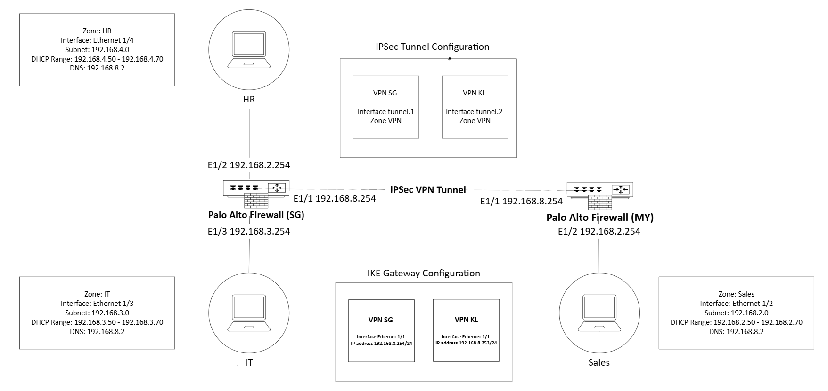

# Technical requirement implementations

## SG

### Zones

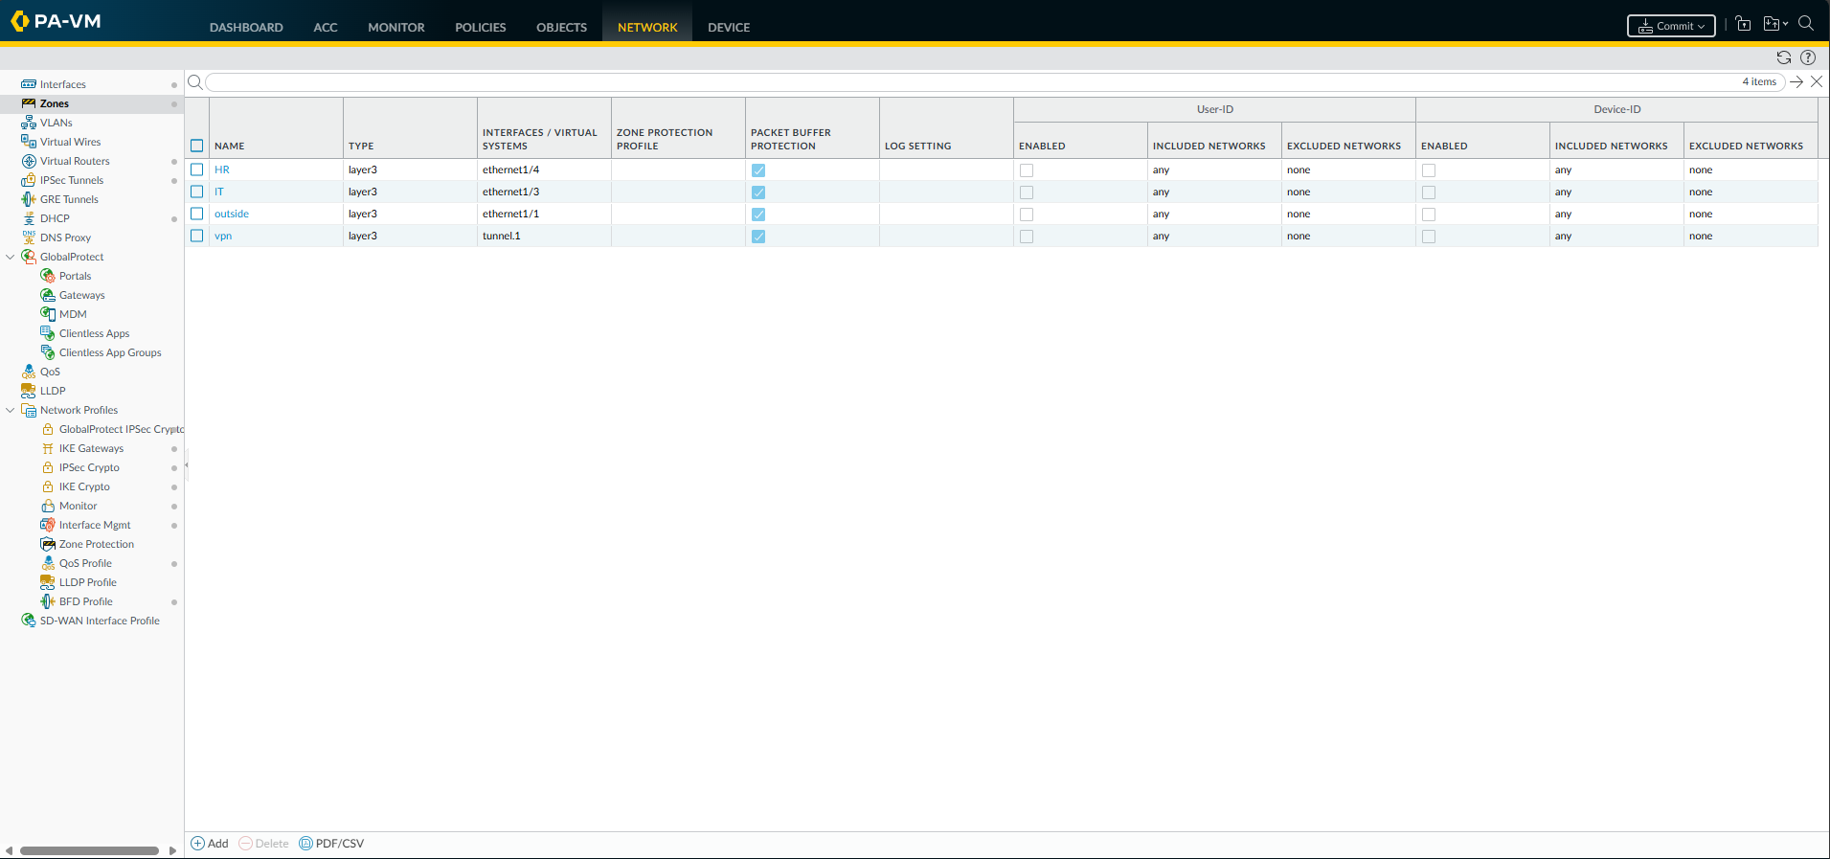Based on the image above, we have created 4 zones, HR, IT, outside and vpn. 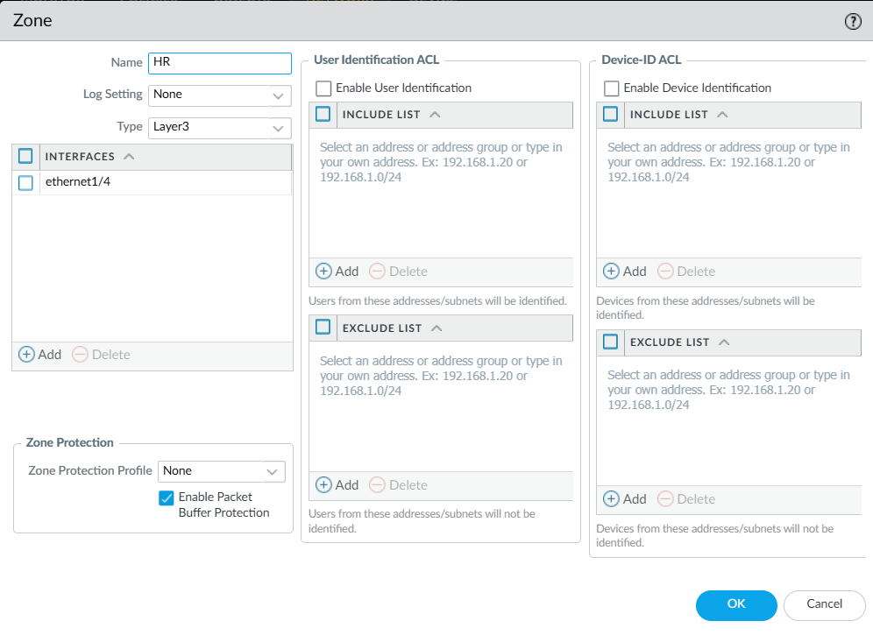 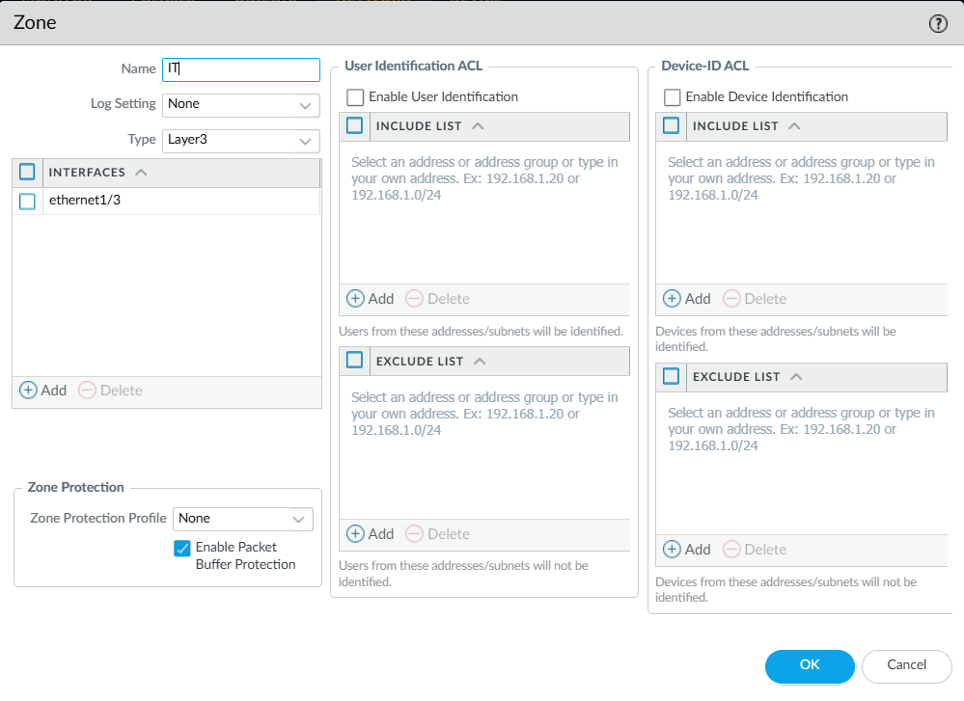

### Virtual network adapters

For SG, 4 virtual network adapters are required. VMnet1 acts as the management interface, VMnet8 is used as the firewall’s ethernet1/1 to access the internet through NAT, VMnet3 is used as the firewall’s ethernet1/3 for the IT department, and VMnet4 is used as the firewall’s ethernet1/4 for the HR department. Ethernet1/2 is used for the KL’s Sales department.

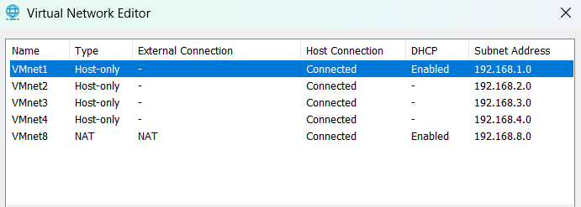

The subnet for all 4 of the virtual networks used is 255.255.255.0, with VMnet1, VMnet3, VMnet4 and VMnet8 having the subnet addresses of 192.168.1.0, 192.168.3.0, 192.168.4.0, 192.168.8.0 respectively. Only VMnet8 uses NAT, the rest uses Host-only to simulate a network with independent hosts.

### IP address allocation

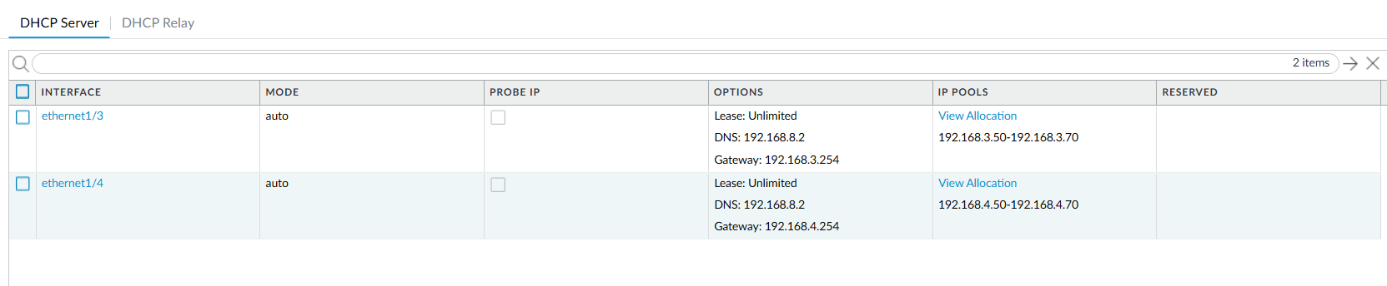

By setting up a DHCP server for ethernet1/3 and ethernet1/4, the hosts in both the IT and HR department are automatically assigned an IP address from the IP range 192.168.3.50-70 and 192.168.4.50-70 respectively. The DNS 192.168.8.2 through VMnet8 NAT allows the hosts to also have access to the internet.

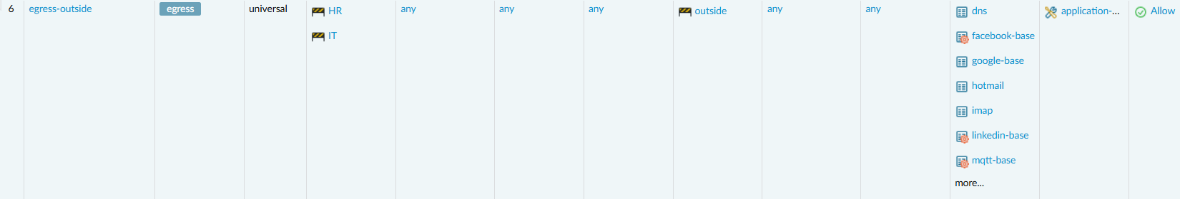

Setting up the policy ‘egress-outside’ that allows traffic from ‘HR’ and ‘IT’ zone to ‘outside’ zone for common applications such as web traffic (web-browsing & ssl), DNS traffic (dns), email traffic (imap & pop3) and remote access (ssh & ms-rdp).



The source NAT configured above allows any host from ‘HR’ and ‘IT’ zone to translate its IP address (192.168.3.x and 192.168.4.x) to 192.168.8.254 and dynamically allocate a port to access the internet through ethernet1/1 (‘outside’ zone).



The security policy ‘allow-standard-apps’ allows traffic from any host from ‘HR’ and ‘IT’ zones to ‘outside’ zone with any standard applications which includes Google (google-base), Microsoft Office 365 (ms-office365) and Outlook email web (outlook-web, hotmail, office365-consumer-access & office365-enterprise-access).

### Decryption Policies

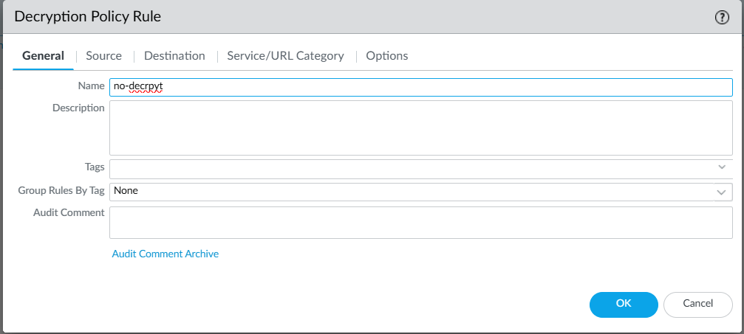

Create a new decryption policy named ‘no-decrypt.

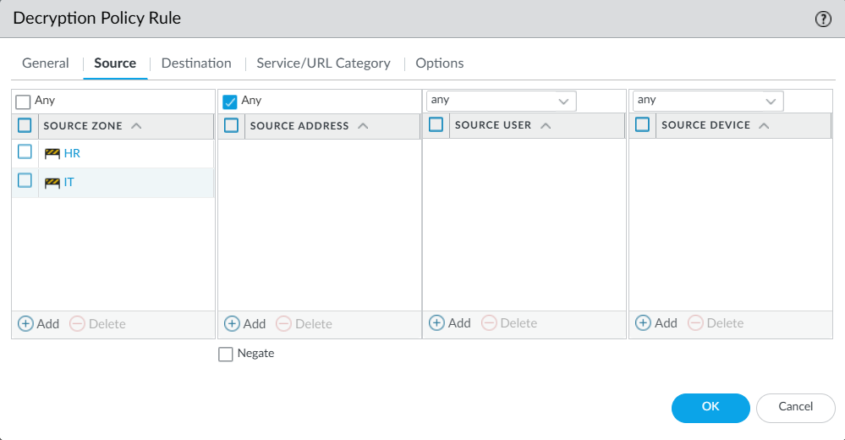

Set the source zones to ‘HR’ and ‘IT’. Set the source address to ‘any’.

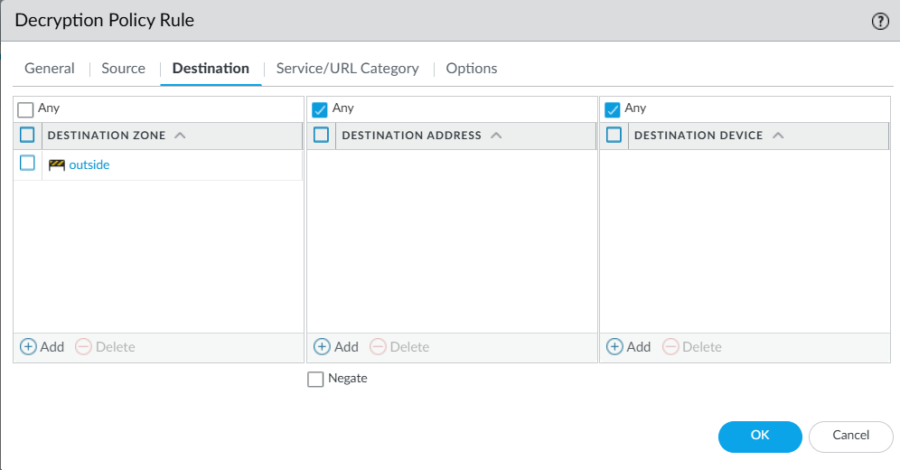

Set the destination address to ‘outside’, the destination address and destination device to ‘any’

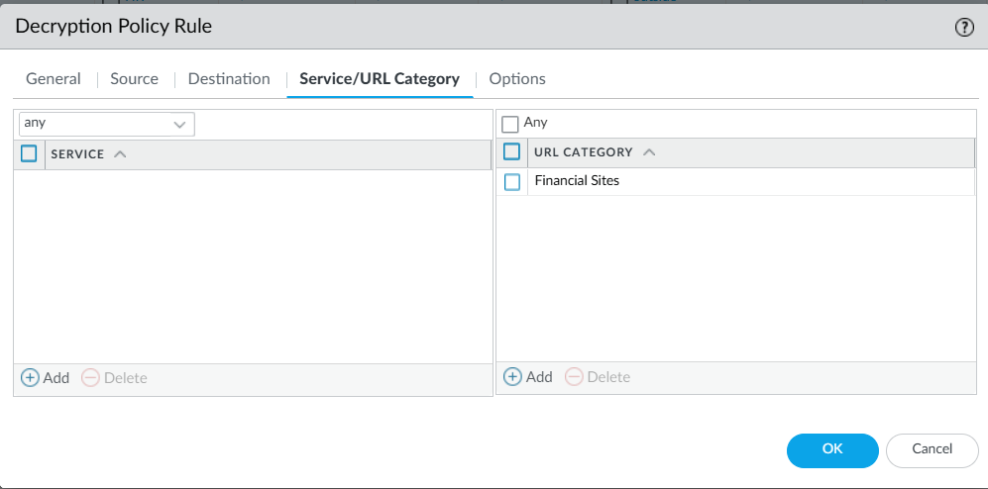

Add the URL category ‘Financial Sites’ as they are not supposed to be decrypted.

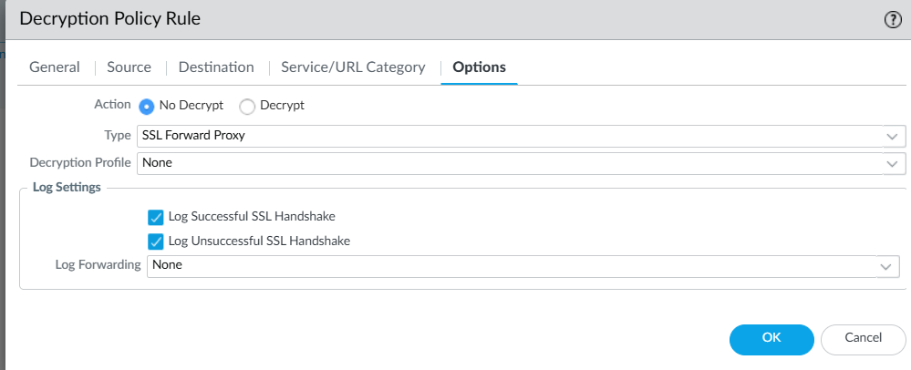

Set the action to ‘No Decrypt’, type to ‘SSL Forward Proxy’ and enable both log settings.

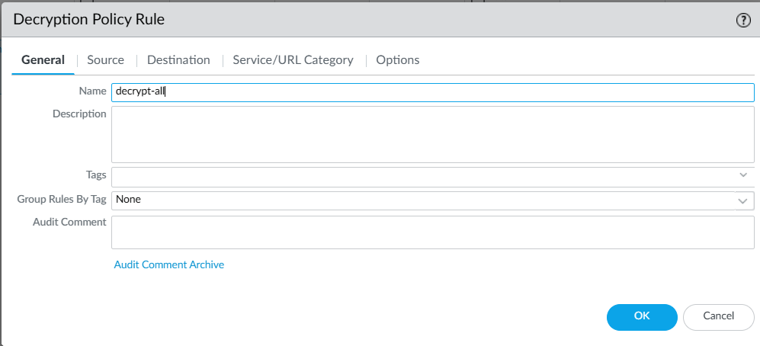

Create a new decrypt policy named ‘decrypt-all’

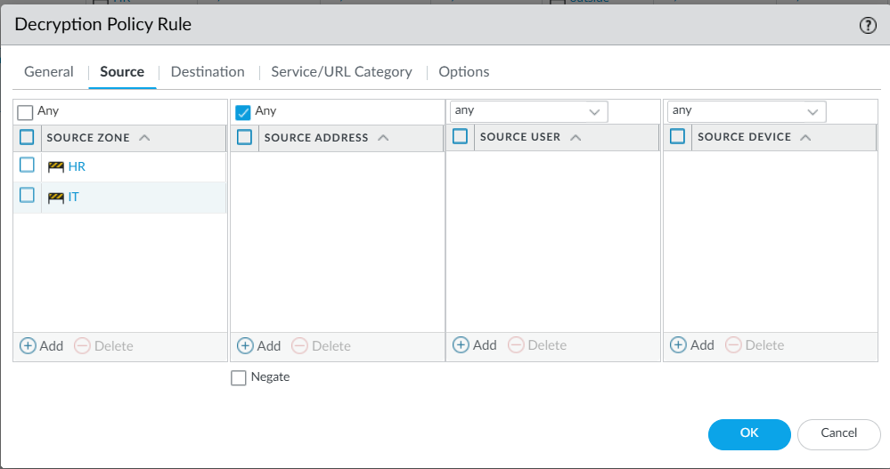

Set the source zones to ‘HR’ and ‘IT’. Set the source address to ‘any’.

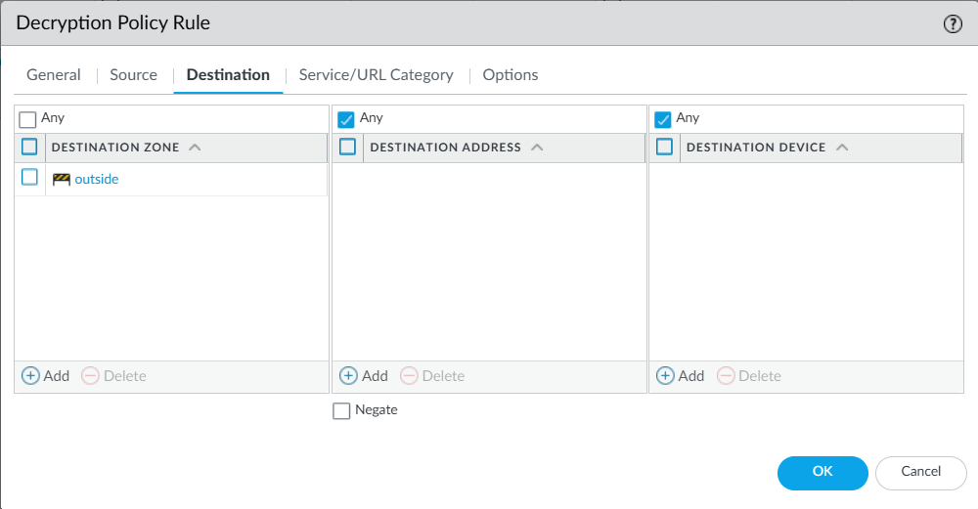

Set the destination address to ‘outside’, the destination address and destination device to ‘any’

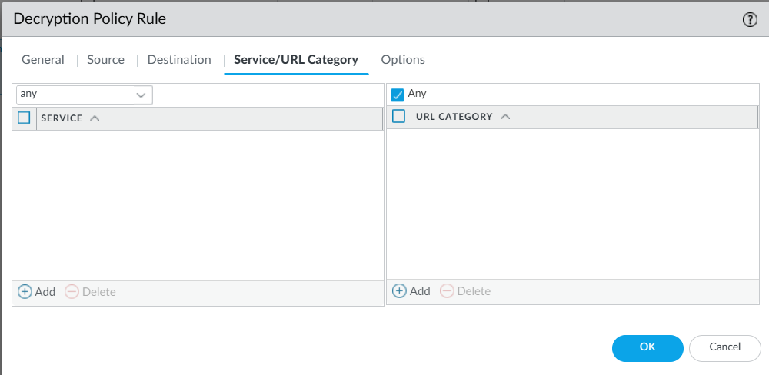

Set the URL category to ‘any’ to decrypt all sites.

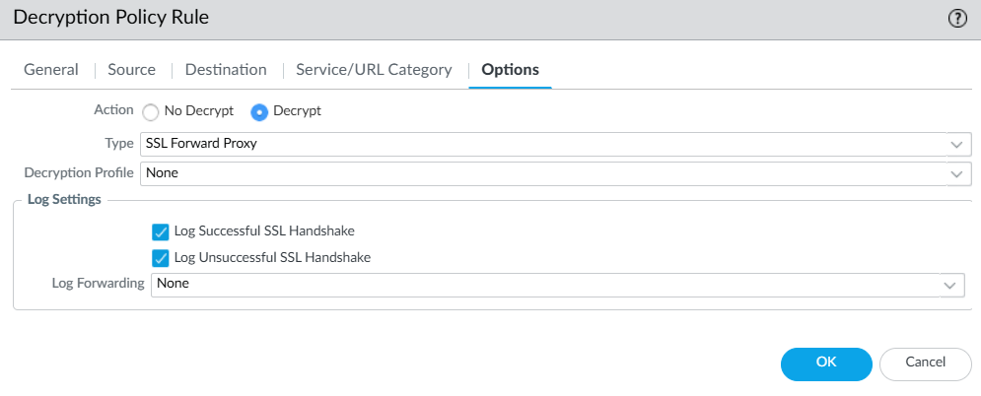

Set the action to ‘Decrypt’, type to ‘SSL Forward Proxy’ and enable both log settings.

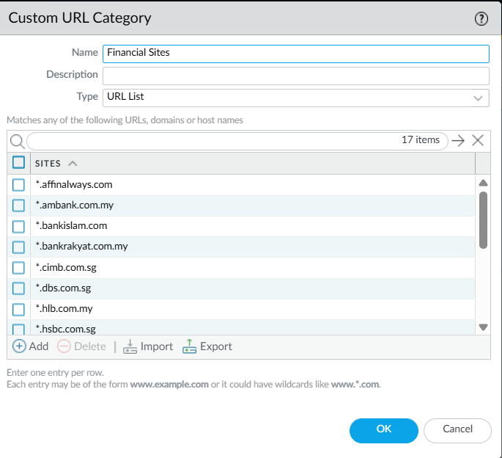

The ‘Financial Sites’ URL category consists the URLs of all the common banking sites used in SG and KL.

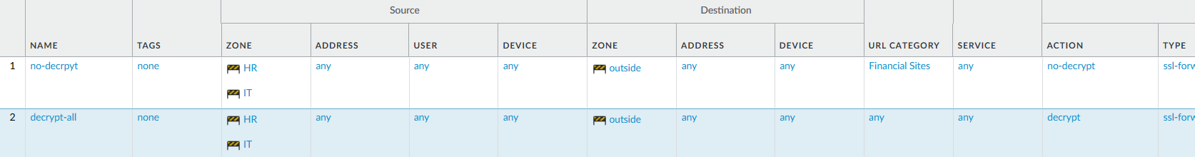

Since the rules are evaluated from top down, by placing the ‘no-decrypt’ policy above the ‘decrypt-all’ policy ensure that the URLs specified in the ‘Financial Sites’ category are not decrypted.

### SSL Certificate Generation

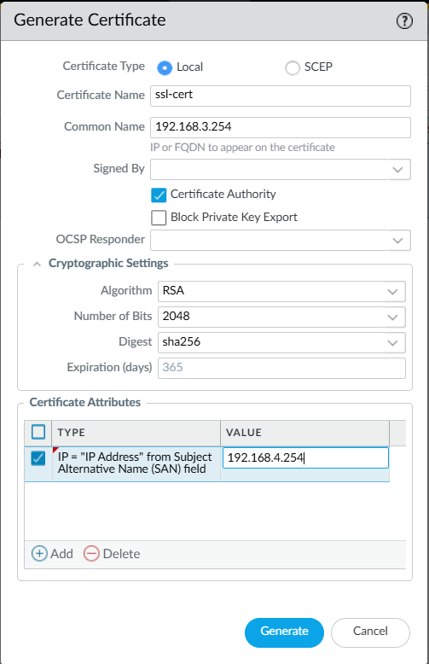

Generate a certificate named ‘ssl-cert’, set the certificate type to ‘Local’, Common Name to 192.168.3.254, check ‘Certificate Authority’ and add the IP address 192.168.4.254 in ‘Certificate Attributes since its for both ‘HR ‘ and ‘IT’ departments.

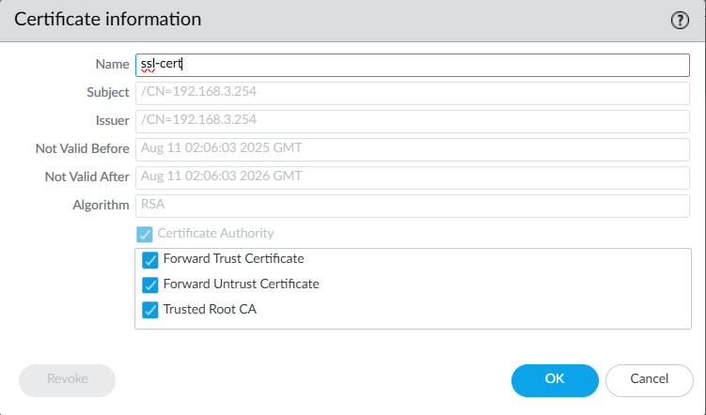

Check the ‘Forward Trust Certificate’ ‘Forward Untrust Certificate’ and ‘Trusted Root CA’ options after generating the certificate.

### HR Allow LinkedIn but Block LinkedIn Messaging



Create a new security policy ‘HR Deny Linkedin Chat’ with the following configuration

* Rule Order: 1st / 2nd (before ‘egress-outside’ allowing ‘linkedin-base')
* Type: universal
* Source:
  + Location: HR
  + Address/User/Device: any
* Destination:
  + Location: outside
  + Address/User/Device: any
* Application: ‘linkedin-mail’ application only
* Service: any
* Action: ‘application-default'

This security policy allows HR to access Linkedin but not use Linkedin chat.

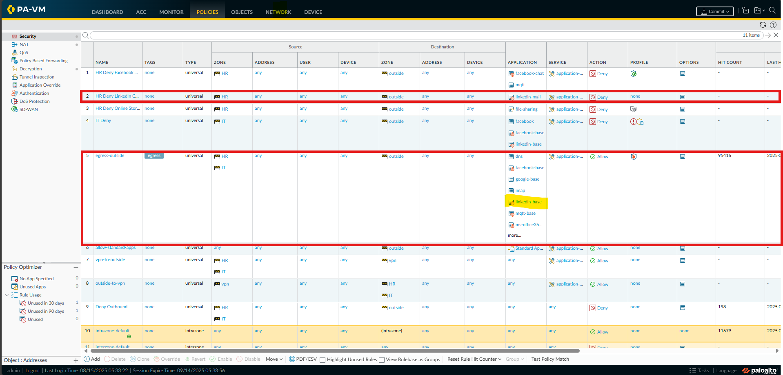From the image, ’HR Deny LinkedIn Chat” is positioned above ‘egress-outside’, which is configured to allow ‘linkedin-base’ for the HR department,this ensures that HR is unable to access LinkedIn messaging due to the ’HR Deny LinkedIn Chat’ policy but is allowed to access LinkedIn through the ’egress-outside’ policy.

### IT Block LinkedIn and Facebook



Create a new security policy ‘IT Deny’ with the following configuration

* Rule Order: 4th
* Type: universal
* Source:
  + Location: HR
  + Address/User/Device: any
* Destination:
  + Location: outside
  + Address/User/Device: any
* Application: ‘facebook’, ‘facebook-base’ and ‘linkedin-base’
* Service: any
* Action: ‘application-default'

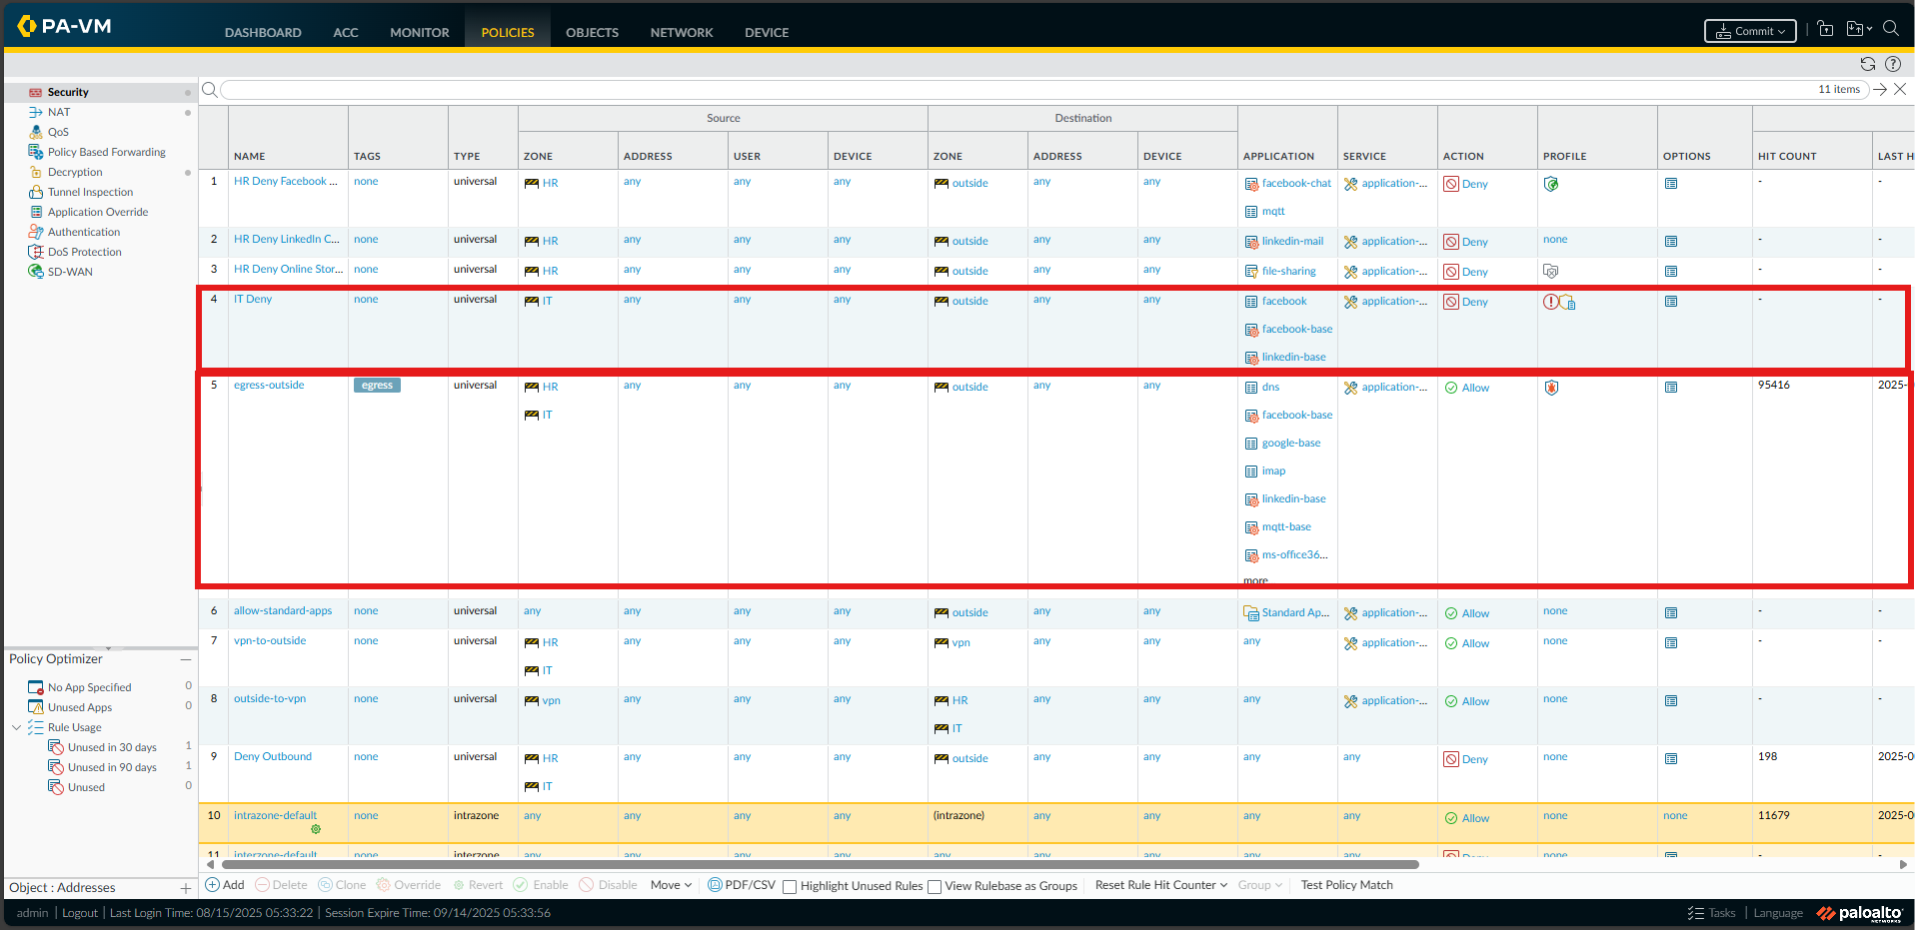This security policy is placed above the ‘egress-outside’ policy and will be matched first before the rule to allow LinkedIn and Facebook in the ‘egress-outside’ policy which would restrict the IT department from accessing Facebook and Linkedin.

### HR Allow Facebook but Block Facebook Messaging



Create a new security policy ‘HR Deny Facebook Chat’ with the following configuration

* Rule Order: 1st (before ‘egress-outside’ that allows ‘facebook-base’)
* Type: universal
* Source:
  + Location: HR
  + Address/User/Device: any
* Destination:
  + Location: outside
  + Address/User/Device: any
* Application: ‘facebook-chat’ and ‘mqtt’
* Service: any
* Action: ‘application-default'

This security policy blocks the HR department from using Facebook chat.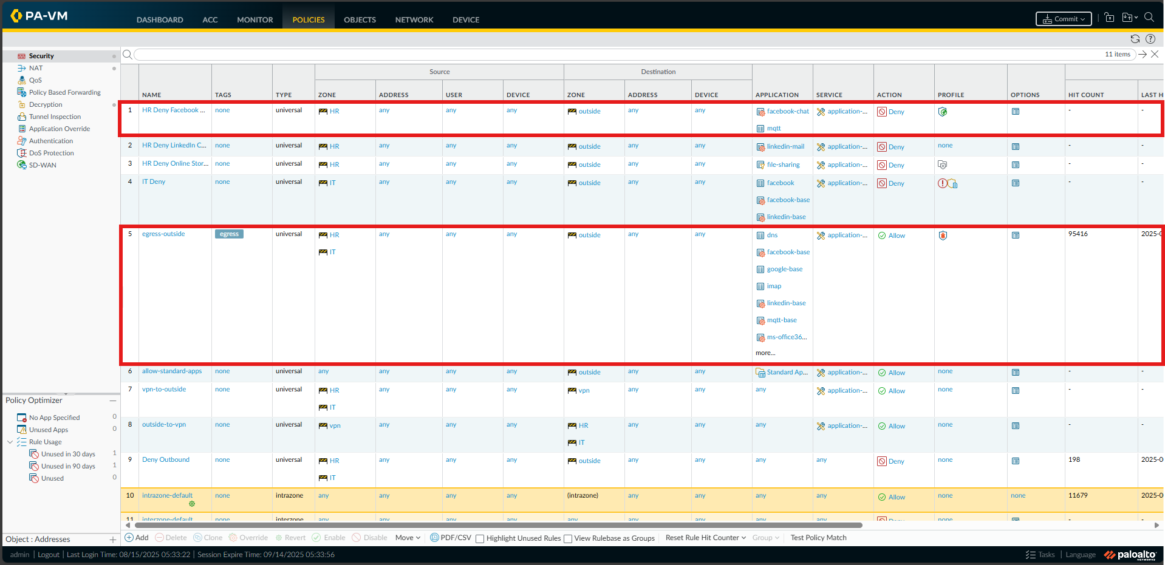From the image, ’HR Deny Facebook Chat” is positioned above ‘egress-outside’, which is configured to allow ‘facebook-base’ for the HR department, this ensures that HR is unable to access Facebook Chat due to the ’HR Deny Facebook Chat’ policy but is allowed to access Facebook through the ’egress-outside’ policy.

### HR Deny access to online storage services



Create a new security policy ‘HR Deny Online Storage Services’ with the following configuration

* Rule Order: 1st (or anywhere before ‘egress-outside’ that allows ‘facebook-base’)
* Type: universal
* Source:
  + Location: HR
  + Address/User/Device: any
* Destination:
  + Location: outside
  + Address/User/Device: any
* Application: Created a new ‘file-sharing’ application filter *(covers most Cloud storage solutions, like OneDrive, Google Cloud and Dropbox)*

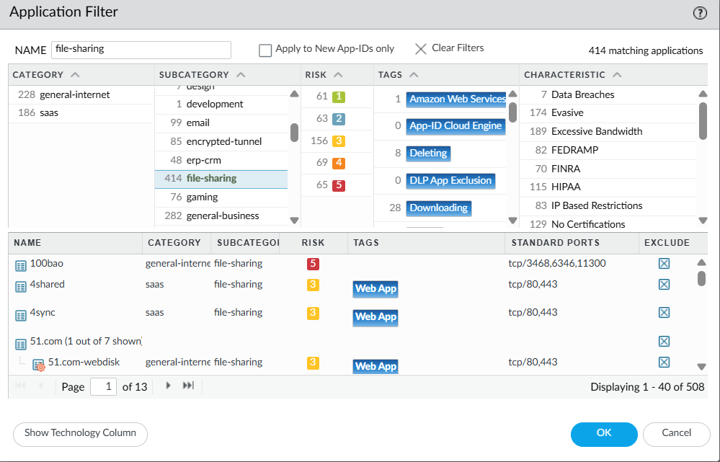

* Service: any
* Action: ‘application-default'

This security policy blocks the HR department from using any online storage services like Google Drive, OneDrive and Dropbox.

### VPN Configuration

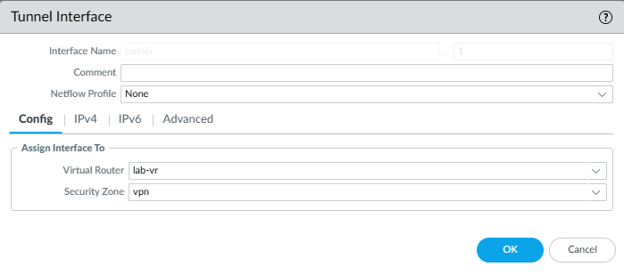Configure a tunnel interface and for SG we name it tunnel.1 and as mentioned earlier we have created a zone named vpn and we will be defining the security zone here as vpn and as for the Virtual Router, we will be using the default lab-vr.

Steps:

1. Navigate to Network > Interfaces > Tunnel and click Add
2. Expand the security zone to define a zone (For us we are using **vpn**)
3. Select the virutal router (For us we are using the default **lab-vr**)

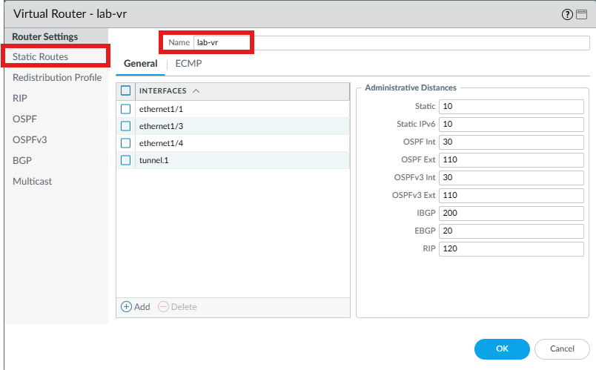

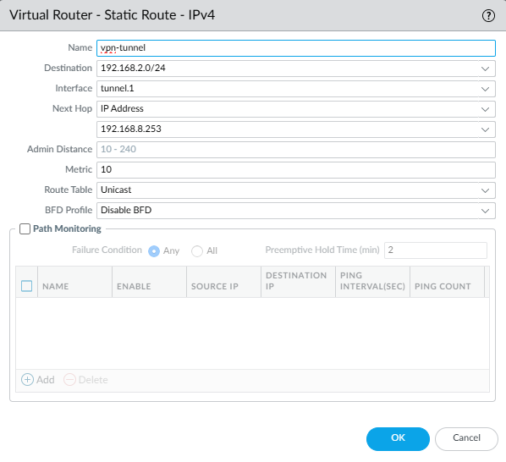

Configure a static route to tell the firewall which interface to use to reach a specific network to ensure that traffic destined for that network is sent through the correct VPN tunnel for secure communication.

Steps:

1. Navigate to Network > Virtual Router and click on the router defined in the tunnel interface (lab-vr)
2. Select Static Route and click Add to enter a new route to access the subnet that is at the other end of the tunnel. (For us, because we are trying to access to KL and as mentioned previopusly KL is on VMnet2 which is on 192.168.2.0/24 hence our Destination would be 192.168.2.0/24)

As for the crypto profiles, we will be using the default IKE and IPSec Crypto profile.

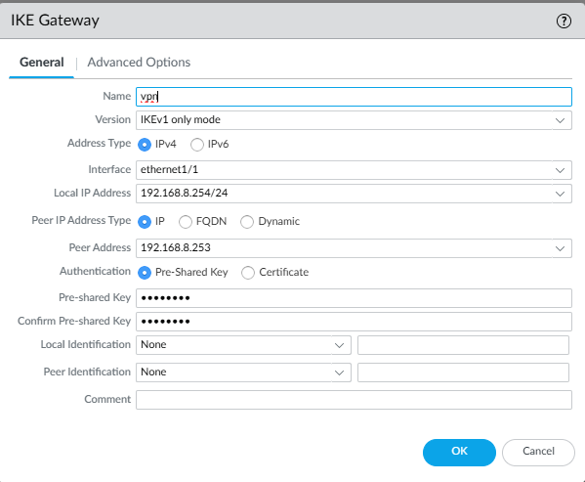Configure the IKE gateway to define how the firewall will communicate with the KL firewall to establish the VPN tunnel

1. Navigate to Network > Network Profiles > IKE Gateway
2. Click on Add and configure the interface and IP as well ass Peer Address accordingly.

Based on the image, it shows that we will be using the interface ethernet 1/1 with the IP 192.168.8.254 to connect to the remote peer (KL) at 192.168.8.253 using IKEv1 and a pre-shared key for authentication.

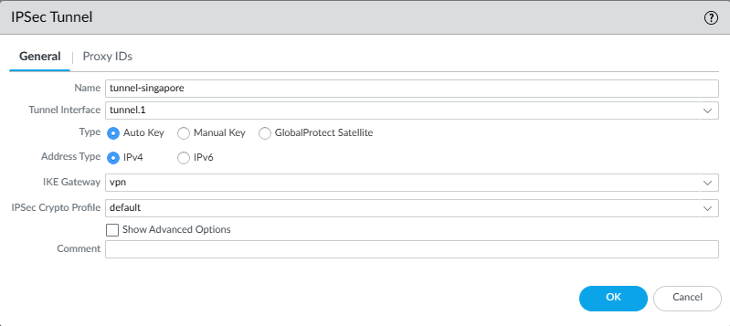

Create an IPSec Tunnel using tunnel.1 linked to the vpn IKE Gateway with IPv4 addressing and the default phase 2 crypto settings.



Based on the image, it can be seen that the SG tunnel and gateway are working and has VPN connection tot he KL office based on the green light indicator.



As seen from the screenshot, we have created 2 security policies ‘vpn-to-outside' and ‘outside-to-vpn'. The ‘vpn-to-outside’ policy allows traffic originating from HR and IT to go out to the vpn zone, allowing internal users to send traffic across the vpn to the remote network. Similarly, the ‘outside-to’vpn’ policy as its name suggests, it allows traffic from the remote network that is coming through the vpn zone to access the resources in the HR and IT zones.

Even with IKE Gateway, IPSec tunnel and static routes are configure, without these two security policies traffic would not be able to pass through, making it crucial for us to include these 2 policies to allow bidirectional access.

### Advanced Features

#### Antivirus

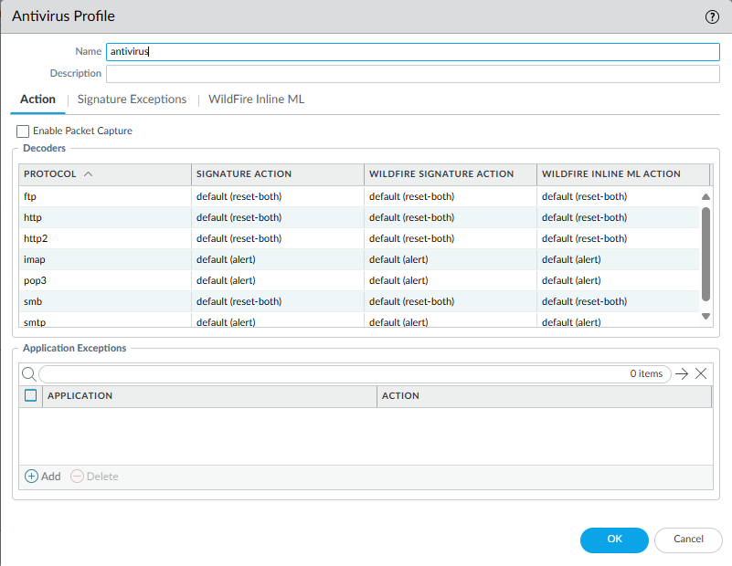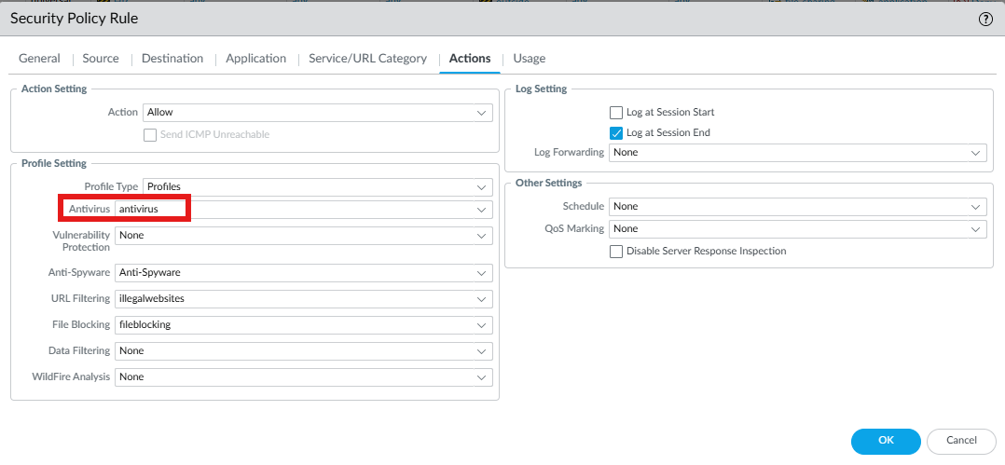Create a new antivirus profile that would be added to ‘egress-outside’ policy to ensure every outbound session is inspected for threats to prevent any form of infection from interactions with external resources.

#### Anti-Spyware

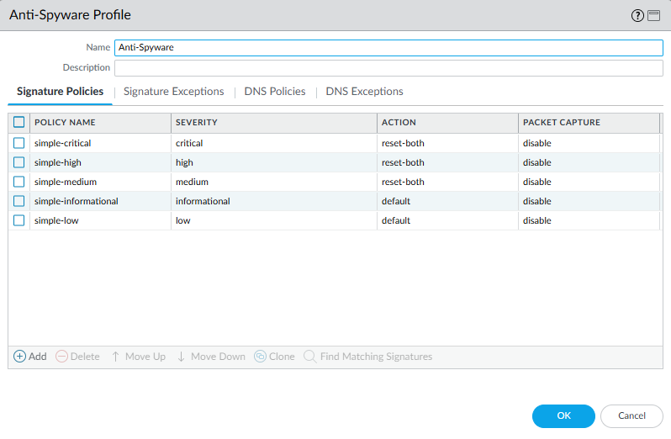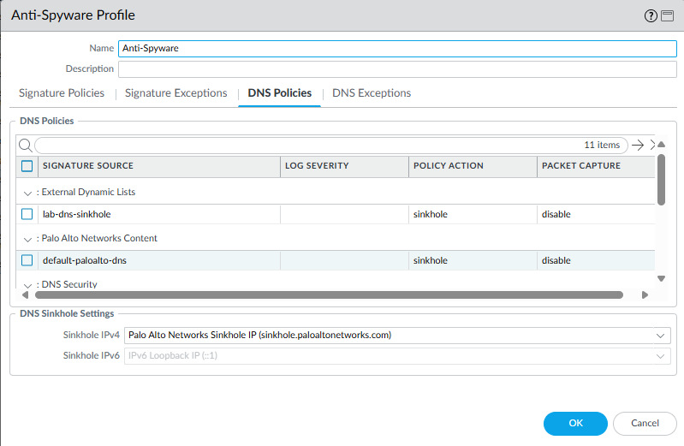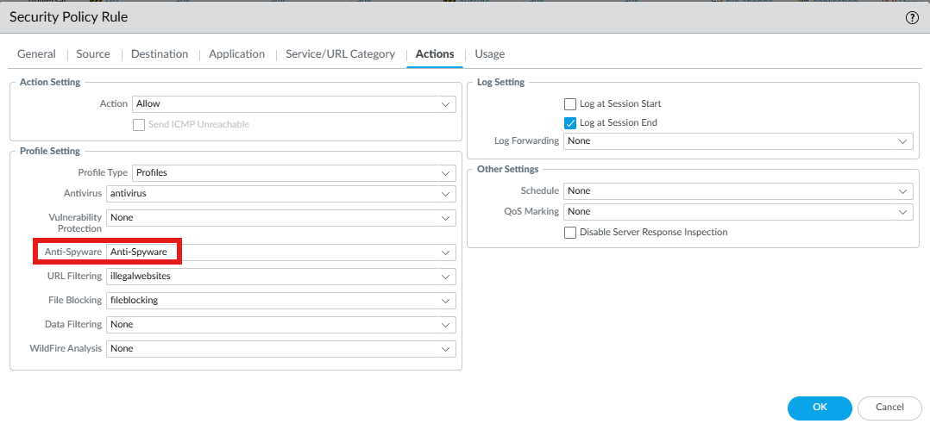Created an Anti-Spyware profile to detect and block malicious activity using Palo Alto’s threat signatures. Critical and high-severity threats are set to reset-both to immediately terminate harmful sessions, while DNS sinkhole is enabled to redirect malicious domain queries to a safe Palo Alto IP, helping identify compromised hosts. This profile is then applied to the ‘egress-outside’ security policy so that all allowed traffic is inspected, preventing spyware communication and strengthening overall network security.

#### URL Filtering

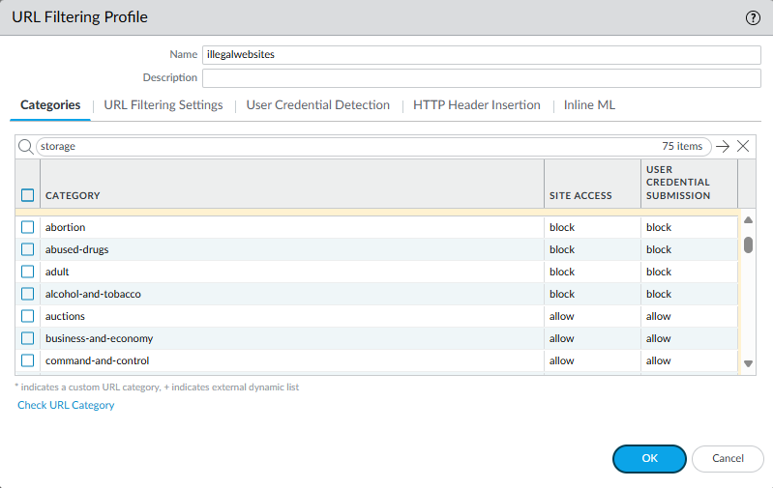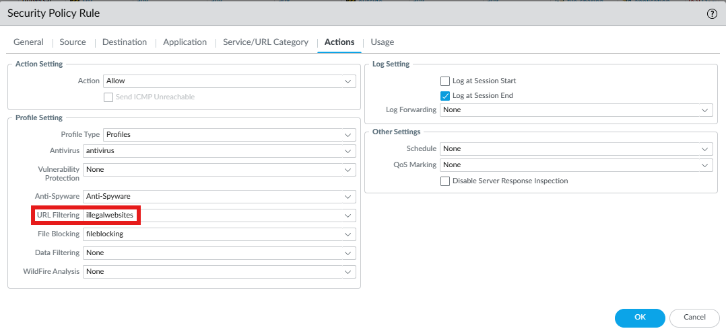  
Created a URL Filtering profile named **illegalwebsites** to control access to harmful or inappropriate web content. Categories such as **adult, abused-drugs, abortion, alcohol-and-tobacco** ,etc were set to **block**, preventing users from visiting these sites, while other categories remain allowed. This profile was then applied to the ‘egress-outside’ security policy so that all traffic passing through it is inspected and restricted according to the defined categories, helping enforce compliance, improve productivity, and protect the network from high-risk websites.

#### File Blocking

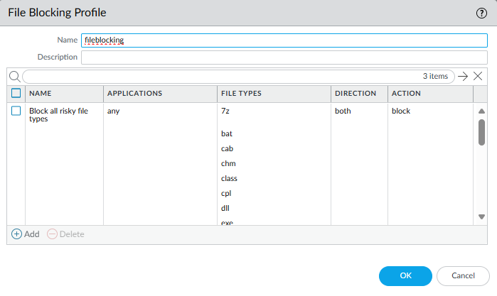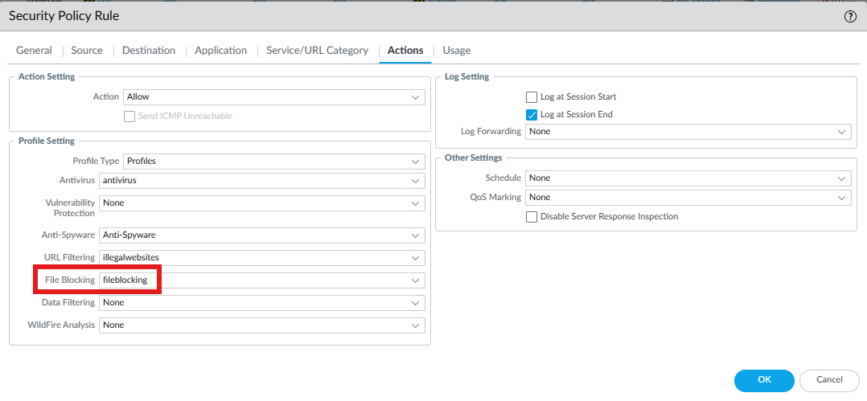

Created a File Blocking profile named **fileblocking** to prevent risky file types such as **.exe, .dll, .bat, .cpl,** and others from being transferred over the network. The rule is set to block these files in both directions, upload and download, protecting against malware infections from incoming files as well as potential data leakage from internal hosts. This profile is then applied to a security policy, ensuring all sessions that match the policy are inspected and restricted from carrying dangerous file types.

#### HA

Network > Interface > Internet

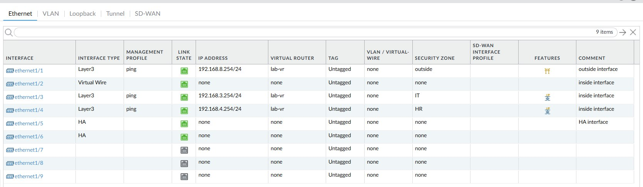

On both the firewall, the active, 192.168.1.254, and the passive, 192.168.1.252, ethernet 1/5 and ethernet 1/6 was set up to HA under interface type.

For the passive firewall, 192.168.1.252, below is the configurations for HA1 and HA2.

Device > High Availability > HA Communications 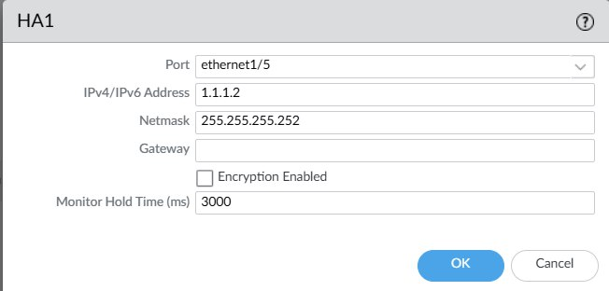

Port: ethernet 1/5

IPv4/IPv6 Address: 1.1.1.2   
Netmask: 255.255.255.252

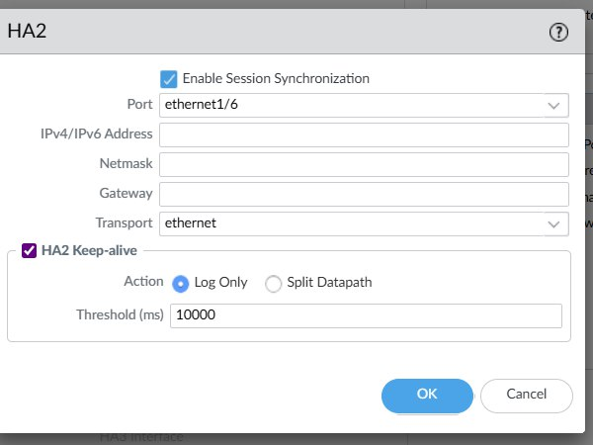

Enable Session Synchronization: Checked

Port: ethernet 1/6

HA2 Keep-alive: Checked

For the active firewall, 192.168.1.254, below is the configurations for HA1 and HA2.

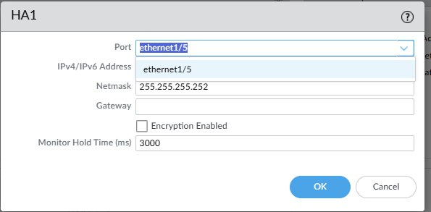

Port: ethernet 1/5

IPv4/IPv6 Address: 1.1.1.2   
Netmask: 255.255.255.252

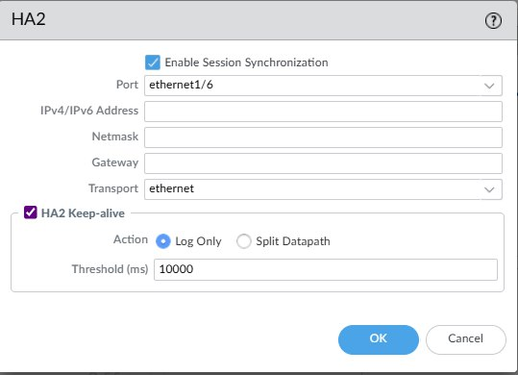

Enable Session Synchronization: Checked

Port: ethernet 1/6

HA2 Keep-alive: Checked

For the active firewall, below is the configuration to set up the HA.

Device > High Availability > General

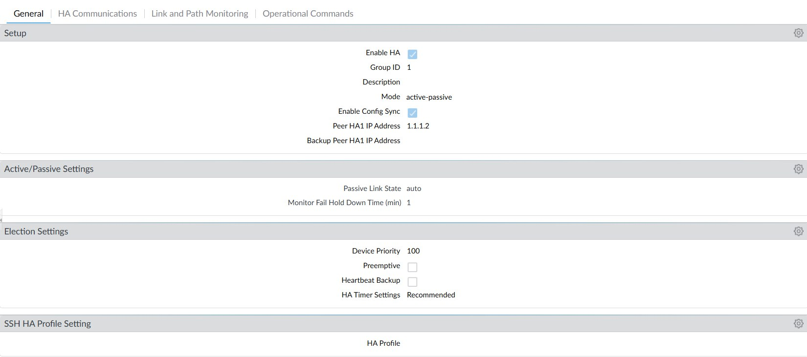

Setup

Enable HA: Checked   
 Group ID: 1

Mode: active-passive   
 Enable Config Sync: Checked   
 Peer HA1 Peer Address: 1.1.1.2

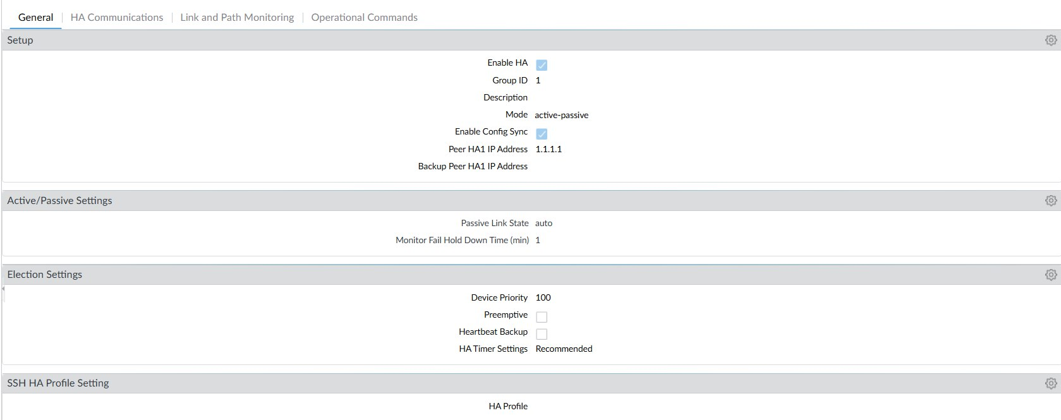

Setup

Enable HA: Checked   
 Group ID: 1

Mode: active-passive   
 Enable Config Sync: Checked   
 Peer HA1 Peer Address: 1.1.1.1

Commit All Changes.

## KL

### Zones

This is the layer 3 zone with the configured interface being ethernet1/2. It is named ‘Sales’ as this is the trusted zone for KL’s Sales department.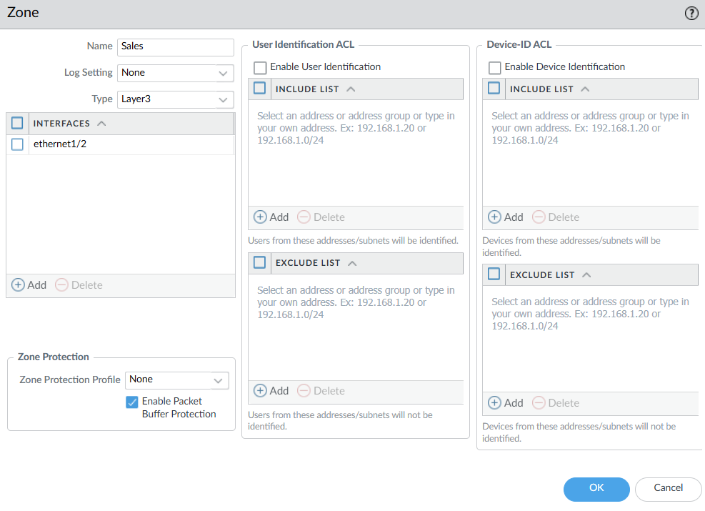

This is the layer 3 zone with the configured interface being ethernet1/1. It is named ‘outside’ as this is the untrusted zone for KL users to access the internet.

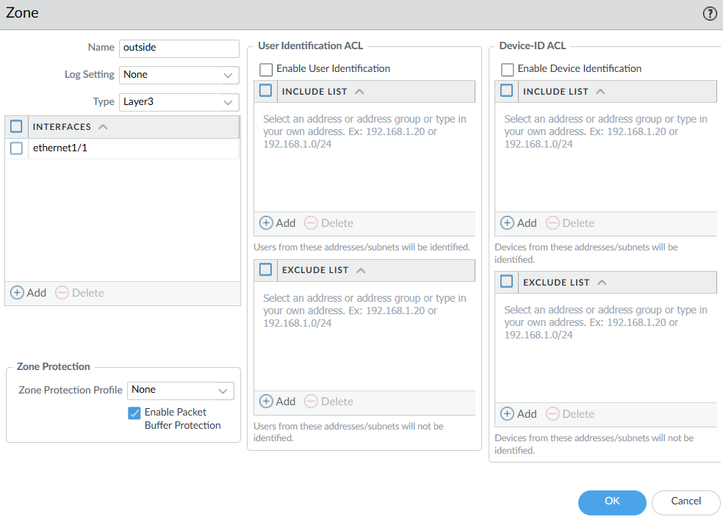

### Virtual network adapters

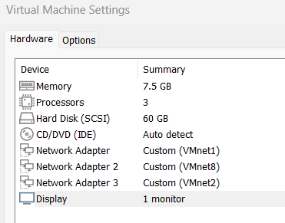

For KL, only 3 virtual network adapters are required. VMnet1 acts as the management interface, VMnet8 is used as the firewall’s ethernet1/1 to access the internet through NAT, and VMnet2 is used as the firewall’s ethernet1/2 for the Sales department.

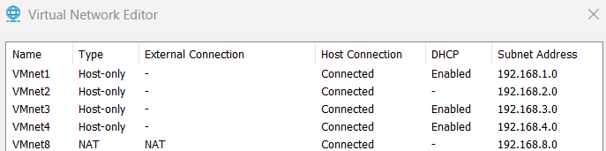

The subnet for all 3 of the virtual networks used is 255.255.255.0, with VMnet1, VMnet2 and VMnet8 having the subnet addresses of 192.168.1.0, 192.168.2.0, 192.168.8.0 respectively. Only VMnet8 uses NAT, the rest uses Host-only to simulate a network with independent hosts.

### IP address allocation

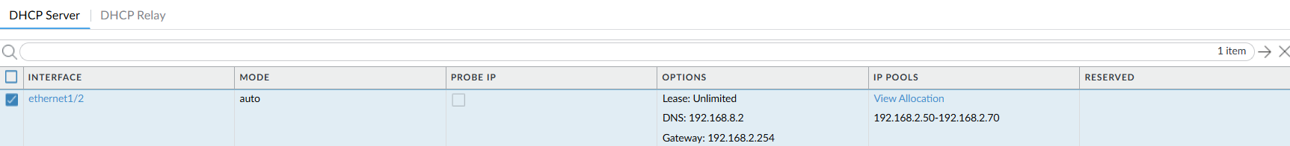

By setting up a DHCP server for ethernet1/2, hosts in the Sales department is automatically assigned an IP address from the IP range 192.168.2.50-70. The DNS 192.168.8.2 through VMnet8 NAT allows the hosts to also have access to the internet.

### Essential Business Features

Configuring common network traffic allowed to support essential business functions

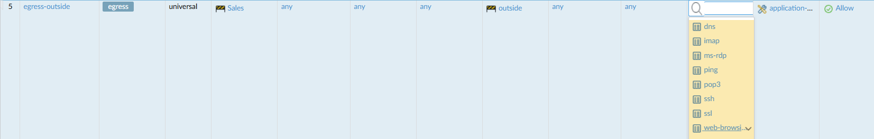

Setting up the policy ‘egress-outside’ that allows traffic from ‘Sales’ zone to ‘outside’ zone for common applications such as web traffic (web-browsing & ssl), DNS traffic (dns), email traffic (imap & pop3) and remote access (ssh & ms-rdp).

### Source NAT



The source NAT configured above allows any host from ‘Sales’ zone to translate its IP address (192.168.2.x) to 192.168.8.253 and dynamically allocate a port to access the internet through ethernet1/1 (‘outside’ zone).

### Allow Standard Application



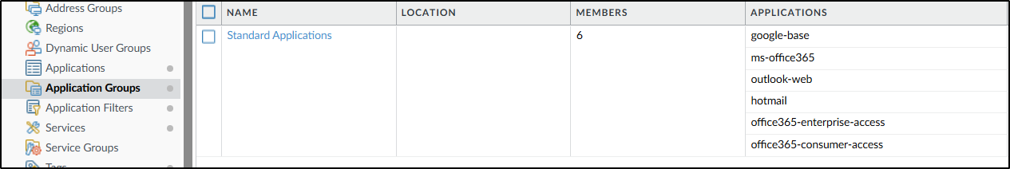

The security policy ‘allow-standard-apps’ allows traffic from any host from ‘Sales’ zone to ‘outside’ zone with any standard applications which includes Google (google-base), Microsoft Office 365 (ms-office365) and Outlook email web (outlook-web, hotmail, office365-consumer-access & office365-enterprise-access).

### Decryption Policies

To enable decryption on all websites apart from banking, a decryption profile must first be set. Since SSL Forward Proxy would be the decryption method used, I have configured the profile based on best practices defined by Palo Alto. The protocol versions are also set from TLSv1.2 to the Max version, which allows decryption for most modern applications.

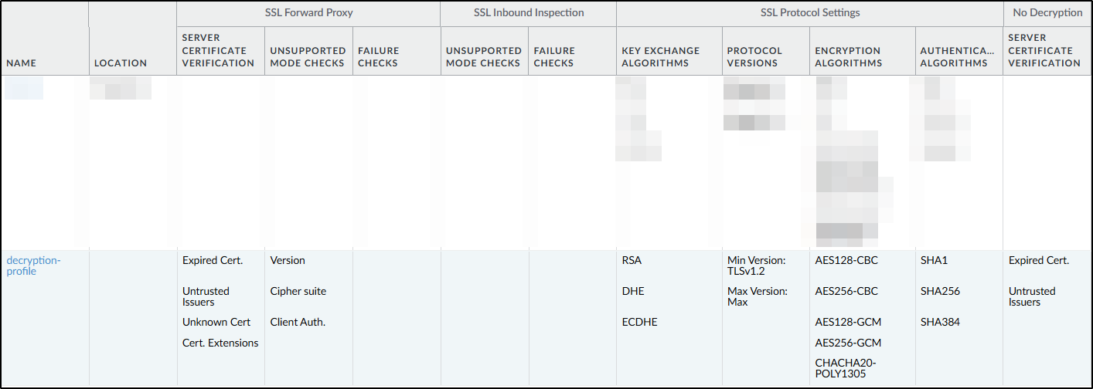

The URL category ‘Financial Sites’ is also created which contains all the common banking / finance websites available in Singapore and Malaysia.

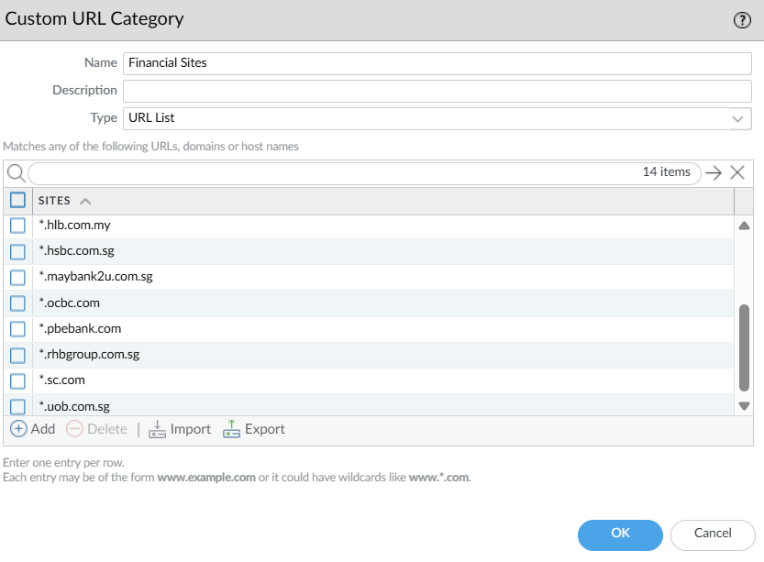

Next, there will be 2 decryption policies that needs to be created: “no-decrypt” and “decrypt-all”. The “no-decrypt” policy ensures that banking websites do not get decrypted. The “decrypt-all” policy is placed below the “no-decrypt” policy to decrypt all other traffic.

#### No Decryption on Banking Websites

1. Create a decryption policy named ‘no-decrypt’.

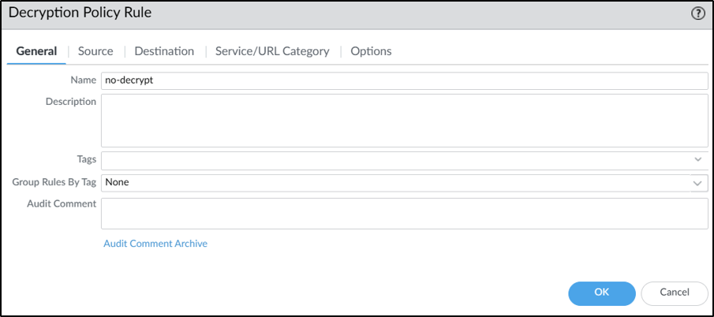

2. Add ‘Sales’ to the source zone and select ‘Any’ for the rest.

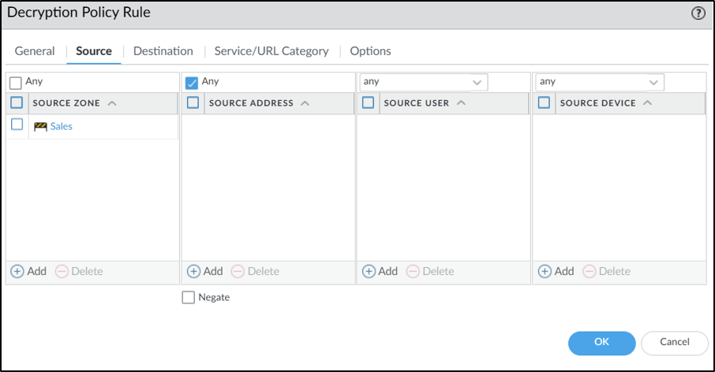

3. Add ‘outside’ to the destination zone and select ‘Any’ for the rest.

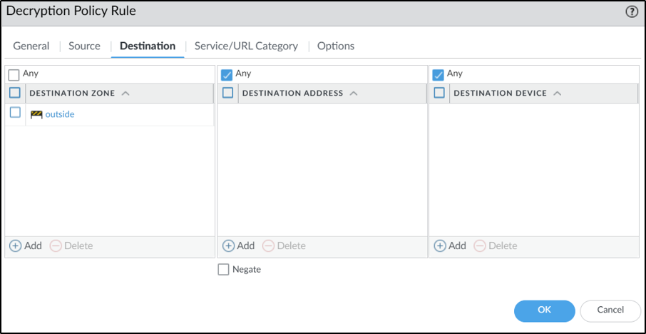

4. Add the URL category ‘Financial Sites’.

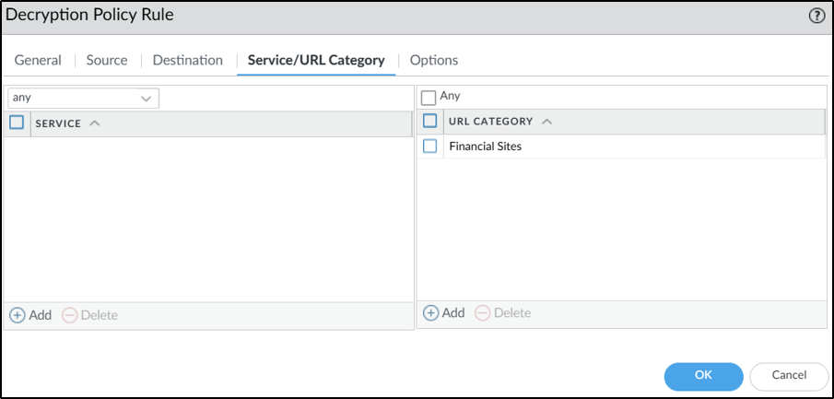

5. Select ‘No Decrypt’ as decrypt action and ‘SSL Forward Proxy’ as the connection type. Set the decryption profile to be the one created at the start.

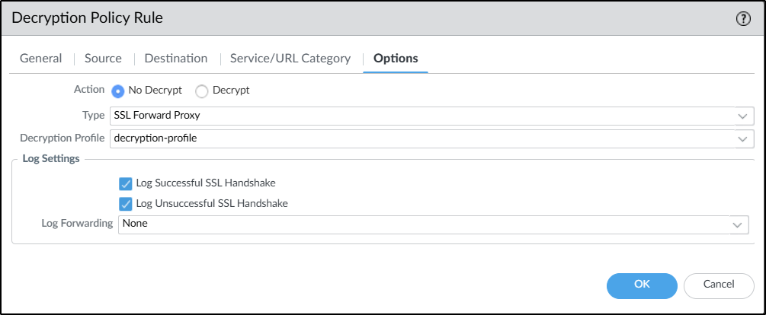

#### Decryption for all websites

1. Create a decryption policy named ‘decrypt-all’.

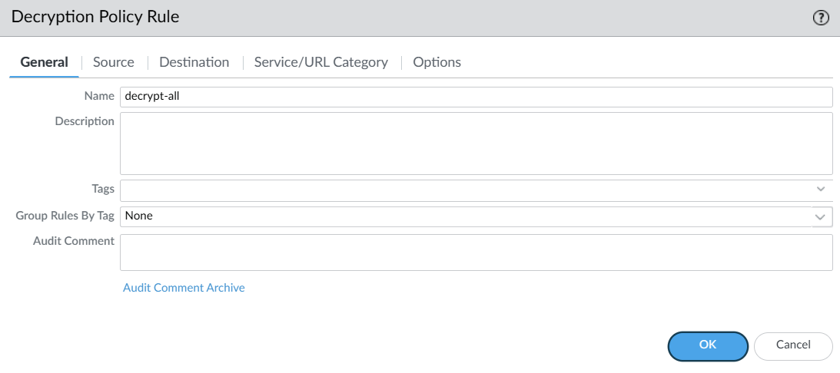

2. Add ‘Sales’ to the source zone and select ‘Any’ for the rest.

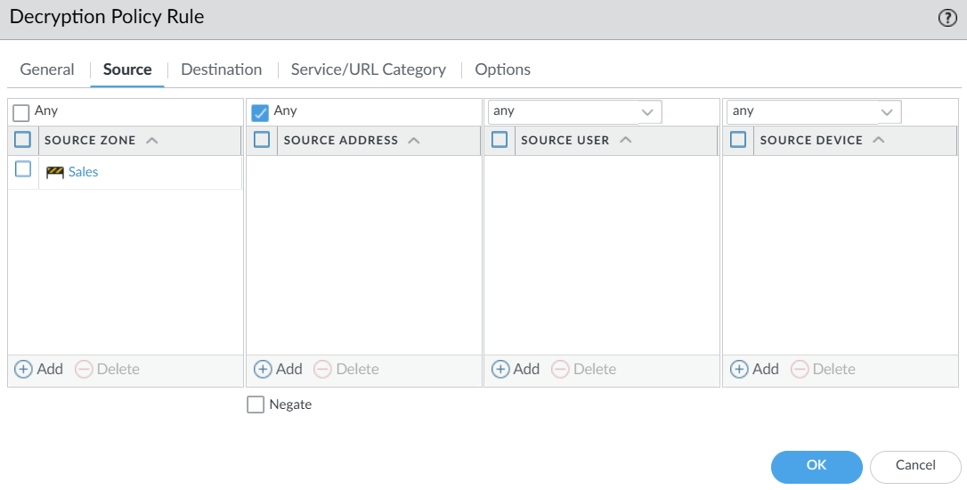

3. Add ‘outside’ to the destination zone and select ‘Any’ for the rest.

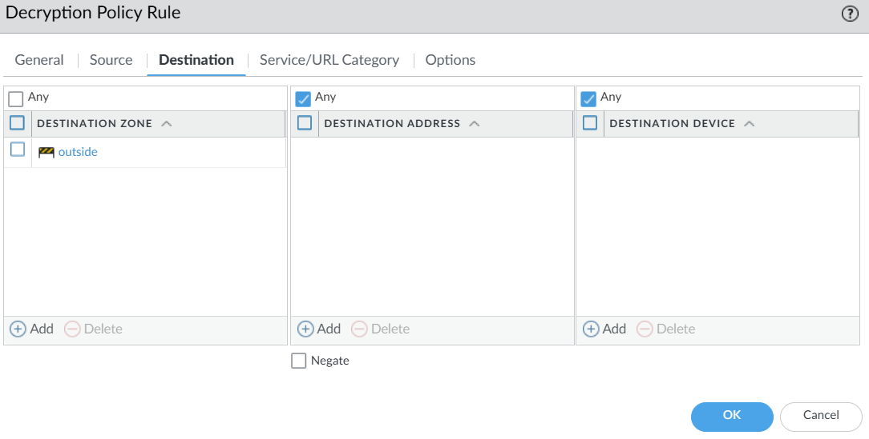

4. Select ‘Any’ for both service and URL category.

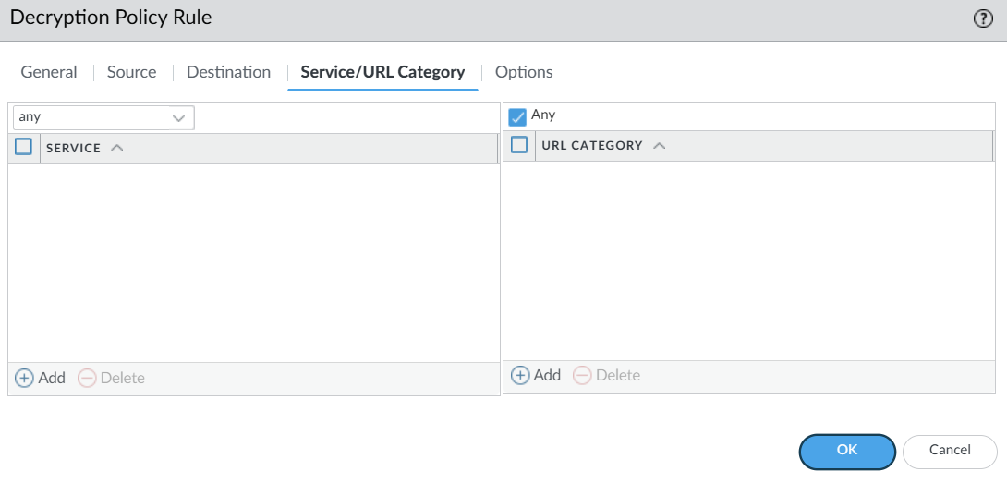

5. Select ‘Decrypt’ as decrypt action and ‘SSL Forward Proxy’ as the connection type. Set the decryption profile to the one created at the start.

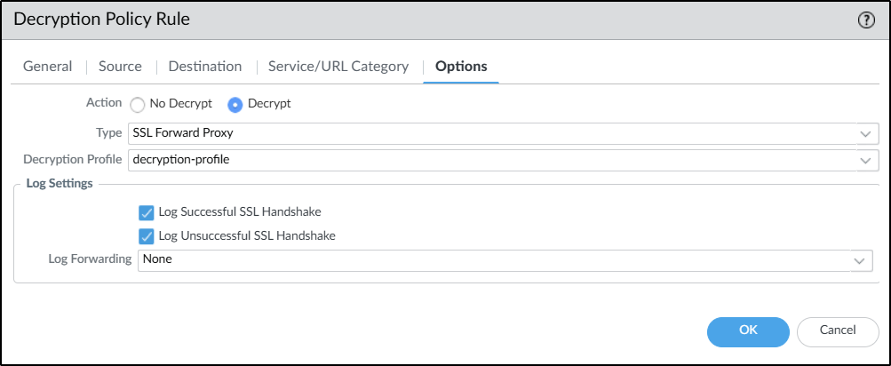

Arrange the decrypt policy rules such that the ‘no-decrypt’ rule is on top of the ‘decrypt-all’ rule. This would decrypt every site except for the URLs specified in the ‘Financial Sites’ URL category.



### SSL Certificate Generation

SSL/TLS secures network communication across a shared network and helps to prevent malware introduction and data exfiltration. Since most web traffic is encrypted, Palo Alto firewalls can decrypt SSL/TLS inbound and outbound traffic with a generated certificate to validate identity.

1. Set the time zone to Singapore and the time to when it was being configured.

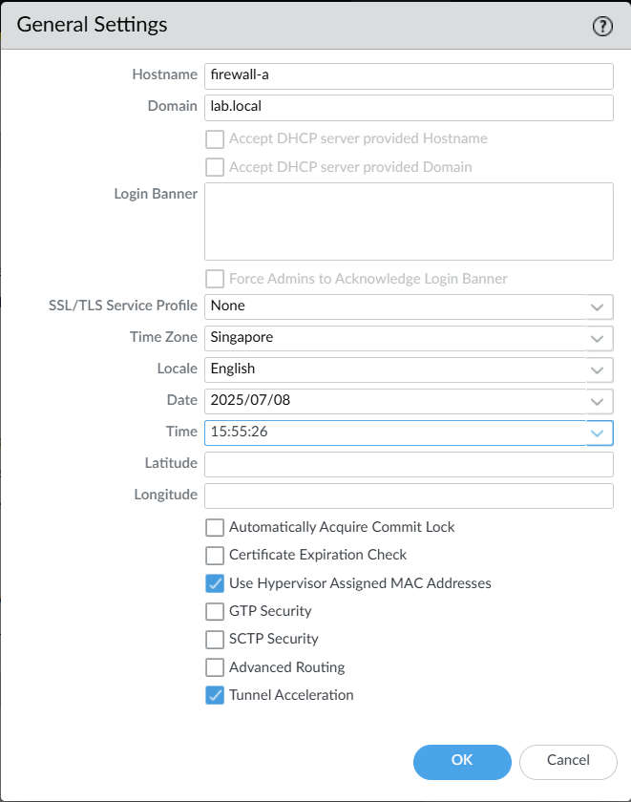

2. Generate the certificate named ‘ssl-cert’.

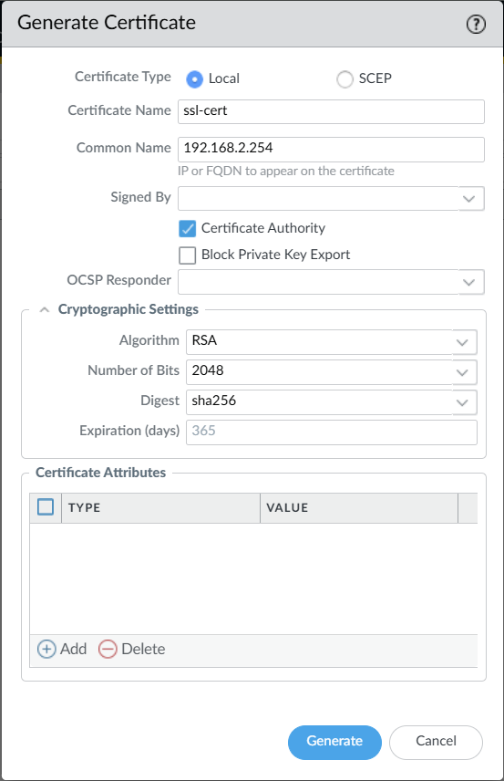

3. Select Forward Trust Certificate, Forward Untrust Certificate and Trusted Root CA Certificate for the ssl-cert generated.

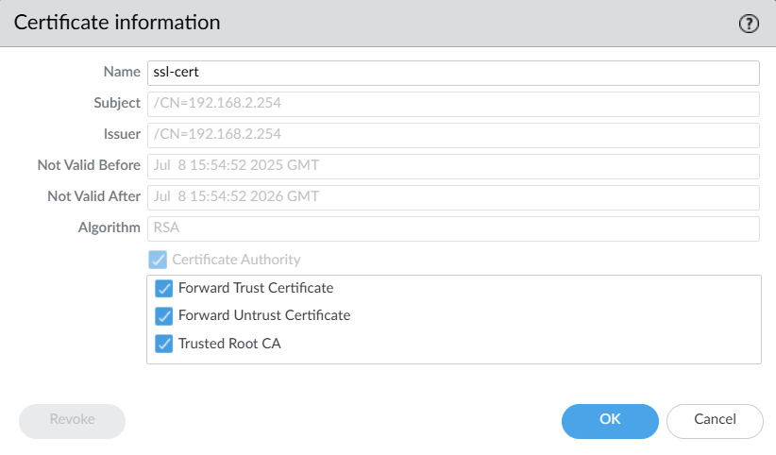

4. This certificate can now be exported and installed on the local machines in the Trusted Root CA directory.

### Deny access to online storage services

Create a new security policy with the following configurations:

* Rule Order: 1st / 2nd (before all Allow policies)
* Type: universal
* Source:
  + Location: HR/Sales
  + Address/User/Device: any
* Destination:
  + Location: Outside
  + Address/User/Device: any

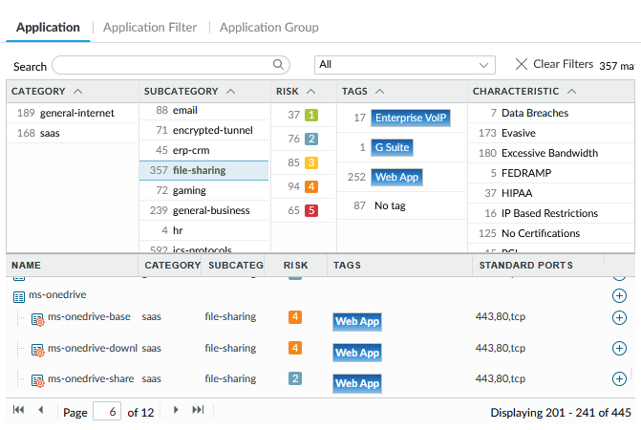

* Application: Create an Application Filter and choose ‘file-sharing’ (covers most Cloud storage solutions, like OneDrive, Google Cloud and Dropbox)
* Service: application-default
* Action: Deny

This will be the policy that filters out all Cloud-based storage services and solutions. To enforce the policy, commit the changes to the firewall

### Facebook access & deny facebook-chat

Create a new security policy with the following configurations:

* Rule Order: 1st / 2nd (before the policy allowing Facebook)
* Type: universal
* Source:
  + Location: HR/Sales
  + Address/User/Device: any
* Destination:
  + Location: Outside
  + Address/User/Device: any
* Application: Choose the “facebook-chat” application only
* Service: any
* Action: Deny

This will be the policy that will prevent HR and Sales staff from being able to chat on Facebook.

Now, create another new policy.



This policy has the following configurations:

* Rule Order: 3rd to “egress-outside”
* Type: universal
* Source:
  + Location: HR/Sales
  + Address/User/Device: any
* Destination:
  + Location: Outside
  + Address/User/Device: any
* Application: Choose the “facebook” or “facebook-base” application
* Service: any
* Action: Allow

This policy will allow HR and Sales access to Facebook itself. Like the other policies, commit the changes to put the policies in effect.

### Advanced Feature

#### Intrusion Detection & Prevention System (IDPS)

This is a configuration that stops / slows down internet attackers to keep public servers behind the firewall safe. For this to work, the threat prevention license needs to be activated so that the vulnerability protection feature can be leveraged to automatically identify and block attackers for a certain time. In this case, the attacker would be quarantined for 24 hours.

1. Create a new tag “bad_ips_dynamic”. Colour code this tag red.

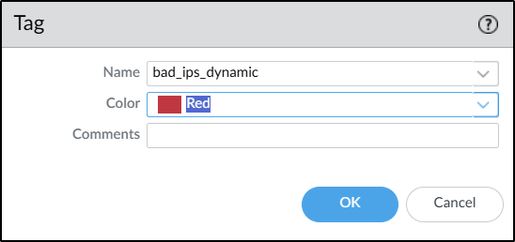

2. Create a new address group “grp_bad_ips_dynamic” and select the Type “Dynamic”. Add the tag created in the previous step to the match criteria.

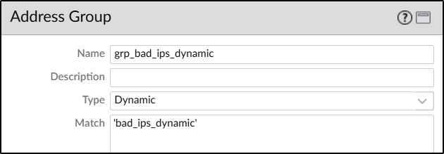

3. Create a log forwarding profile “lf_bad_ips”. Add a new profile match list “add_tag_bad_ips_dynamic” and select the Log Type to be threat.

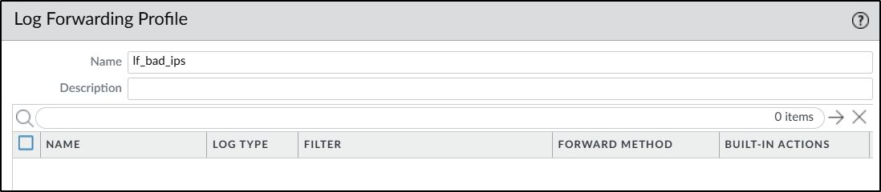

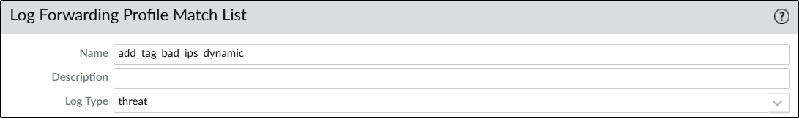

4. Under Filter, select Filter Builder and create a filter for severity greater than or equal to medium. Click Add on the right side once everything is selected.

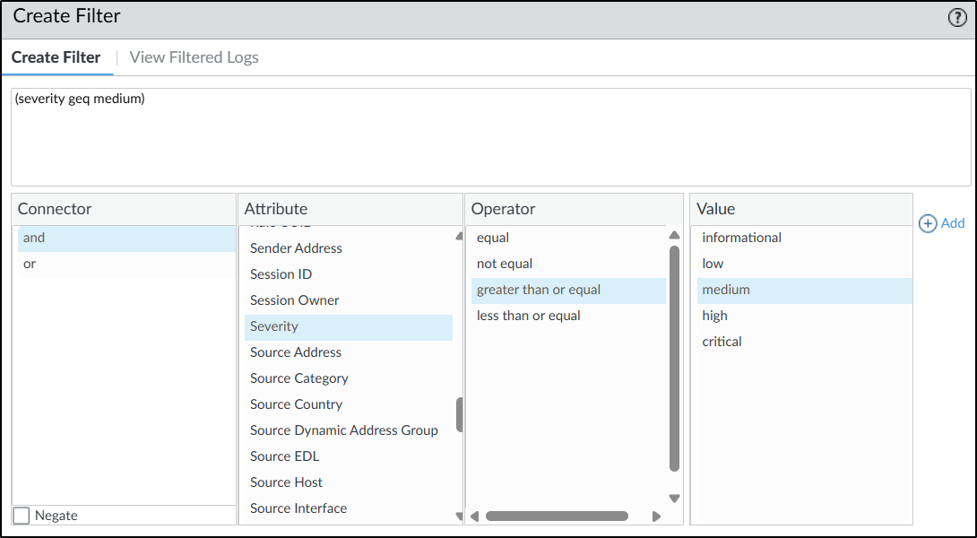

5. Add a Built-in Action “add_tag_bad_ips_dynamic” and select Type to be Tagging. The target would be the source address as the attack would be from an attacker to the public server. Select the Registration to be Local User-ID and set the Timeout (min) to 1440 which converts to 24 hours. Under Tags, select “bad_ips_dynamic”.

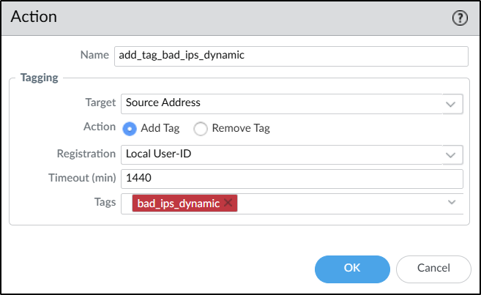

6. The Log Forwarding Profile should look like the following now:

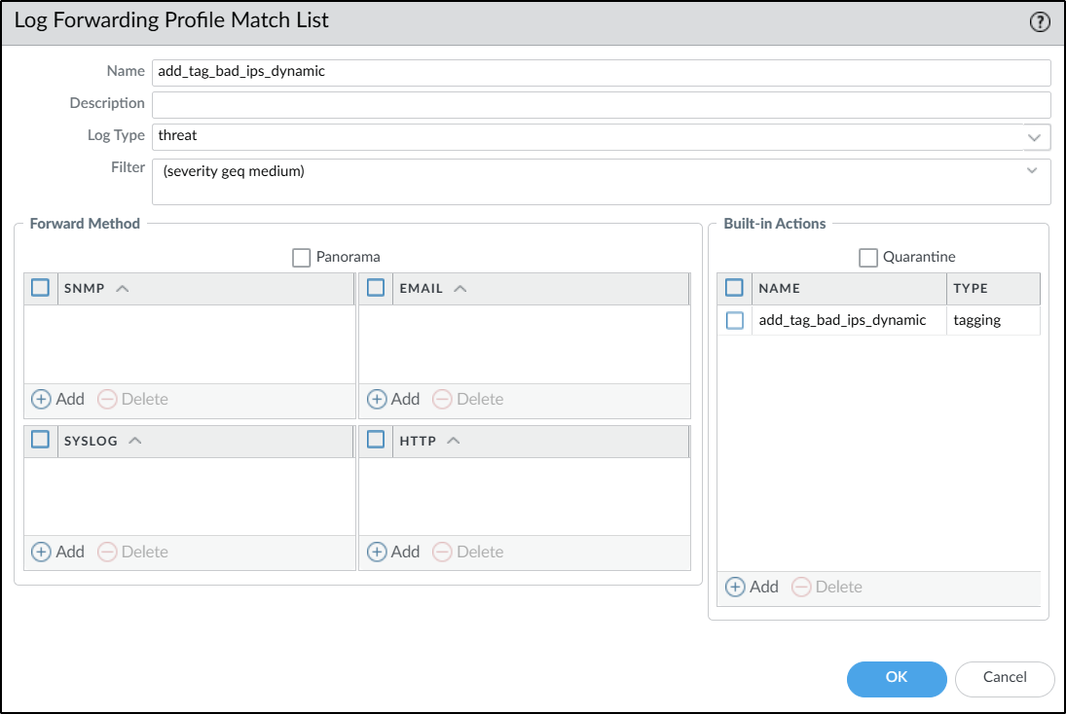

7. Configure a new security policy “bad_ips_dynamic” to block the bad IPs. Select Any for Source Zone and add the address group created in step 2 to the Source Address. Select Any for all settings in Destination tab. Change the Action to Drop and enable Log at Session Start. This blocks all IPs flagged in the address group.

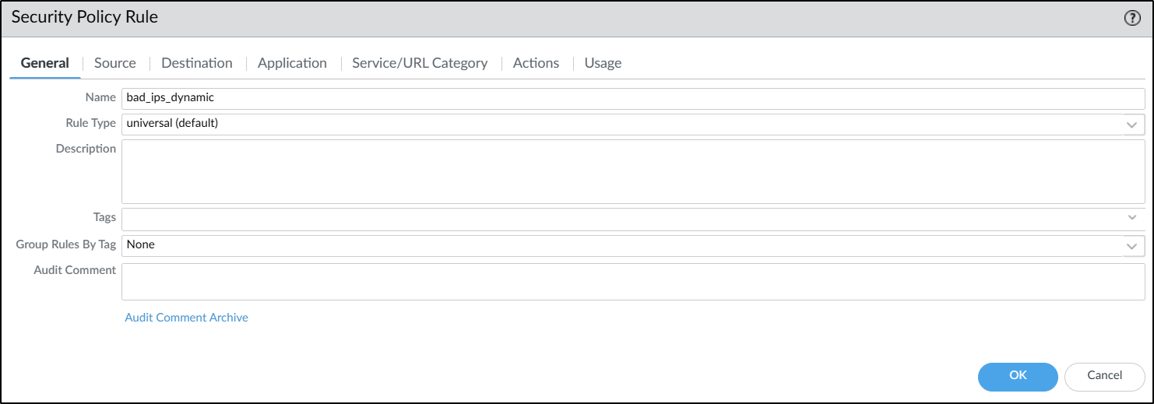

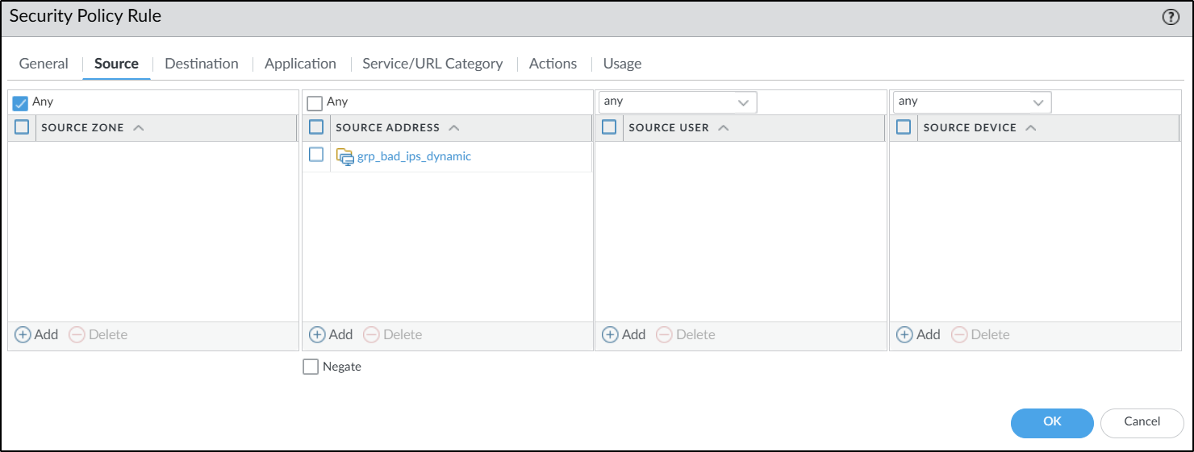

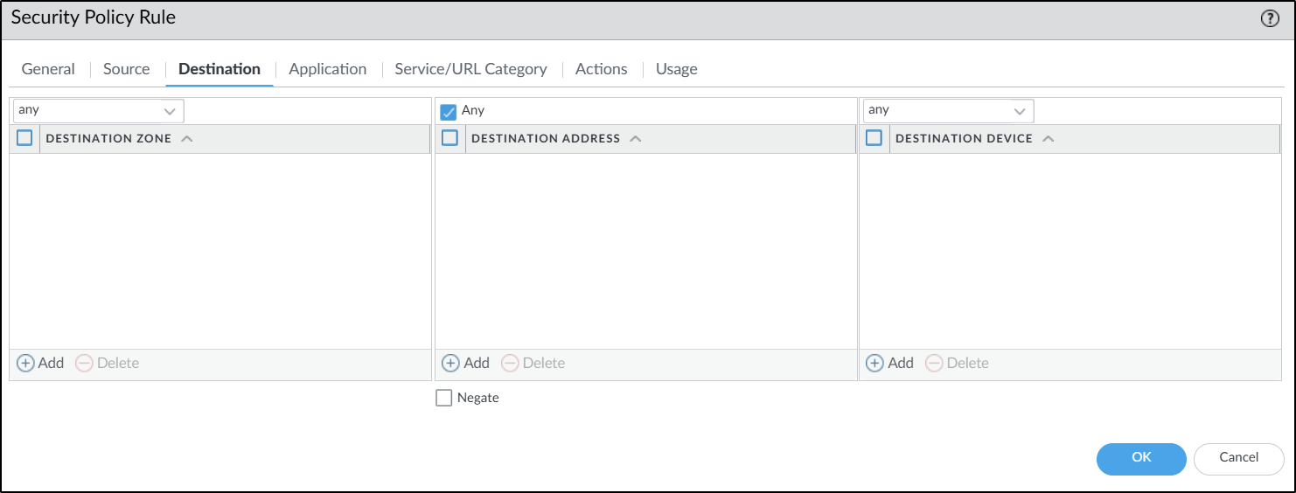

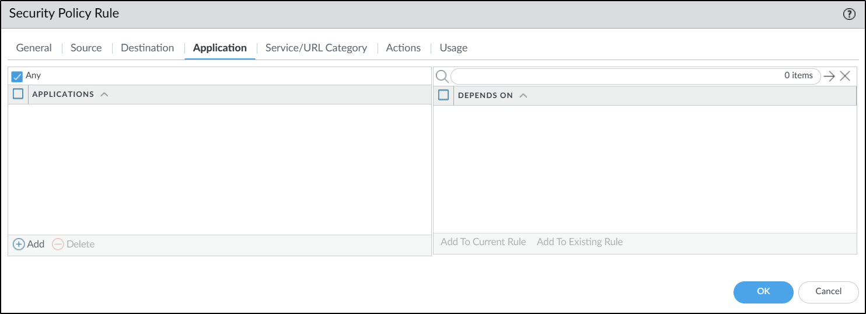

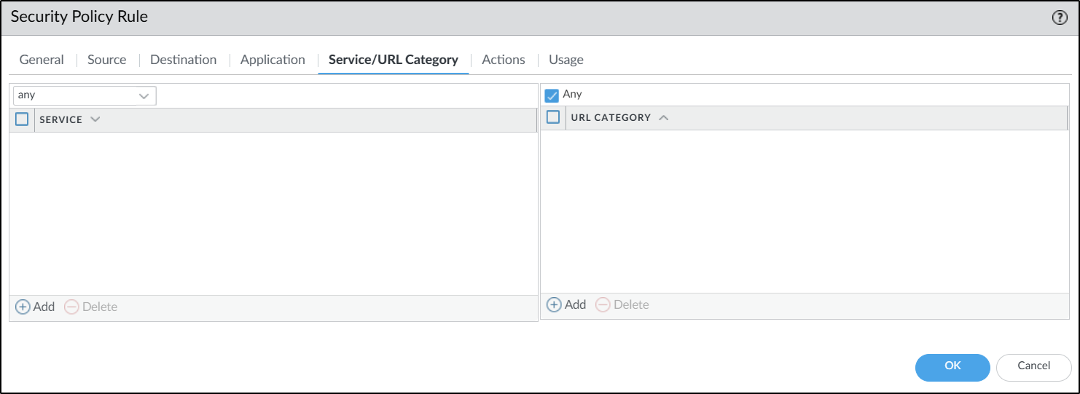

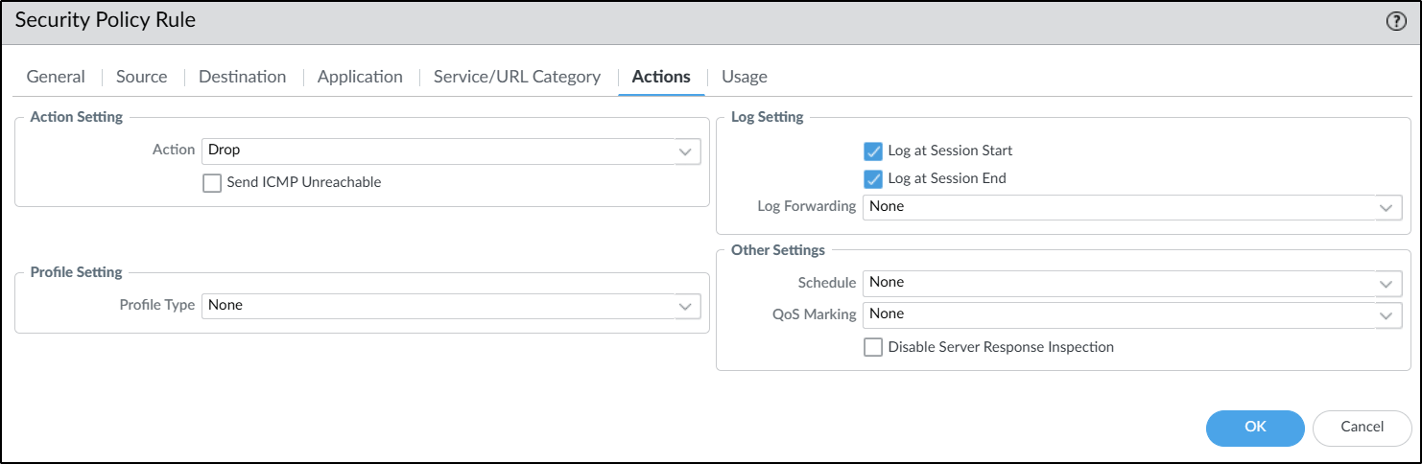



8. Clone the default vulnerability protection profile and name it ‘alert-only’. Set the action for all vulnerabilities to be alert.

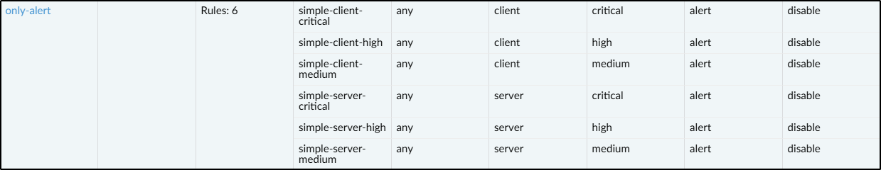

9. Allow web-browing application access to the IIS web server (192.168.3.10) in the dmz zone. Set the vulnerability protection profile to ‘only-alert’ created previously and set the log forwarding to ‘lf_bad_ips’.



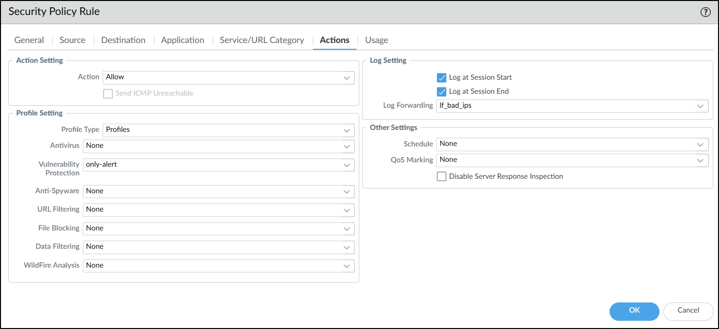

Access to the web server from anywhere would now be monitored and IP addresses would be blocked if any medium alerts appear.

#### Client to Site VPN using GlobalProtect

A client-to-site VPN with GlobalProtect is used to let remote users securely connect to an organization’s internal network from anywhere, such as when working from home or traveling. The GlobalProtect client installed on a user’s device establishes an encrypted tunnel to the company’s firewall or VPN gateway, authenticates the user, and assigns them an internal IP address. This allows the user to access corporate resources as if they were physically on the office network, while also enforcing the organization’s security policies like threat prevention and traffic monitoring.





Created a user in ‘Local Database User’ named ‘vpnuser’ used to connect to the VPN, and added that user to a group called ‘vpngroup’



Created an Authentication Profile ‘GP_AuthProfile and set the ‘Allow List’ to ‘vpngroup’ so that the ‘vpnuser’ can be authenticated and connect to the VPN.

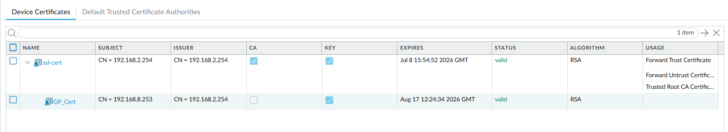

Generated a new certificate ‘GP_Cert’ with the common name ‘192.168.2.253’, set it to signed by ‘ssl-cert’



Created a SSL/TLS Service Profile ‘GP_Certificate’ and set the certificate to ‘GP_Cert’ using TLSv1.2.



Created a new zone named ‘GP-vpn’ and set the interface to tunnel.3



Created a new tunnel interface ‘tunnel.3’ with IP address 192.168.5.0/24 and the zone to ‘GP-vpn’

Under the GlobalProtect Portal, I configured a Portal ‘GP_PortalConf’ with the following settings:

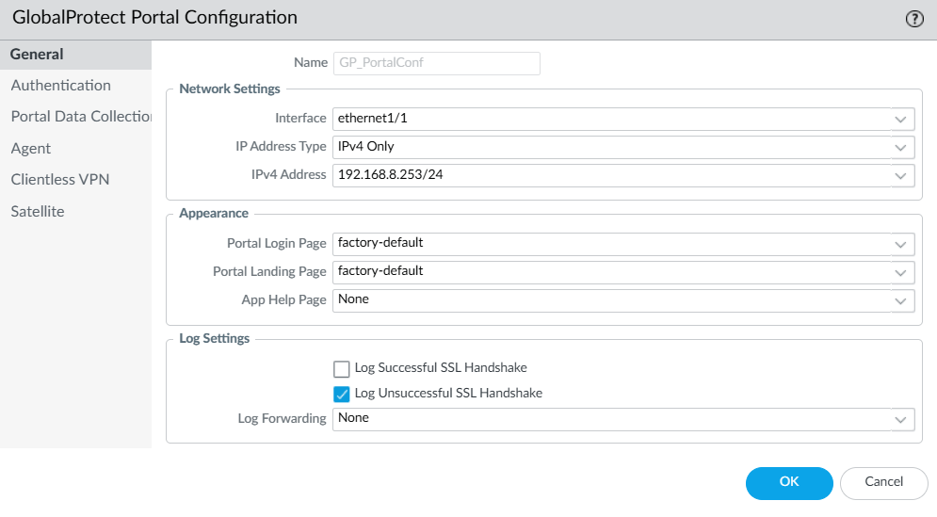

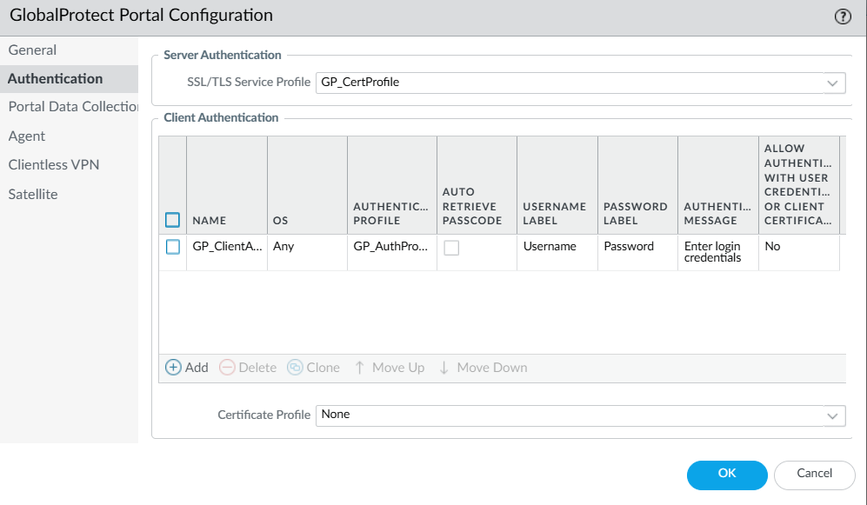

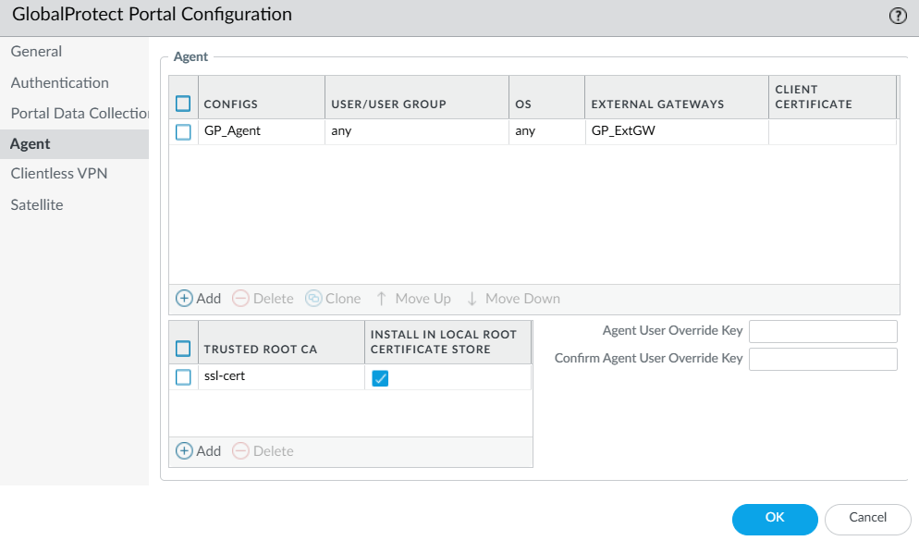

Under the GlobalProtect Gateway, I configured a Gateway ‘GP_GatewayConf’ with the following settings:

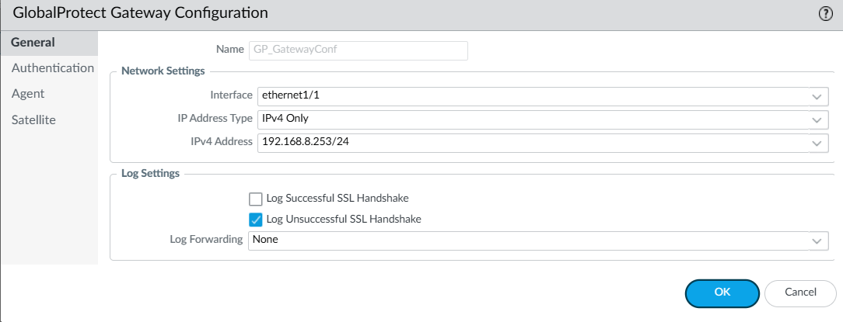

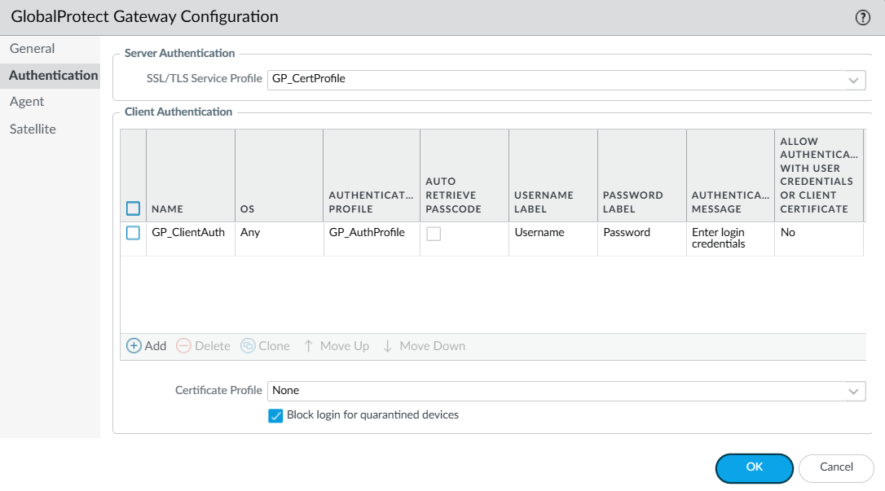

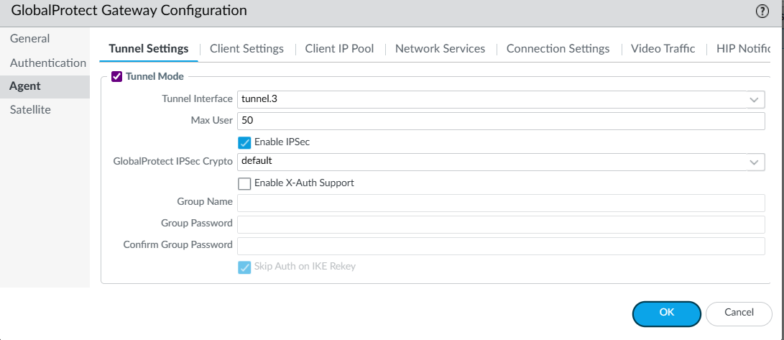

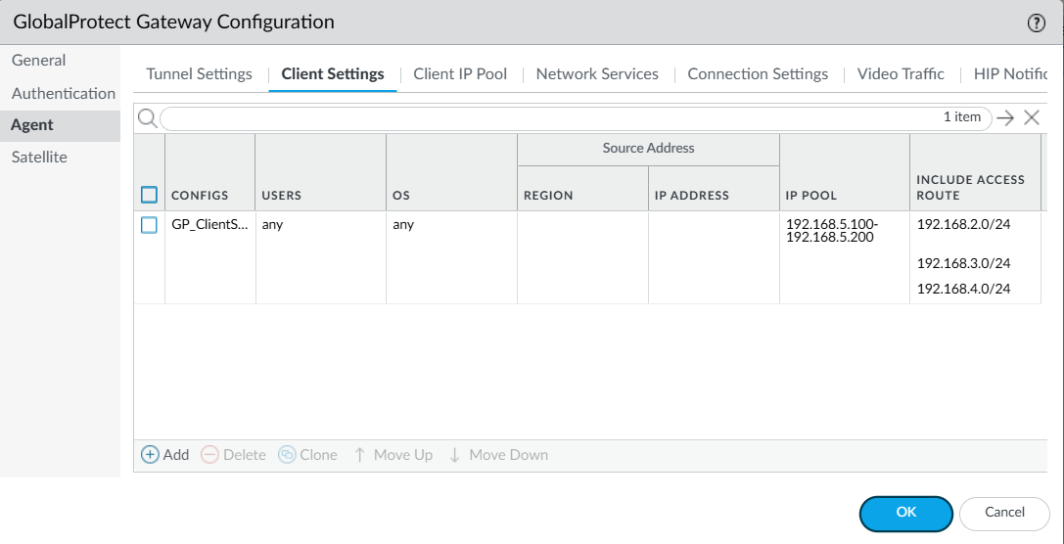

The VPN client will receive a IP address from the pool 192.168.5.100-192.168.5.200

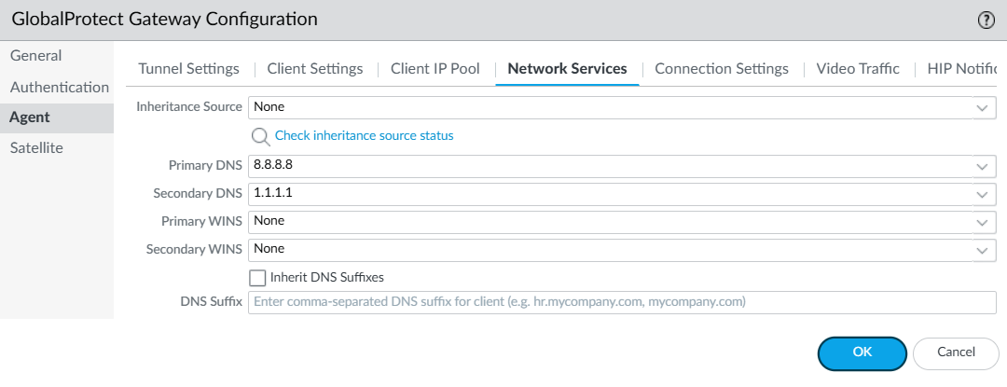



Created a new security policy which allows traffic from ‘GP-vpn’ to ‘any’

## VPN configuration

Configure the following Ethernet interfaces to the lab-vr Virtual router:

Assign the following IP to ethernet1/1

IPv4 -> 192.168.8.254

Assign the following IP to ethernet1/3

IPv4 -> 192.168.3.254

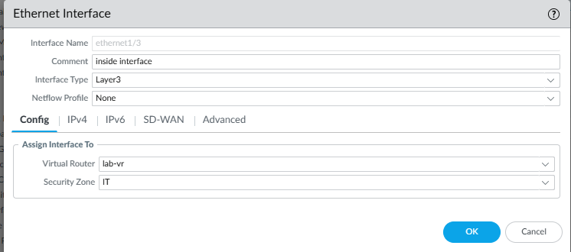

Assign the following IP to ethernet 1/4

IPv4 -> 192.168.4.254

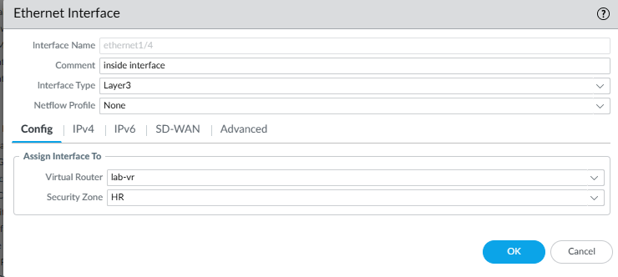

Now, configure the tunnel interface with the virtual router as lab-vr and security zone as vpn. This interface routes traffic between SG and KL, connecting the two networks as if they are directly connected

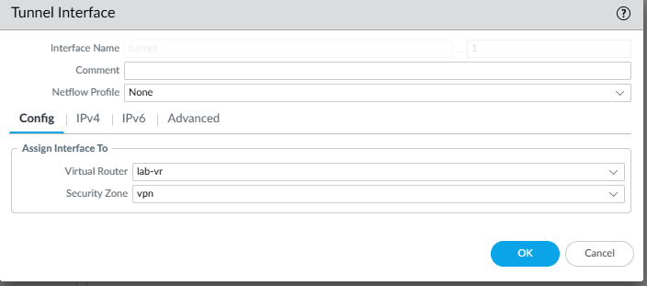  
Configure a static route in the virtual router lab-vr. This handles connections between the two networks by telling the firewall which interface to use. This ensures that data is sent through the correct VPN tunnel for secure communication.   
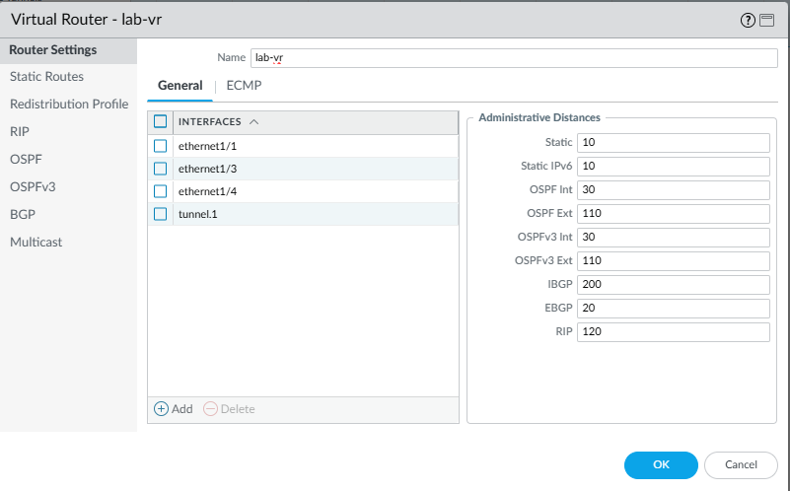  
  
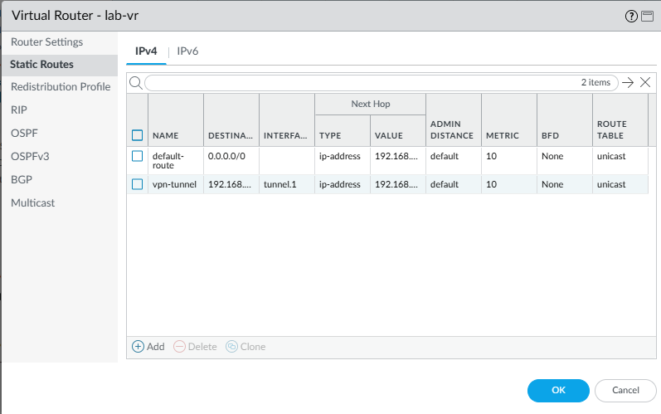

Setup Crypto Profiles. These crypto profiles determine the form of IKE encryption and ensure that the tunnel is fully encrypted by specifying the IP addresses of the tunnel interfaces.

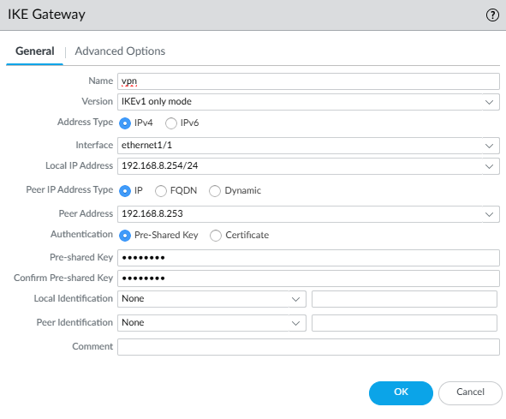  
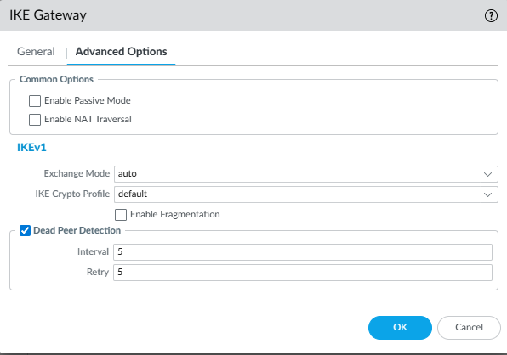  
  
  
Setup IPSec tunnel, this is the VPN tunnel that will be used for the connection between the SG and KL networks.

This uses the tunnel interface, IKE gateway and cryptographic profiles that have been configured earlier.

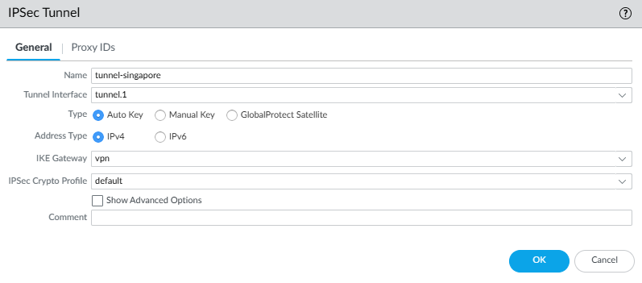

Setup Security Policies for allowing network traffic from the VPN tunnel. By configuring a policy rule, we ensure that the firewall does not block all the traffic coming from the SG network.

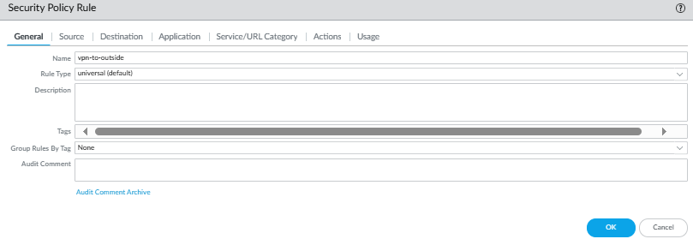source: vpn   
destination: outside   
  
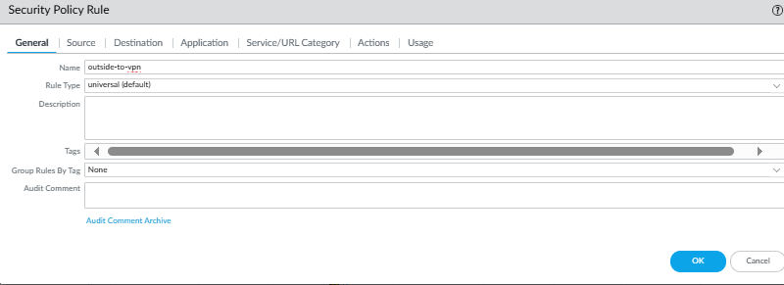  
source: outside   
destination: vpn

# Test plans & results

### HR Department (SG) Essential Business Functions

To test whether web traffic and DNS traffic is allowed, I visited np.edu.sg. 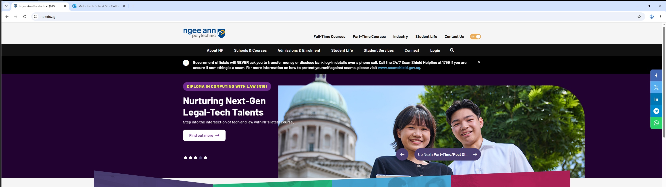

The logs below shows that web-browsing, ssl and dns application is allowed through the egress-outside policy.





To test whether email traffic is allowed, I sent an email through the outlook web.

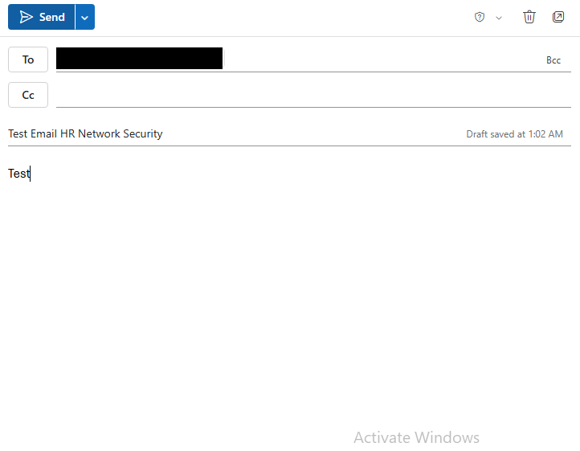

From the logs, the email was allowed through the ms-outlook-send application from the egress-outside policy rule.



### HR Allow Google

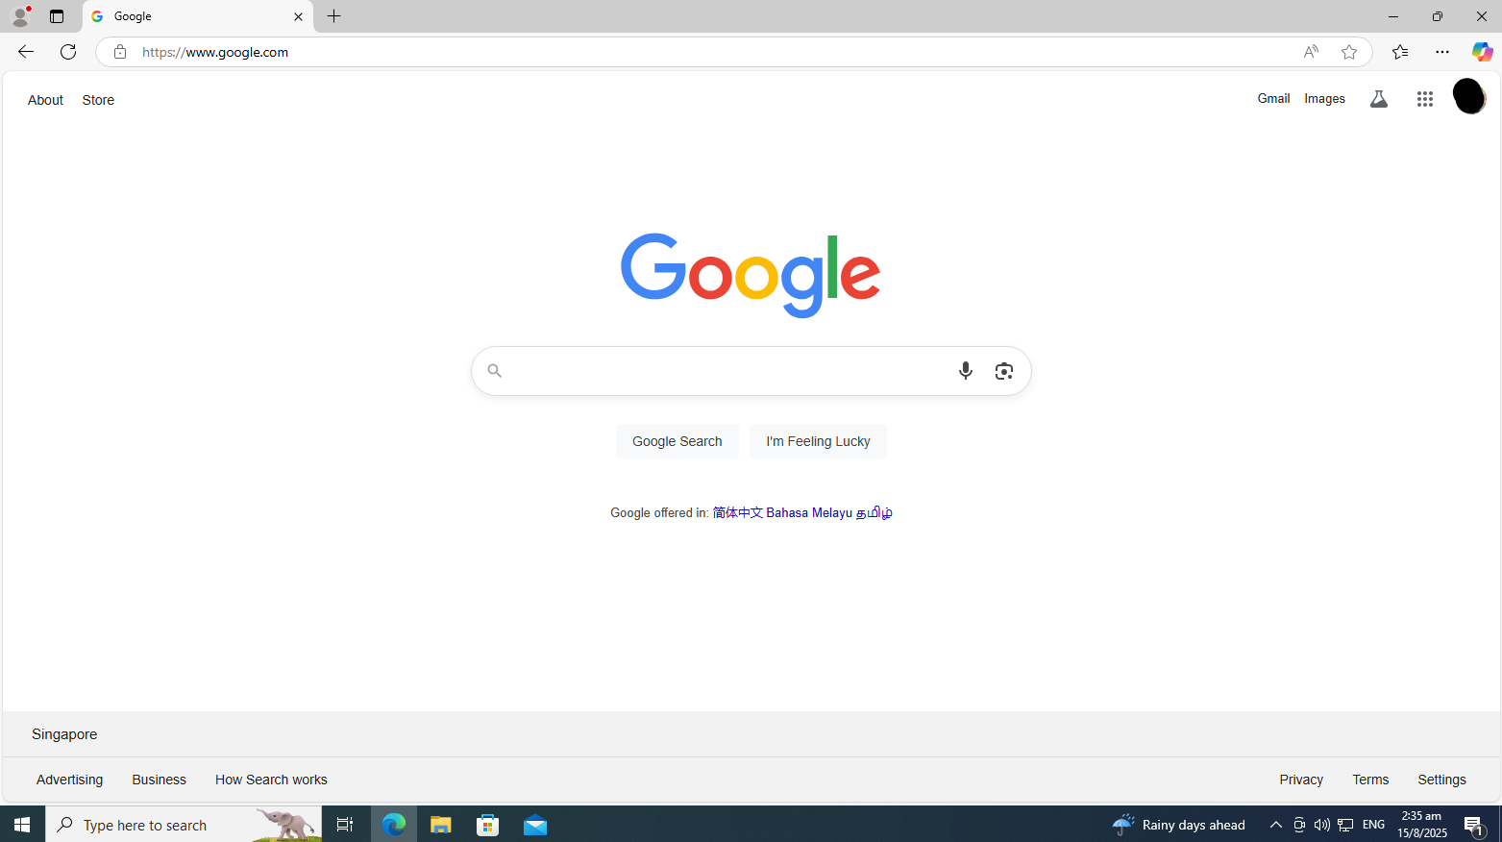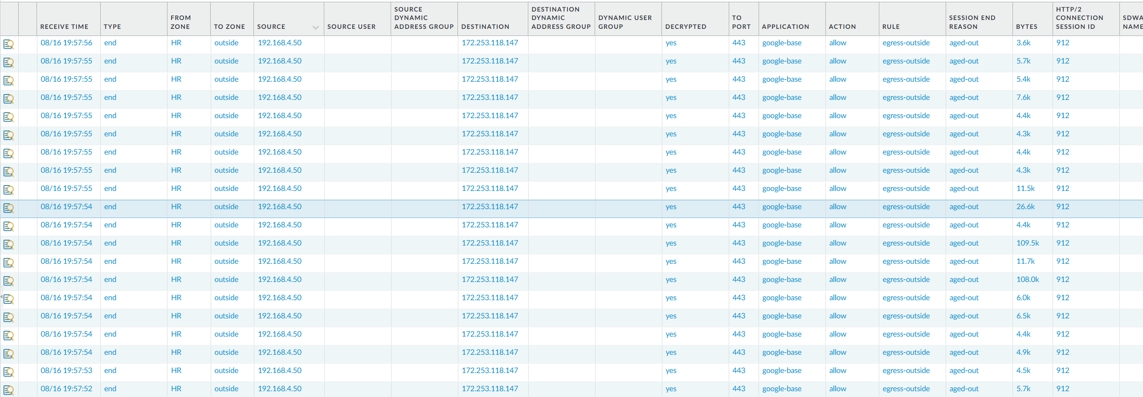

HR department able to access google.com

### HR Allow Microsoft 365

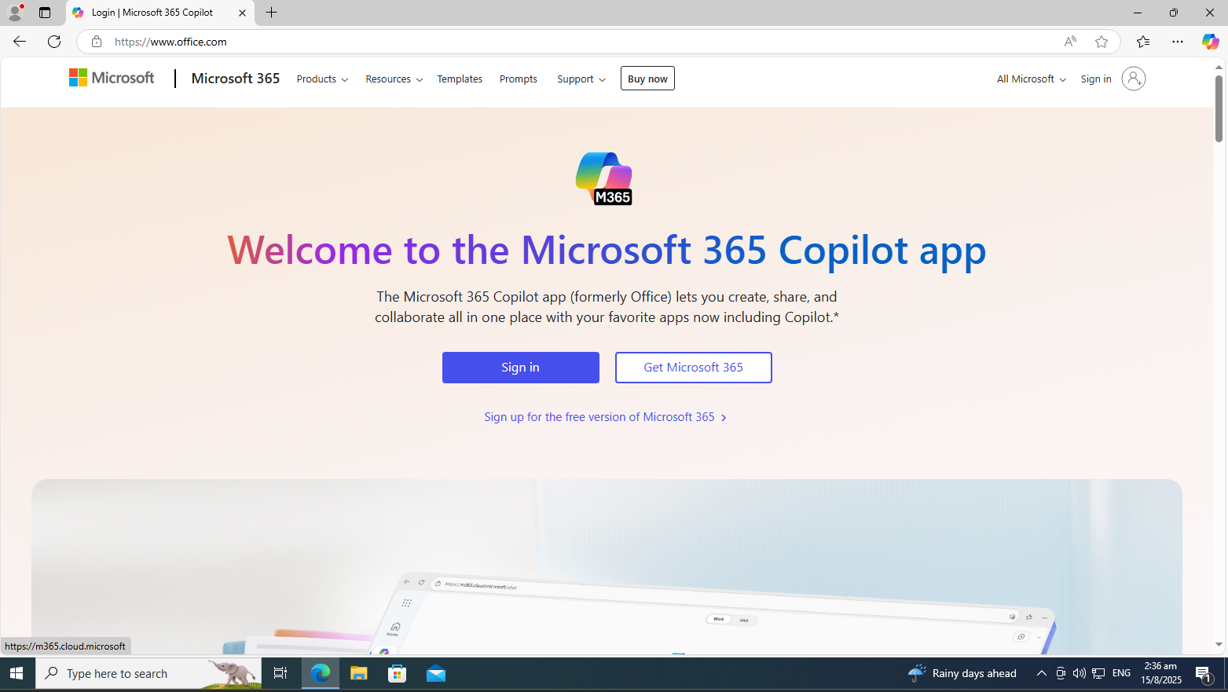



HR department able to access office.com

### HR Allow LinkedIn

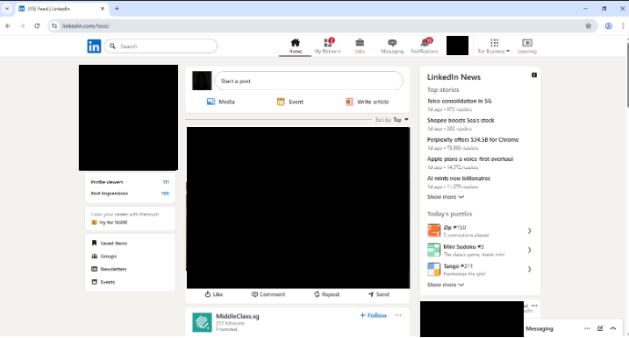



HR department able to access linkedin.com

### HR Block LinkedIn Messaging

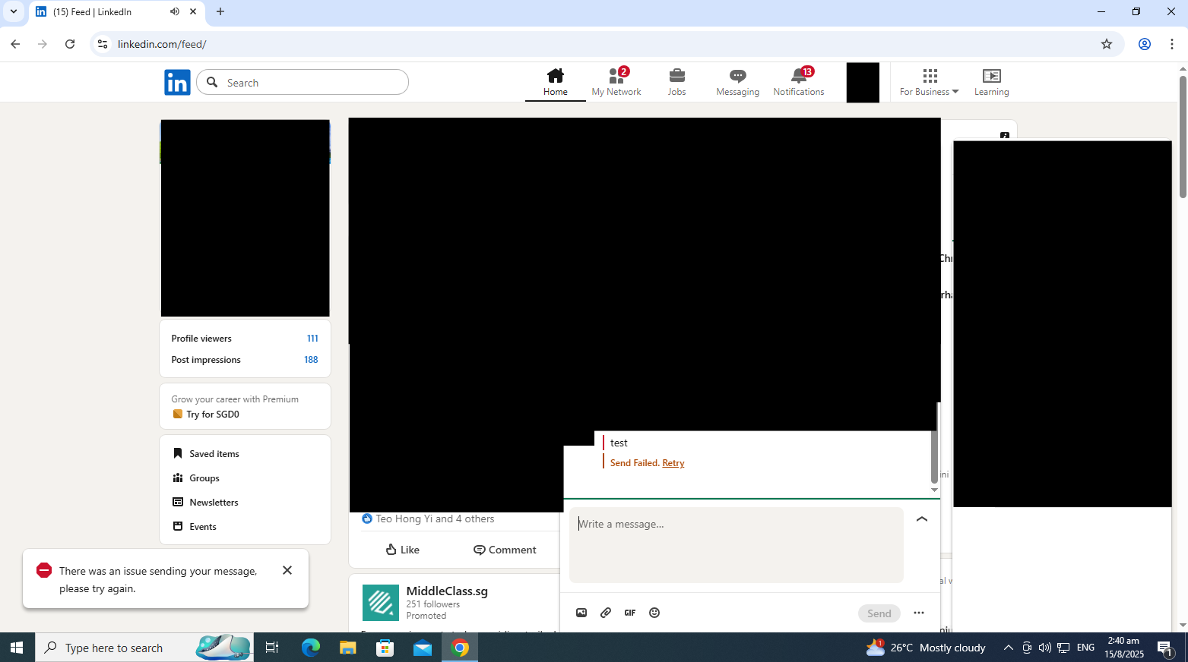



HR department fails to send messages in Linkedin

### HR Allow Facebook

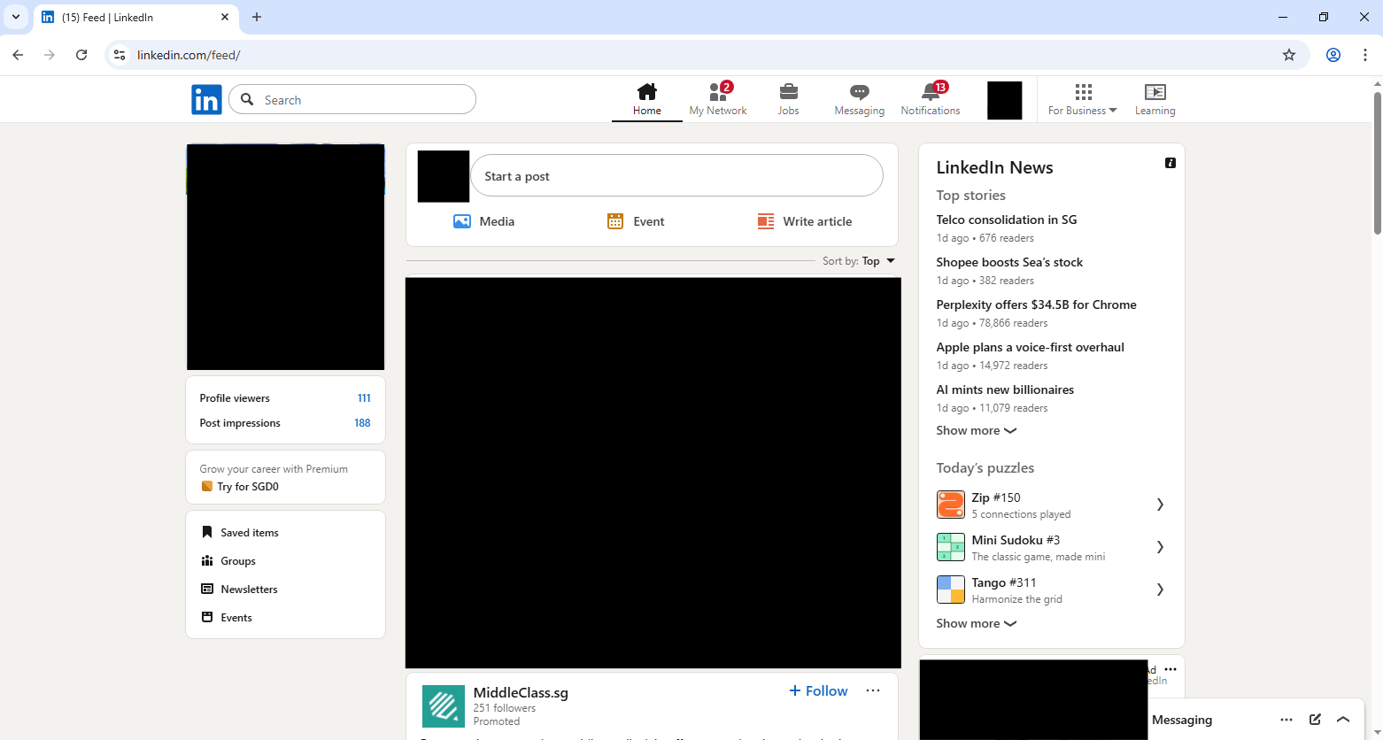



HR department able to access facebook.com

### HR Block Facebook Chat

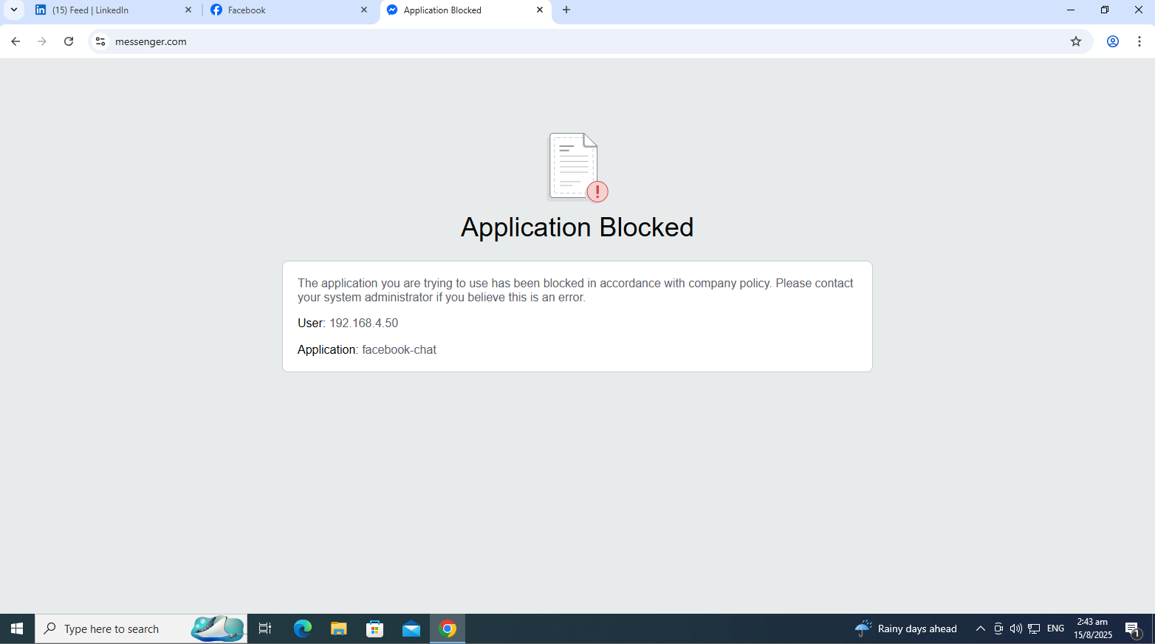

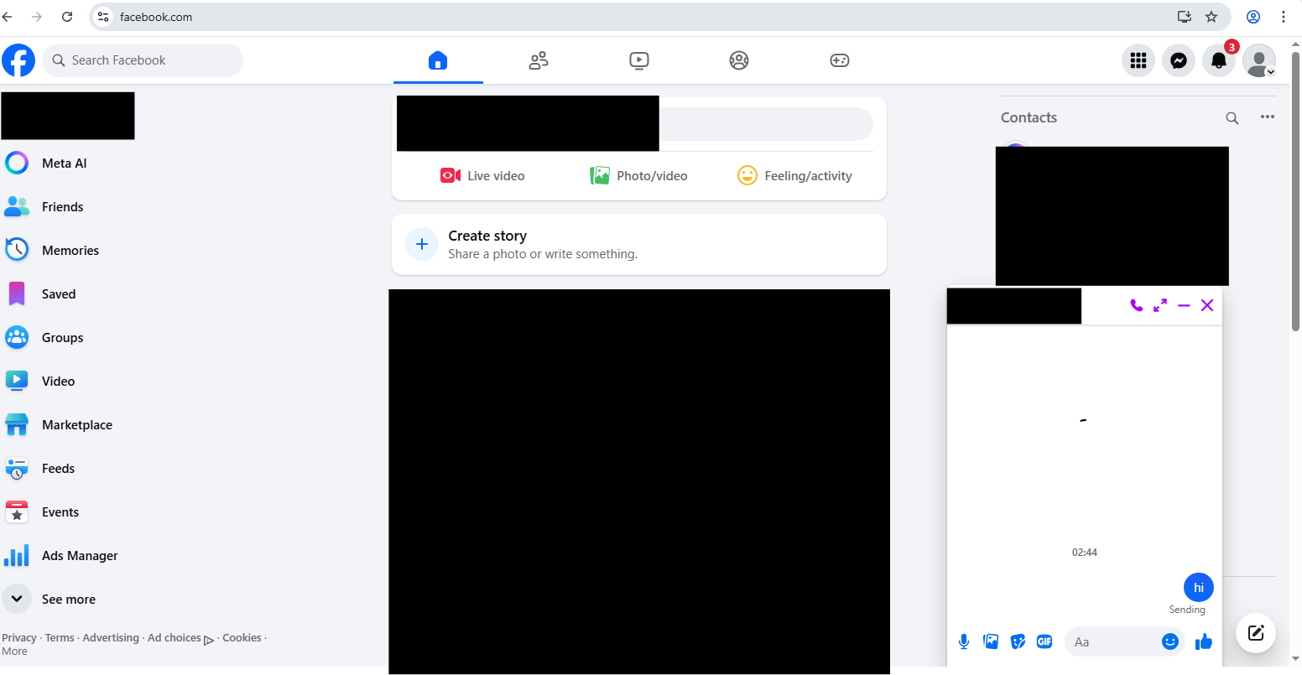



HR department unable to access messenger.com and when sending a message in facebook.com, it does not go through. The chat in facebook.com will just show that its loading but does not load.

### HR Block Online Storage Services

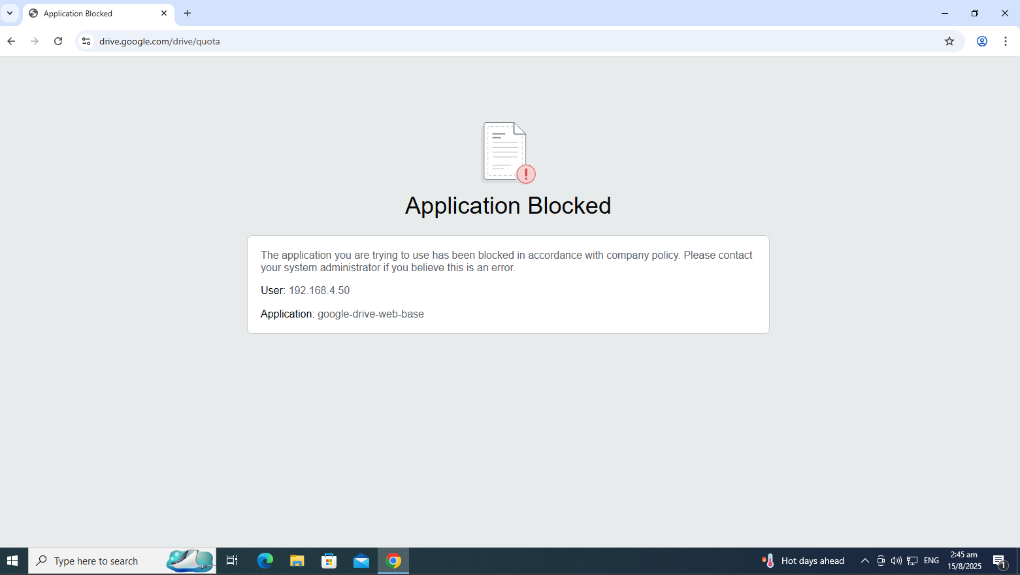

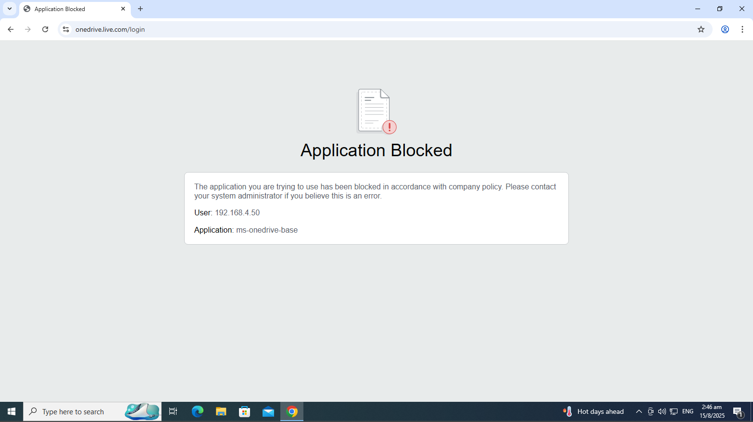

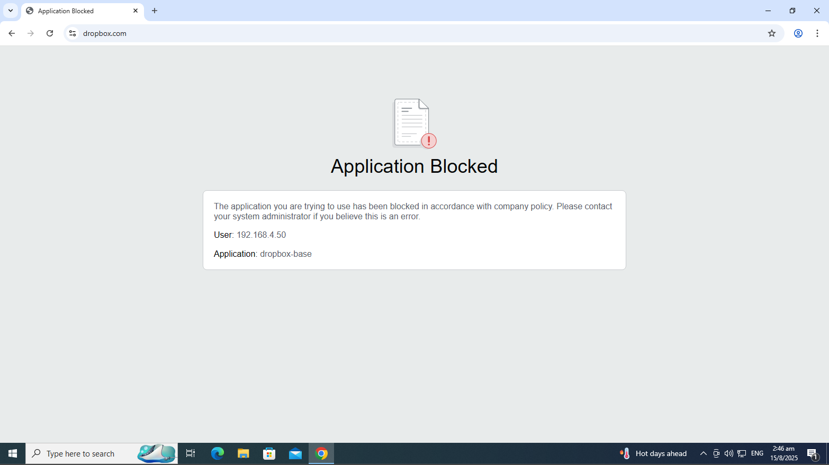

HR department unable to access online storage services like Google drive, Dropbox and OneDrive

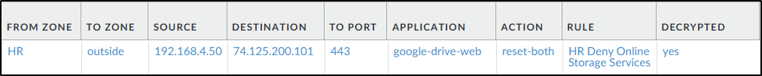



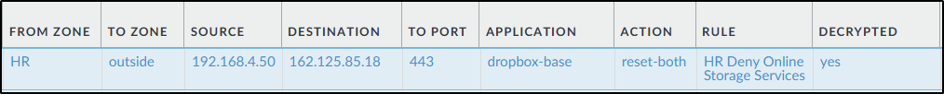

## IT Department (SG)

### Essential Business Functions

To test whether web traffic and DNS traffic is allowed, I visited np.edu.sg. 

The logs below shows that web-browsing, ssl and dns application is allowed through the egress-outside policy.





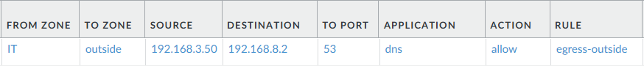

To test whether email traffic is allowed, I sent an email through the outlook web.

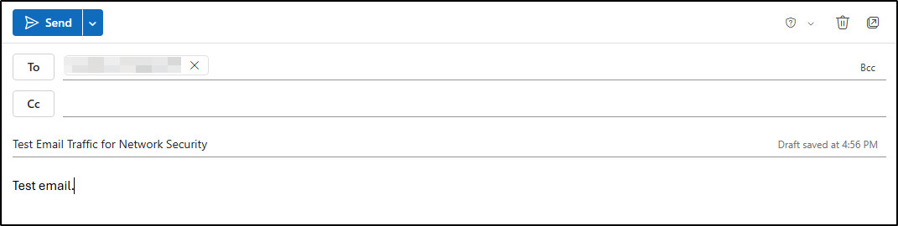

From the logs, the email was allowed through the ms-outlook-send application from the egress-outside policy rule.



To test whether remote access traffic is allowed, RDP was used.

Only testing the rdp connection from IT to HR, as only the IT department should be able to access the HR department’s PCs to resolve any PC issues.

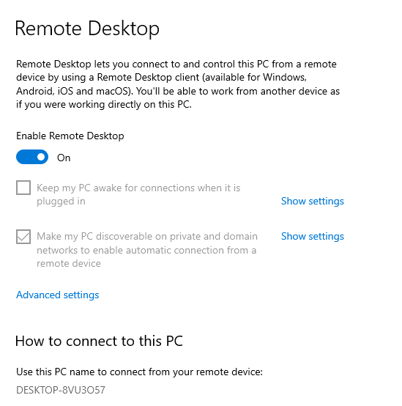

Remote Desktop Connection is enabled on the HR PC.

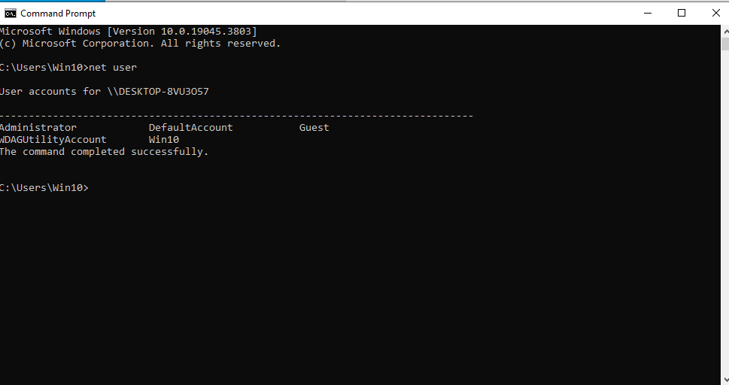

Using the Win10 account to test the connection.

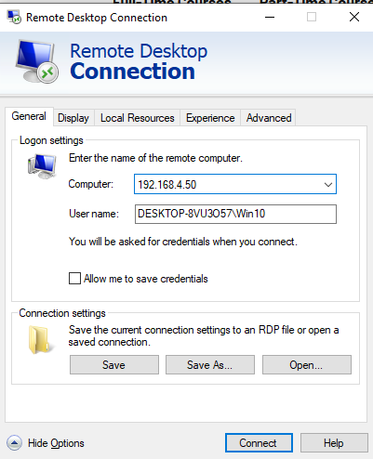

On the IT PC, in the Remote Desktop Connection (RDP), the computer is set to the IP address of the HR PC and username is the DESKTOP-8VU3O57\Win10



Created a new security policy so that ‘ms-rdp’ is allowed from IT zone to HR zone as by default, interzone traffic is denied.

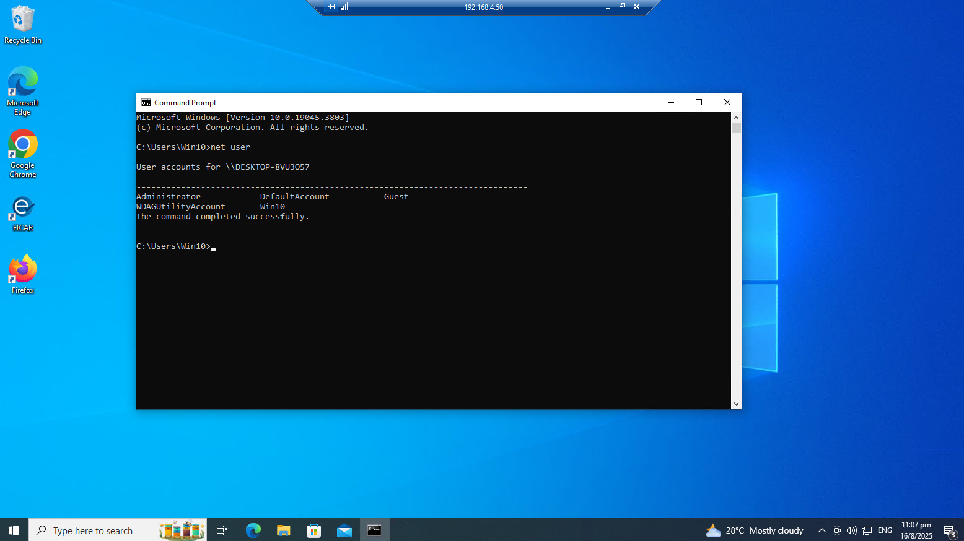

This screenshot shows the successful connection. Net user shows the users of the HR PC.



Under Monitor, it shows there was traffic with application ‘ms-rdp’ from IT to HR zone under the ‘allow IT RDP’ rule.

### IT Allow Google

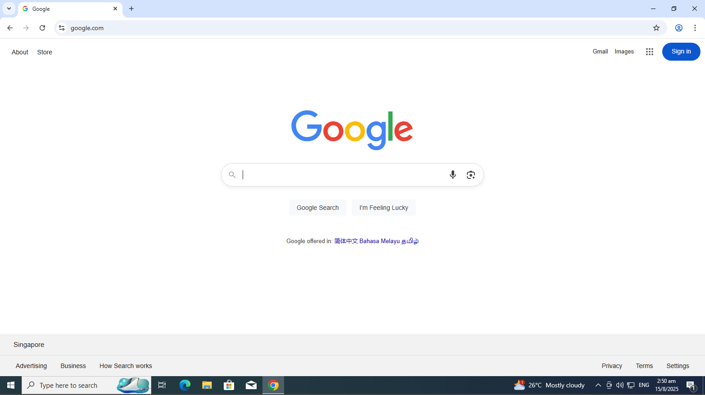



IT department can access google.com

### IT Allow Microsoft 365

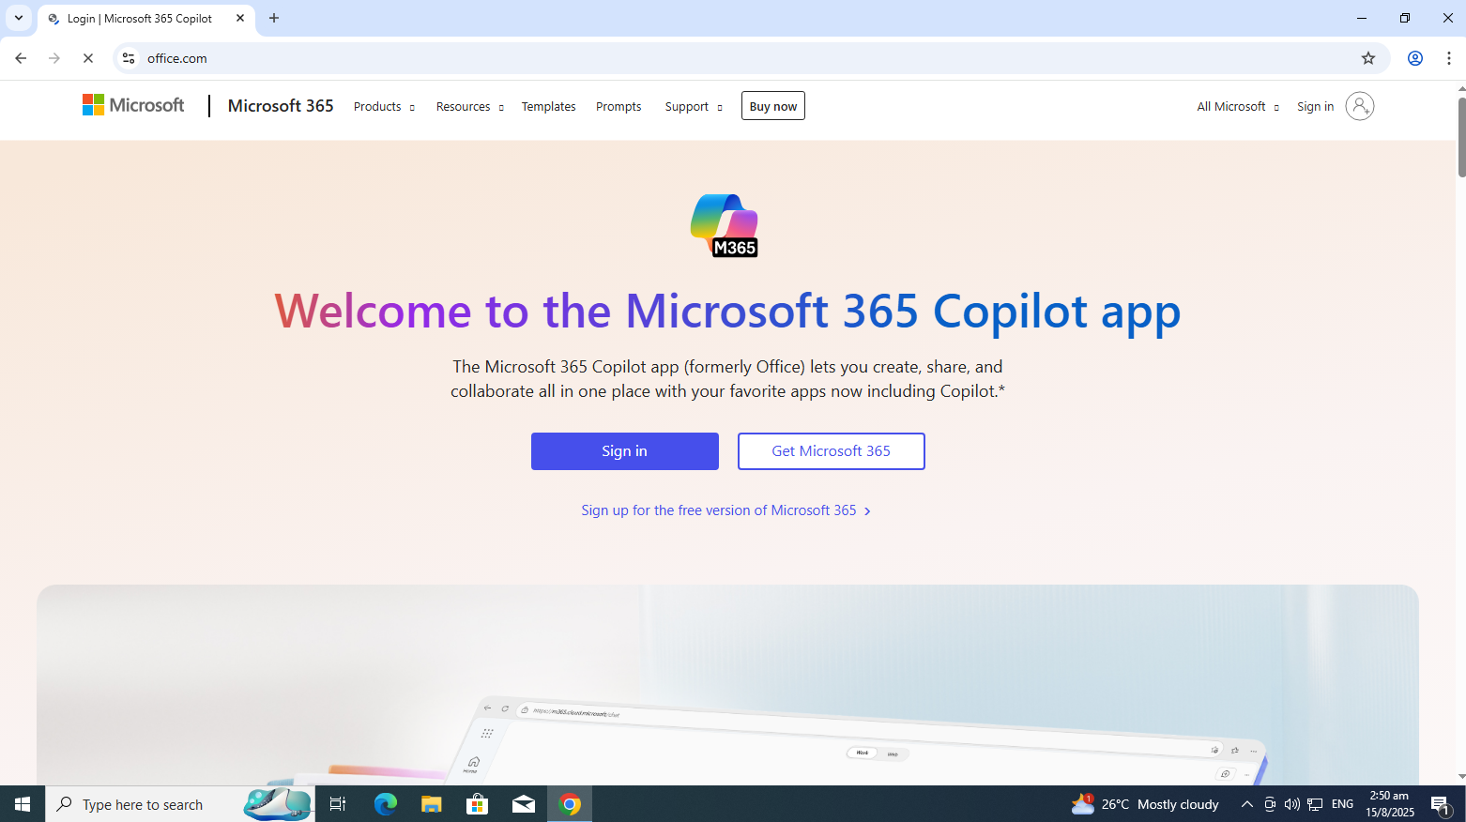



IT department can access office.com

### IT Block LinkedIn & Facebook

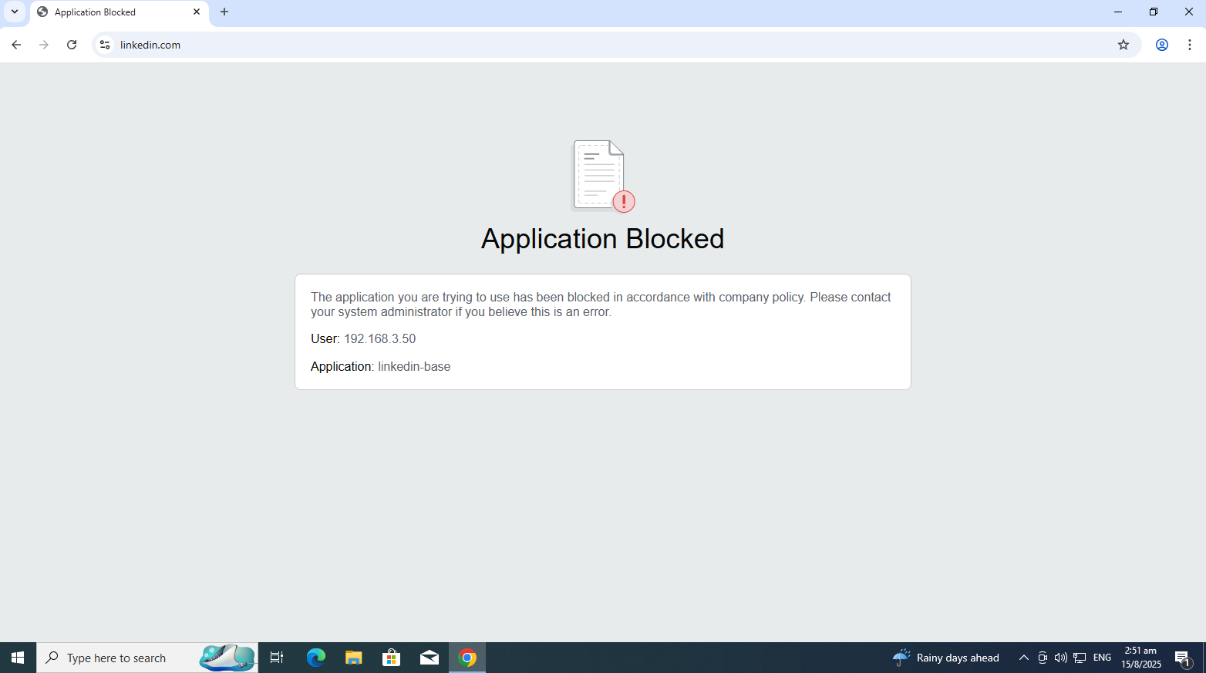

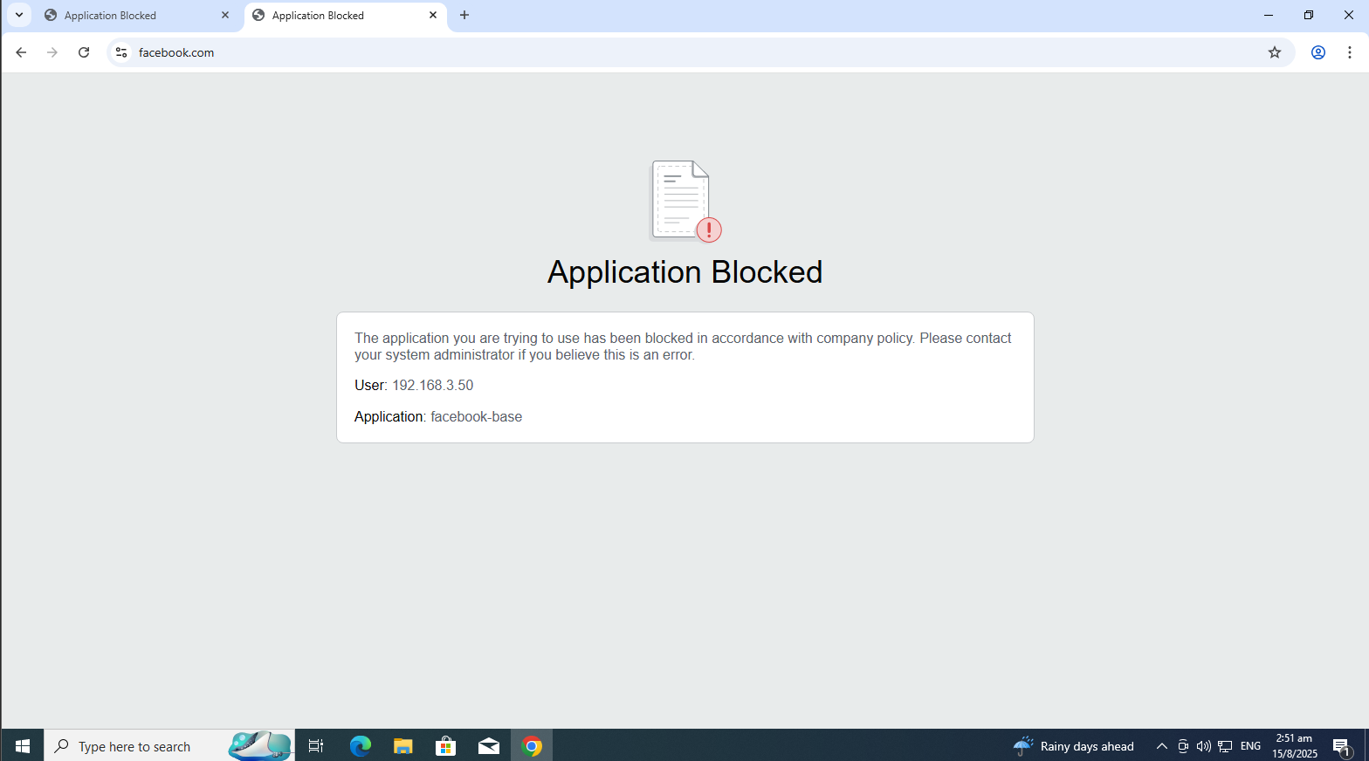





IT department unable to access facebook.com and linkedin.com

## Sales Department (KL)

### Essential Business Functions

To test whether web traffic and DNS traffic is allowed, I visited np.edu.sg.

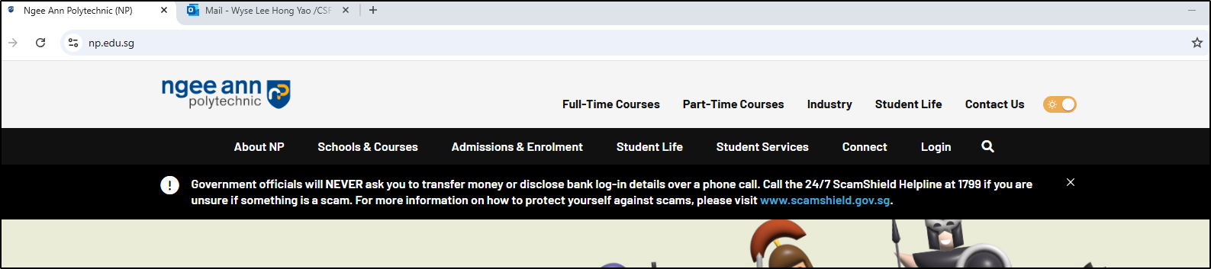

The logs below shows that web-browsing, ssl and dns application is allowed through the egress-outside policy.

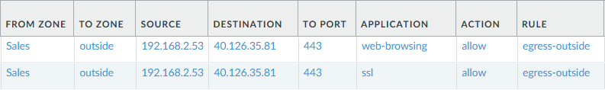

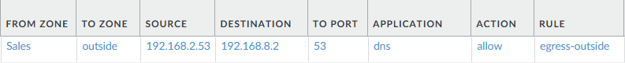

To test whether email traffic is allowed, I sent an email through the outlook web.

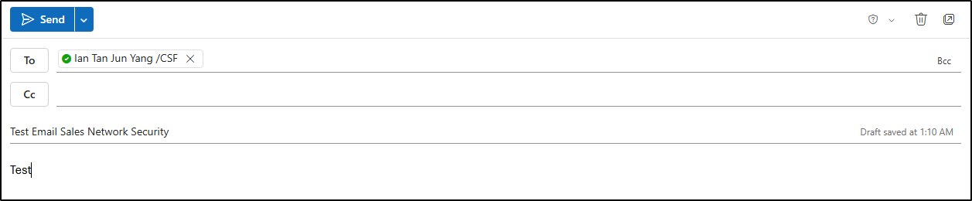

From the logs, the email was sent through the ms-outlook-send application.

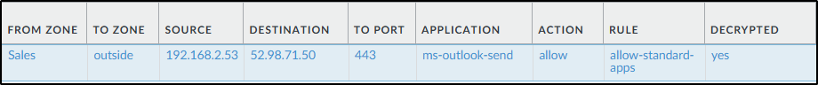

To test whether remote access traffic is allowed, RDP was used. For the setup, I used 2 Windows 10 Pro machines. On one of the machines, I enabled Remote Desktop in the settings, which is where I obtained the PC name as well. I then ran the ‘net user’ command to verify my username which is ‘Win10’.

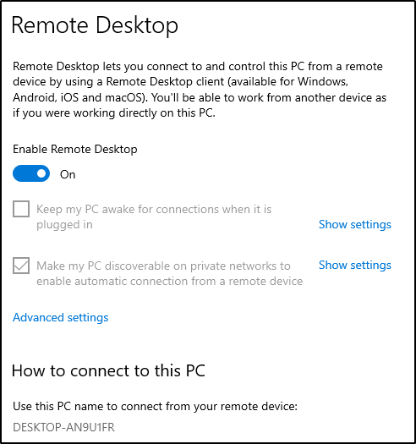

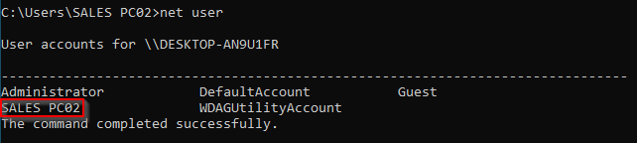

Once the setup is complete, I changed to the other Windows 10 machine and used Remote Desktop Connection (RDP) to connect to the machine with Remote Desktop enabled as the user ‘Win10’.

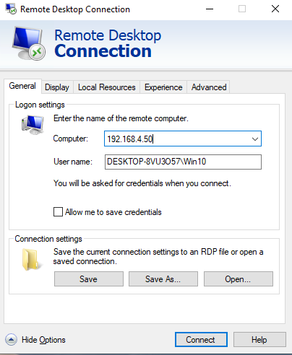

A successful connection can be seen from the following screenshot:

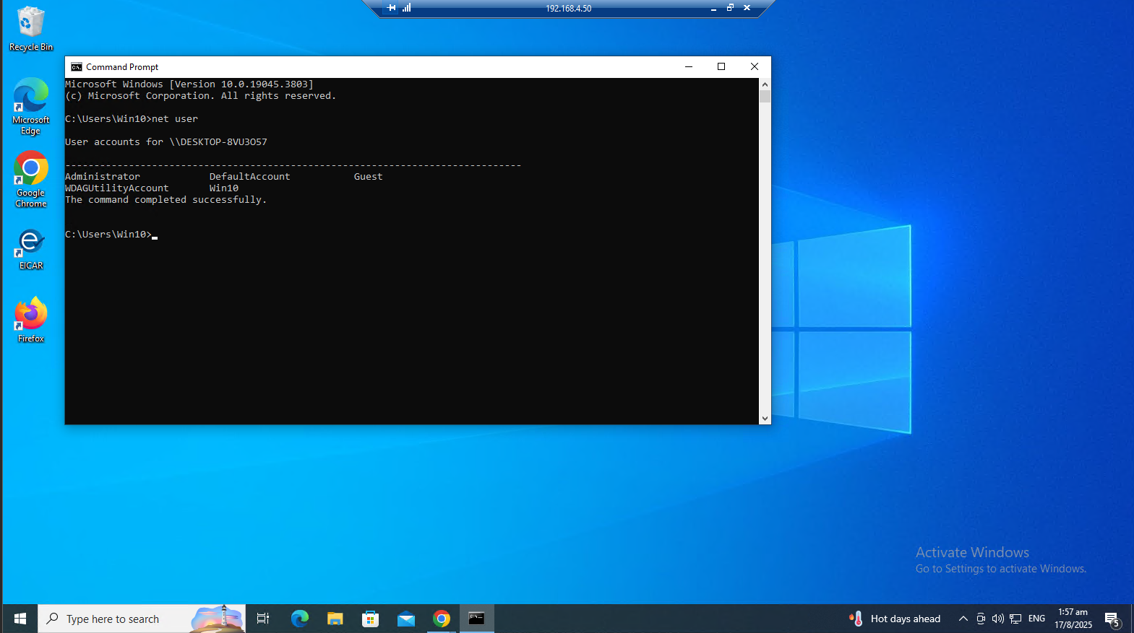

The logs show the ms-rdp connection from Sales to VPN zone.



### Allow Google

Visiting google.com, the successful connection can be seen below:

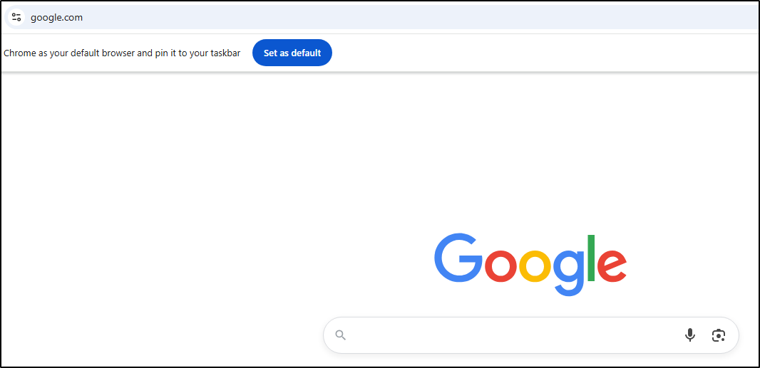

The logs show the allowed traffic to the google-base application.

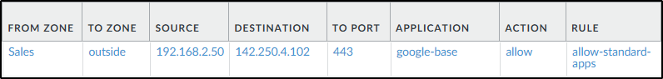

### Allow Microsoft 365

Visiting Microsoft 365 website, the successful connection can be seen below:

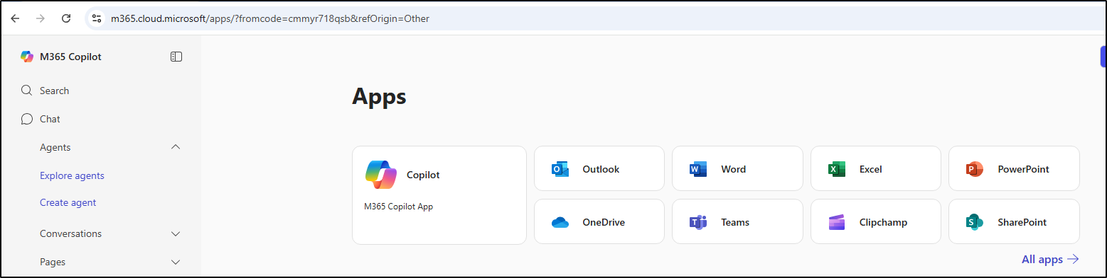

The logs show the allowed traffic to the ms-office365-base application.

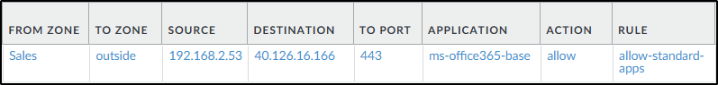

### Block LinkedIn

Upon visiting LinkedIn webpage, the application has been blocked.

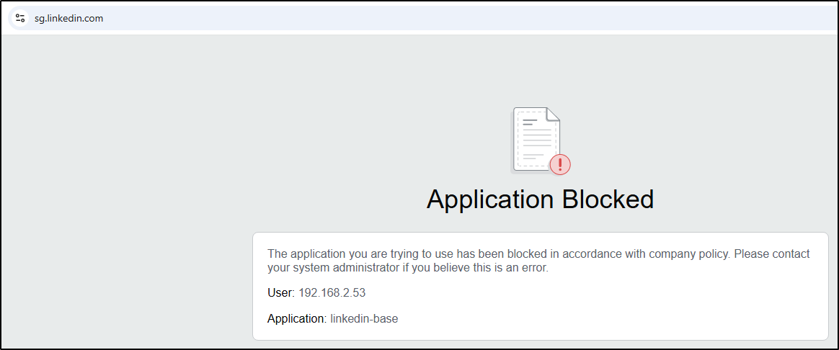

The logs verify this as the deny-outbound policy rule has blocked the traffic to linkedin-base application.

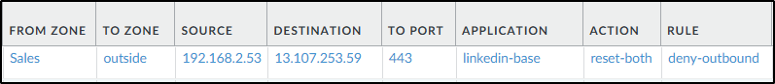

### Allow Facebook

The successful connection to facebook.com can be seen below:

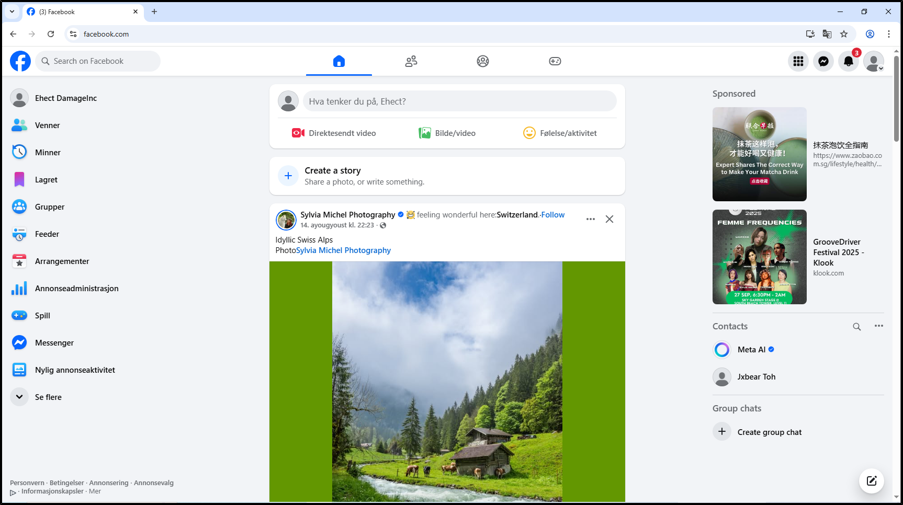

The logs show the allowed traffic to the facebook-base application.

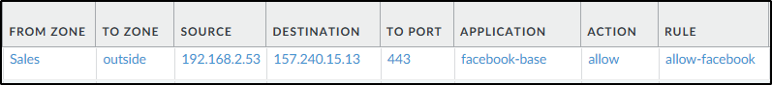

### Block Facebook Chat

On the bottom right of the screenshot below, I have highlighted where the input field for messaging is originally at. It can be seen that the facebook chat feature has been blocked as no messages can be typed and sent.

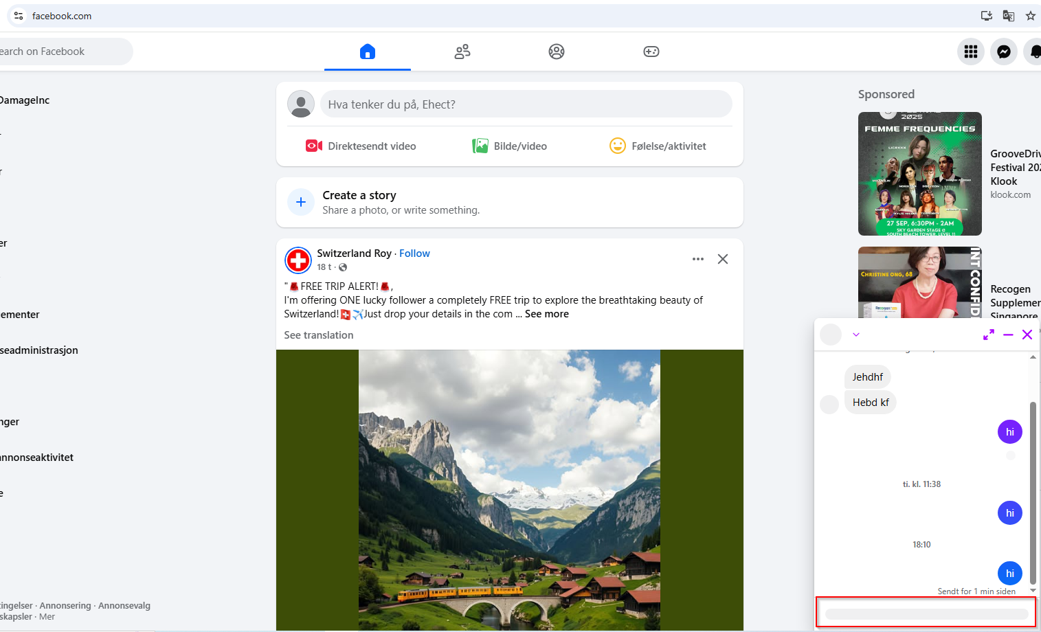

Moreover, there is an external site for facebook messaging on the messenger.com website. It can also be seen that the application has been blocked.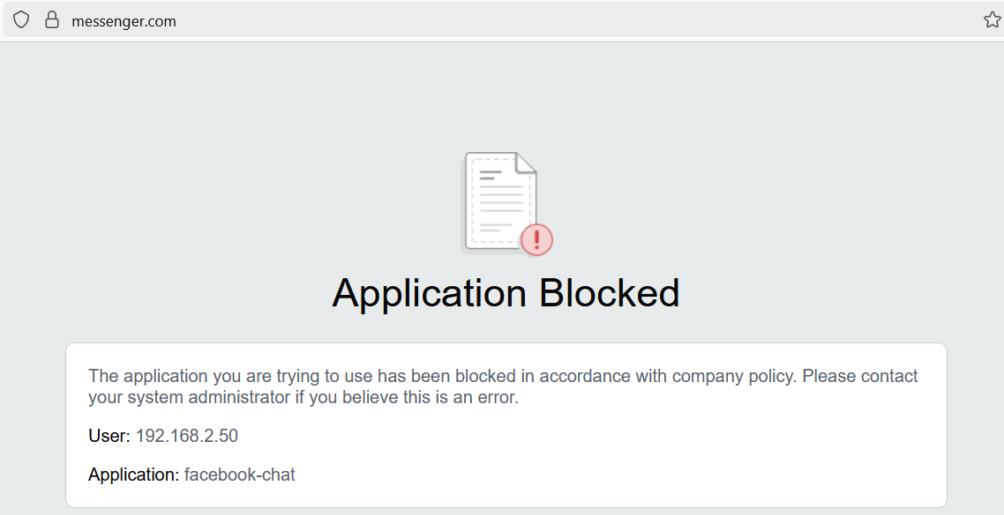

The logs verify the facebook-chat application being blocked.

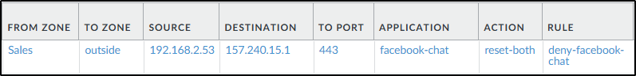

### Block Online Storage Services

Online storage services such as Google Drive and OneDrive should be blocked to prevent data loss. As such, the following 2 screenshots show that access to both of these platforms are being blocked:

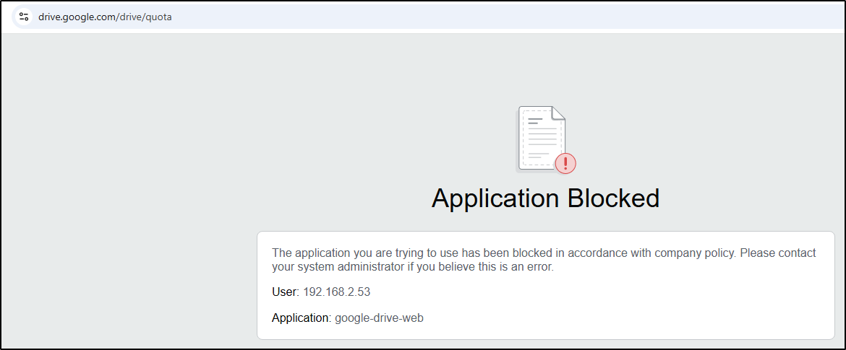

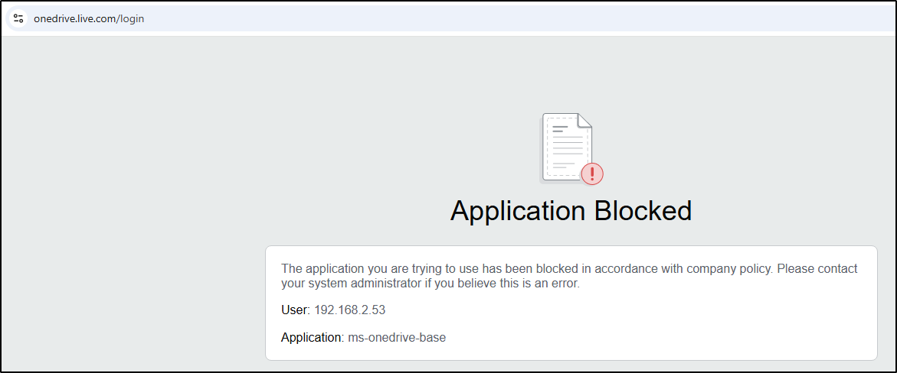

The logs verify that connection to both google-drive-web and ms-onedrive-base applications have been blocked and not allowed.

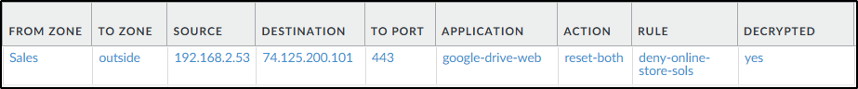

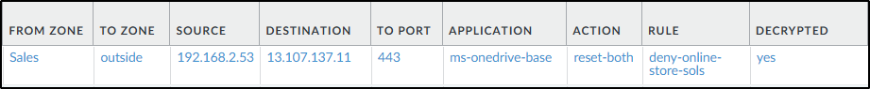

## SG Firewall (Decryption Policy)

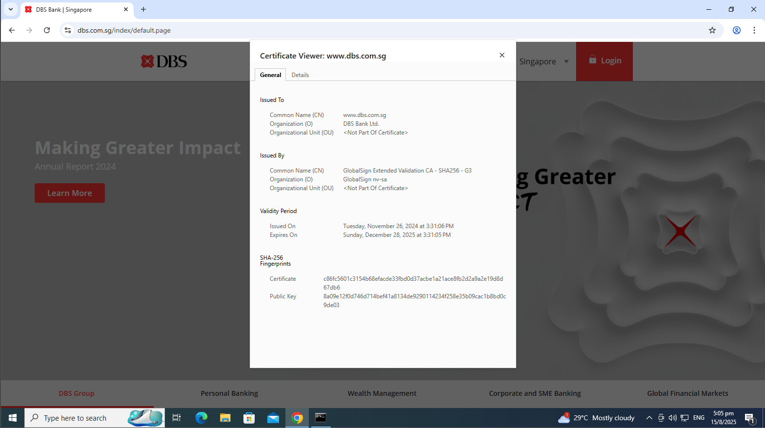

When visiting dbs.com.sg, the certificate is issued by GlobalSign and not the firewall.

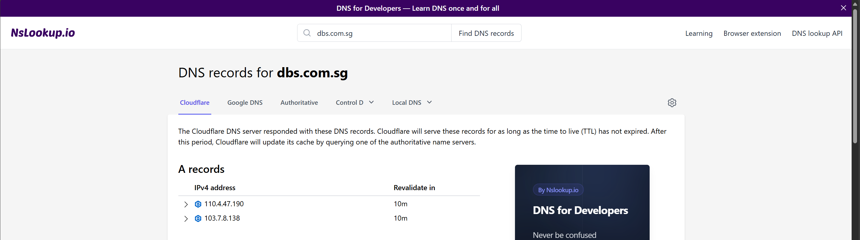

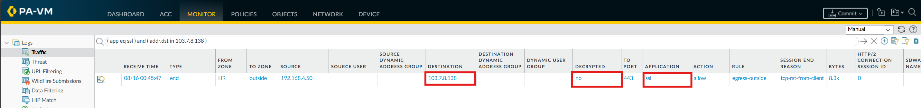

Under the monitor tab, we can see that ssl is not decrypted when visiting dbs.com.sg

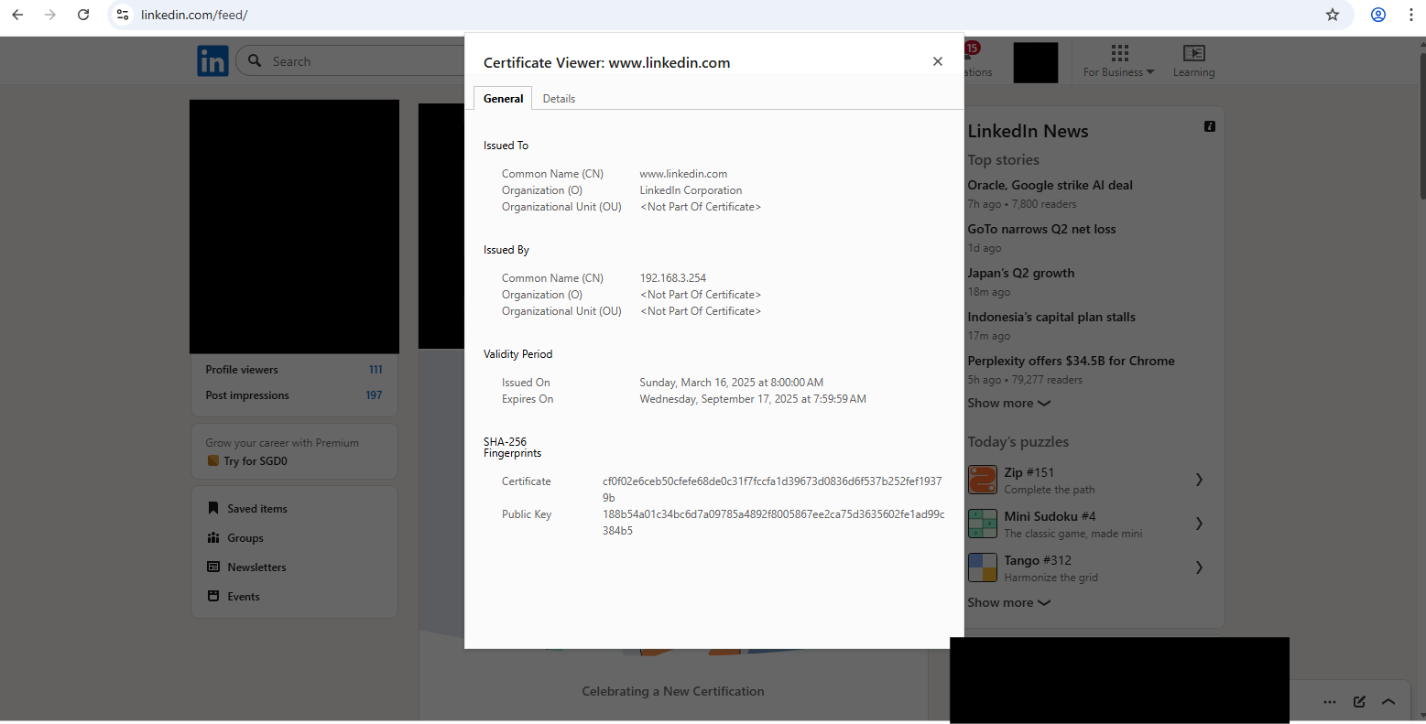

When visiting other sites like linkedin.com, the certificate is issued by the firewall with the common name 192.168.3.254 which set when generating the ssl-certificate.

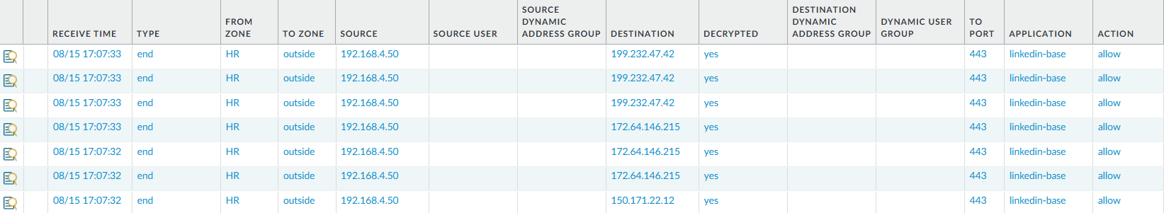

## KL Firewall (Decryption Policy)

To test that the decryption policy was not decryption traffic to and from banking websites, I made a connection to dbs.com.sg.

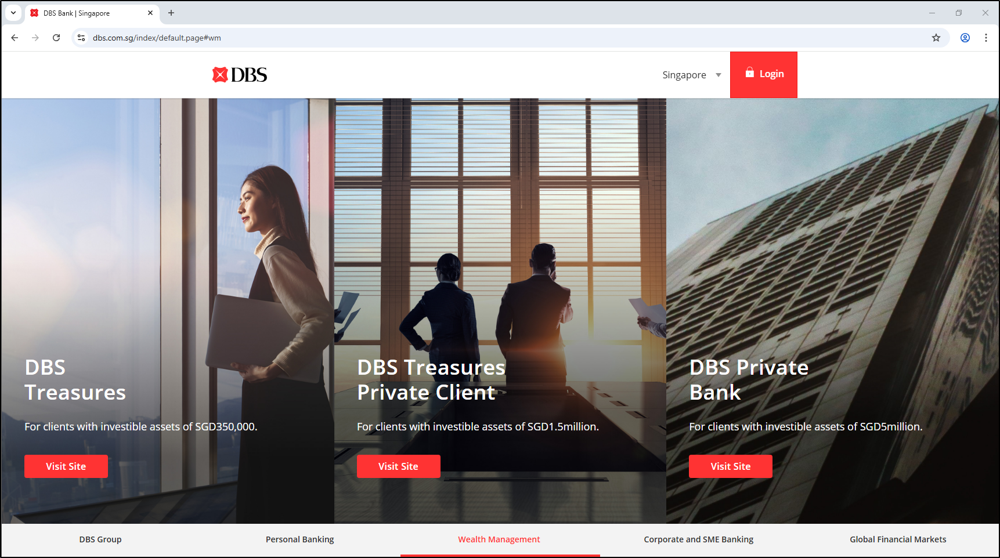

After filtering destination IP address based on the nslookup done on dbs.com.sg previously, the traffic to the bank website is not decrypted as seen in the logs below.



In the decryption logs, the no-decrypt decryption policy is hit for *.dbs.com.sg, further proving that there is no decryption for banking websites.



When visiting a website other than a banking one, the traffic logs show the decrypted column value is yes. This shows that only banking websites are decrypted.



## SG Firewall (VPN Connection to KL Office)

Test IKE Phase 1

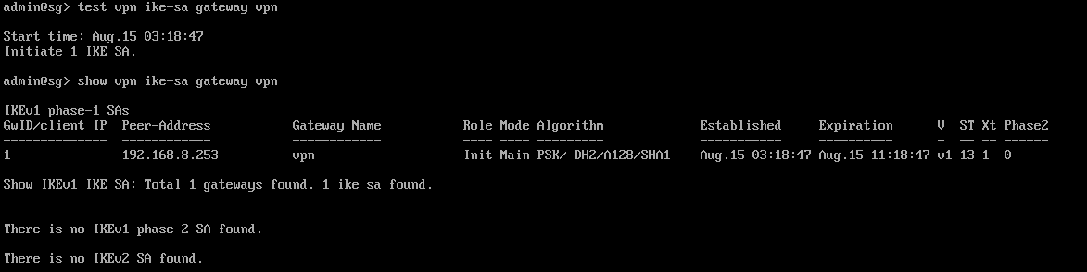

Test IKE Phase 2

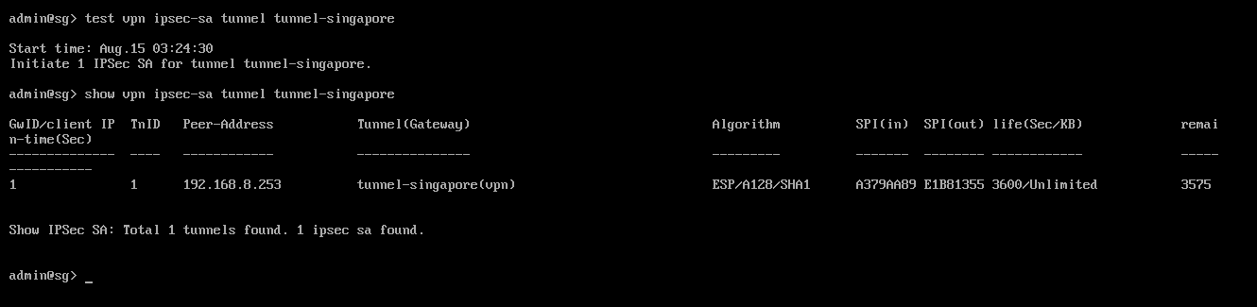

Checking the flow of the VPN, it shows that the peer-ip is 192.168.8.253 (KL) and the state is active.

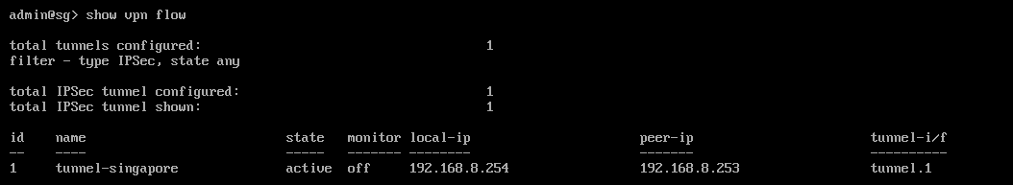

Check VPN status for green light indicators for both IPsec Tunnel and IKE Gateway.

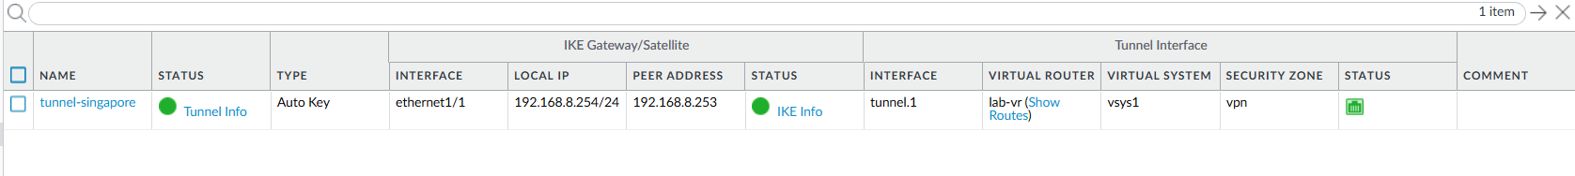

HR (SG) with IP address 192.168.4.50 ping Sales (KL) with IP address 192.168.2.52

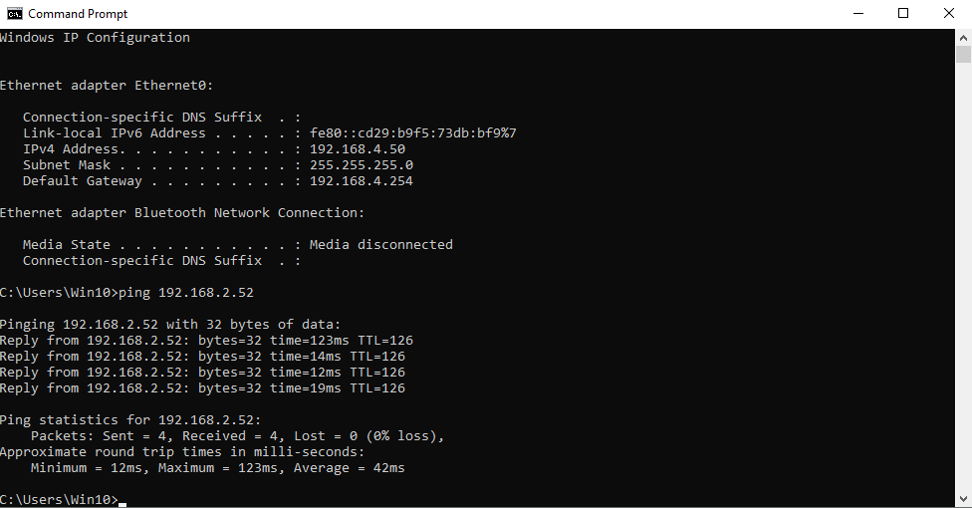

IT (SG) with IP address 192.168.3.50 ping Sales (KL) with IP address 192.168.2.52

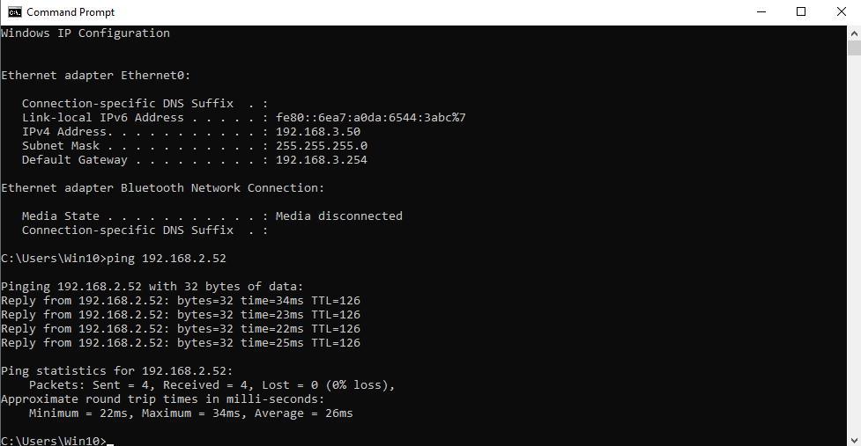

KL Firewall (VPN Connection to SG Office)

Test IKE Phase 1.

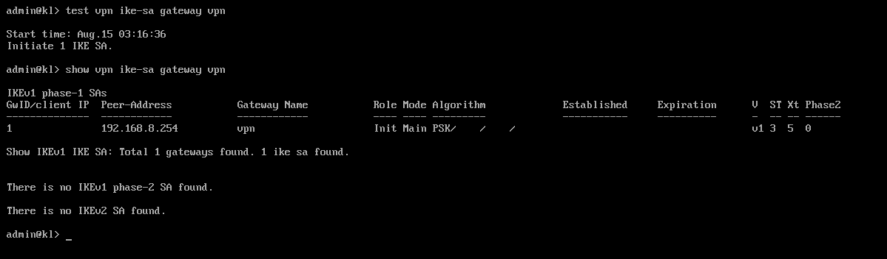

Test IKE Phase 2.

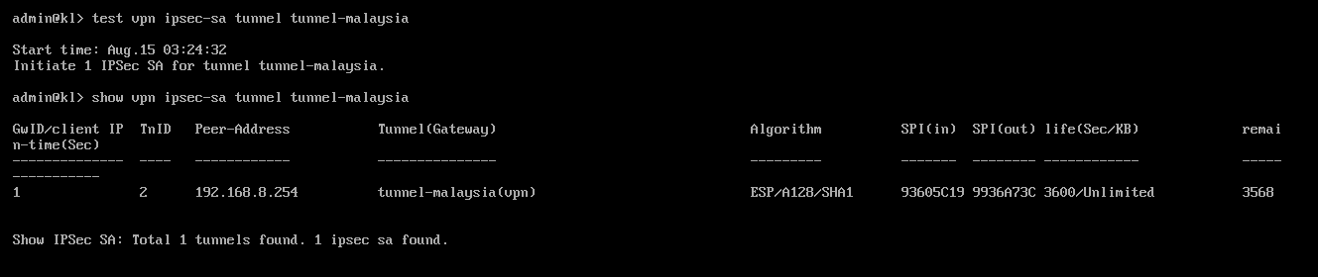  
Checking the flow of the VPN, it shows that the peer-ip is 192.168.8.254 (SG) and the state is active.

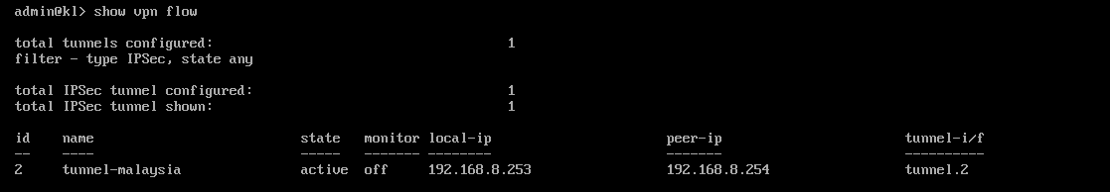

Check VPN status for green light indicators for both IPsec Tunnel and IKE Gateway.



Sales (KL) with IP address 192.168.2.52 ping IT (SG) with IP address 192.168.3.50

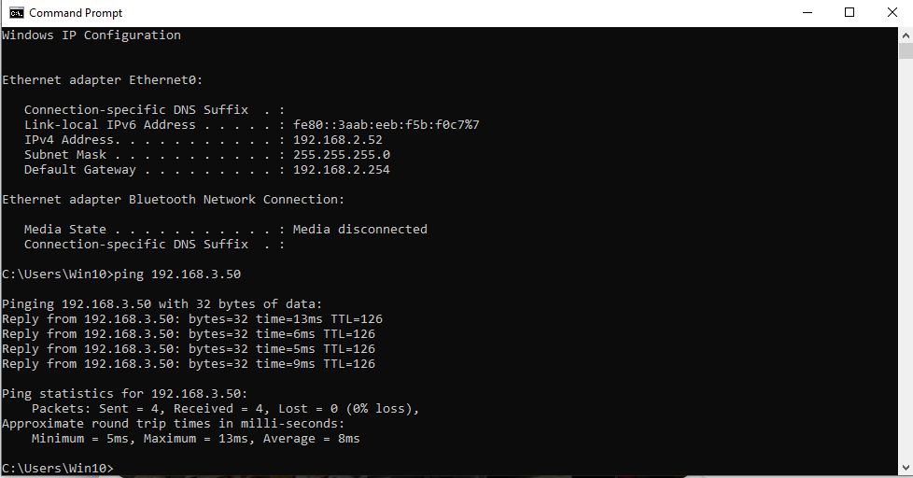

Sales (KL) with IP address 192.168.2.52 ping HR (SG) with IP address 192.168.4.50

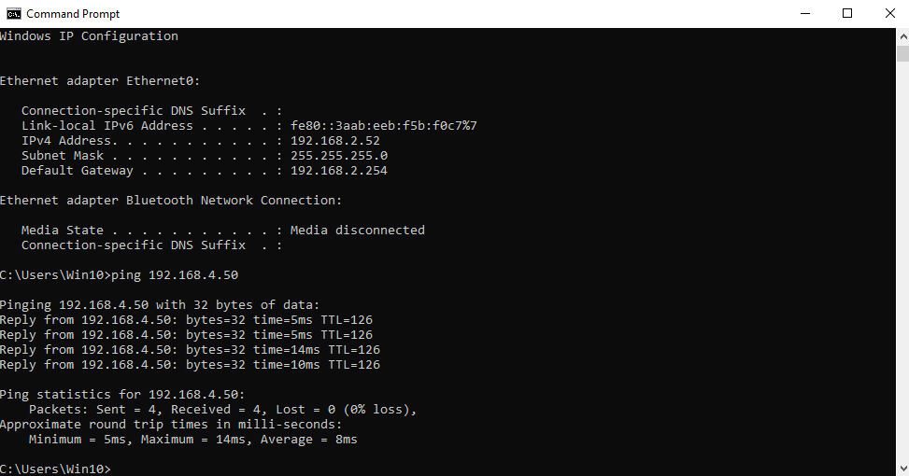

## SG Firewall Content ID

### Anti-Virus/Anti-Spyware

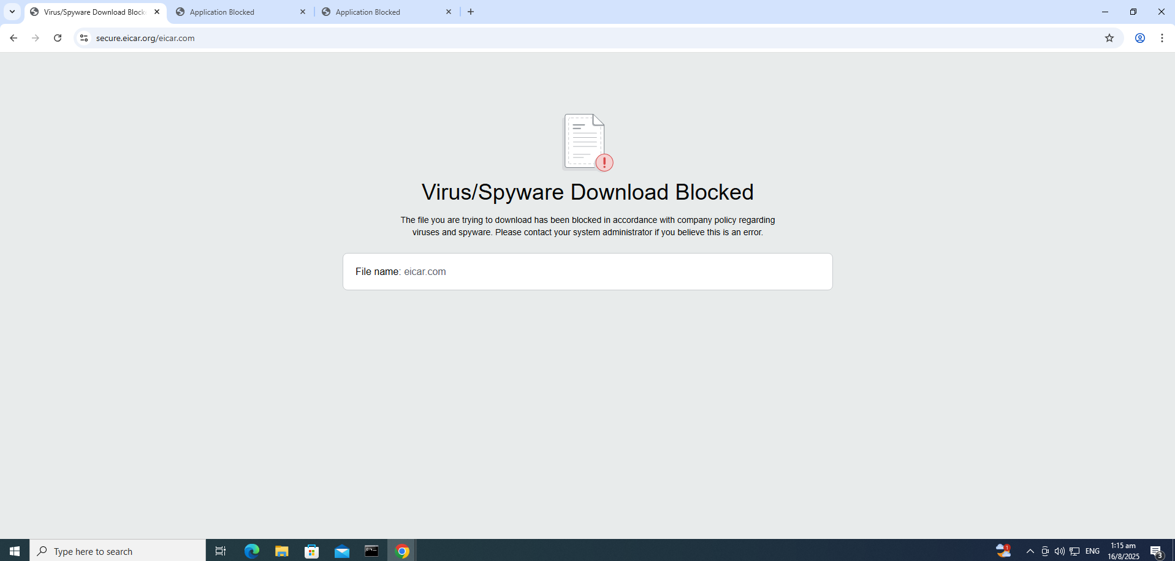

When installing the EICAR test file, the anti-virus/anti-spyware implemented successfully detected the file as malicious and blocked the download, preventing it from entering the network. This indicates that the security profiles are functioning correctly, inspecting traffic in real time and enforcing the configured protection policies.

### Anti-Spyware (DNS sinkhole)

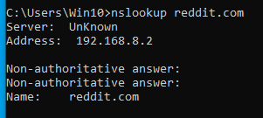

During testing, I performed a DNS lookup query to reddit.com from the **HR zone** and the Anti-Spyware profile with **DNS sinkhole** enabled detected the query and redirected it to the configured sinkhole IP. The Threat Log shows the traffic categorized as **spyware**, with the signature lab-dns-sinkhole, source IP 192.168.4.50, and destination DNS server 192.168.8.2 on port 53. The action taken was **sinkhole**, with a severity of **medium**. This demonstrates that the DNS sinkhole feature is working as intended, allowing identification of potentially compromised hosts attempting to resolve malicious or suspicious domains.

### URL Filtering

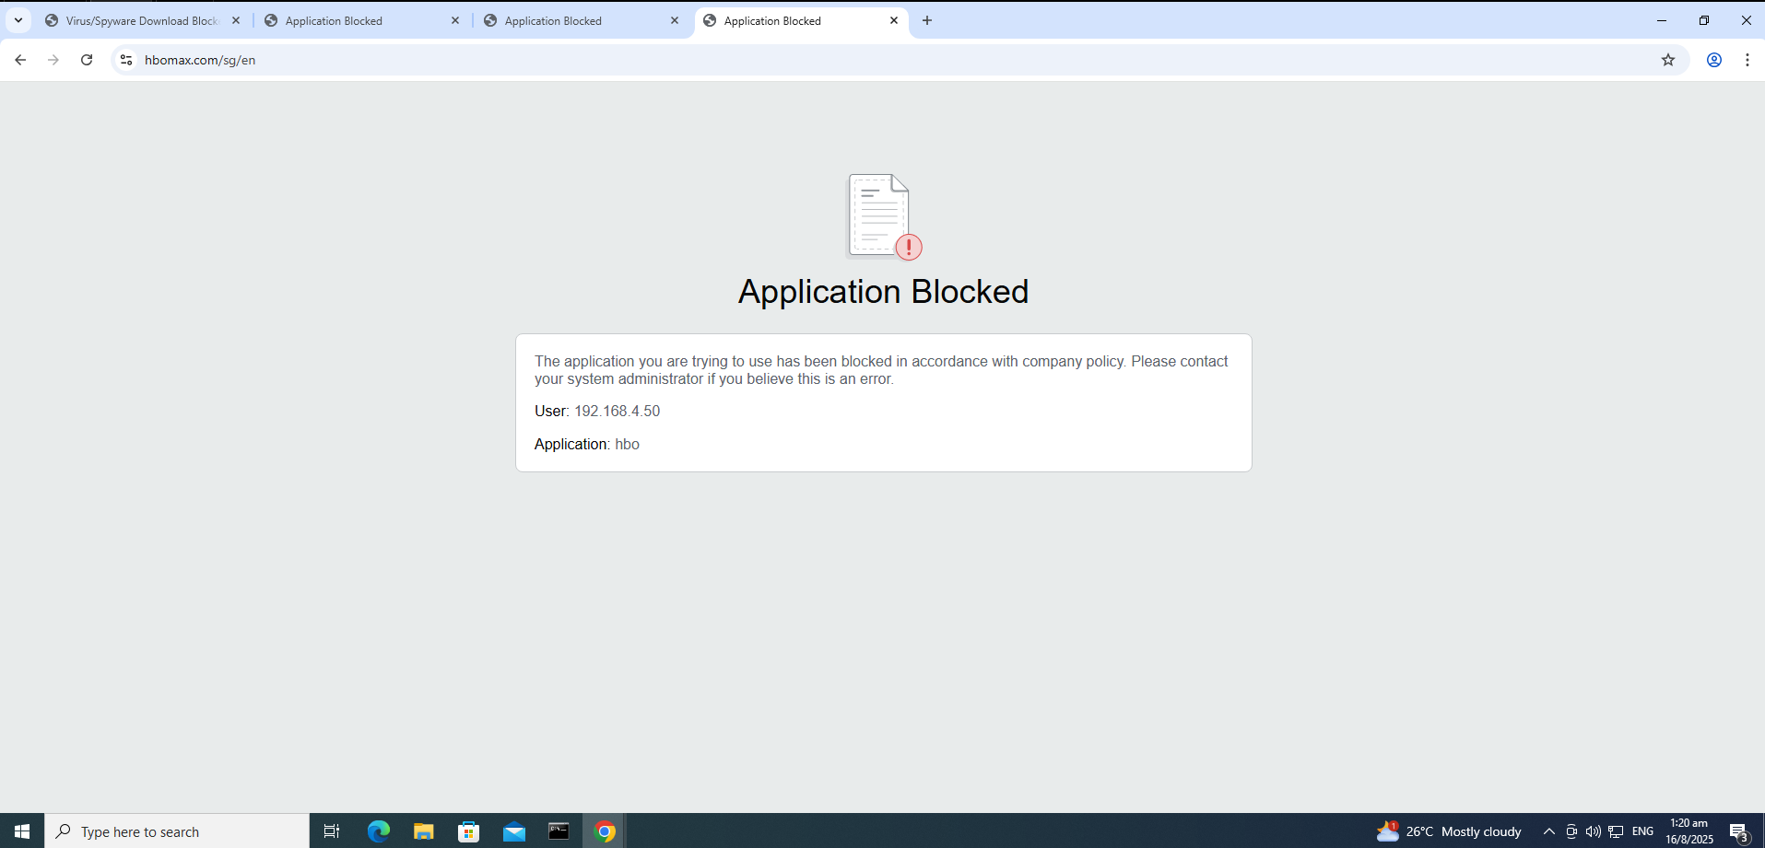

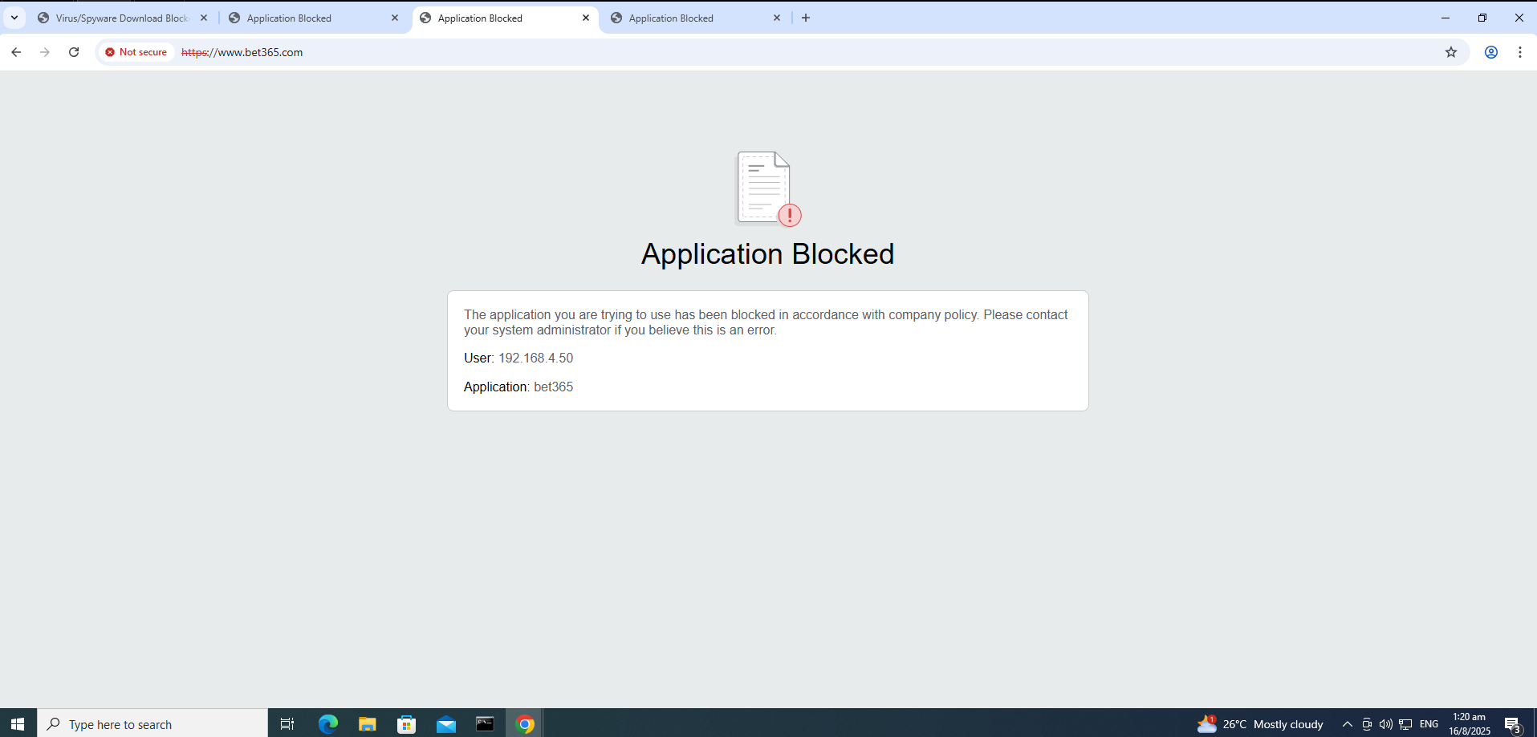

When attempting to access restricted websites such as **HBO Max (streaming media) and Bet365 (gambling)**, the configured URL Filtering profile successfully blocked the applications. Instead of granting access, the firewall displayed an Application Blocked page, showing the user’s IP and the detected application name. This demonstrates that the URL Filtering policy is correctly identifying and controlling traffic based on web categories, helping enforce company policies, prevent access to illegal or non-work-related sites, and reduce security risks.

### File Blocking

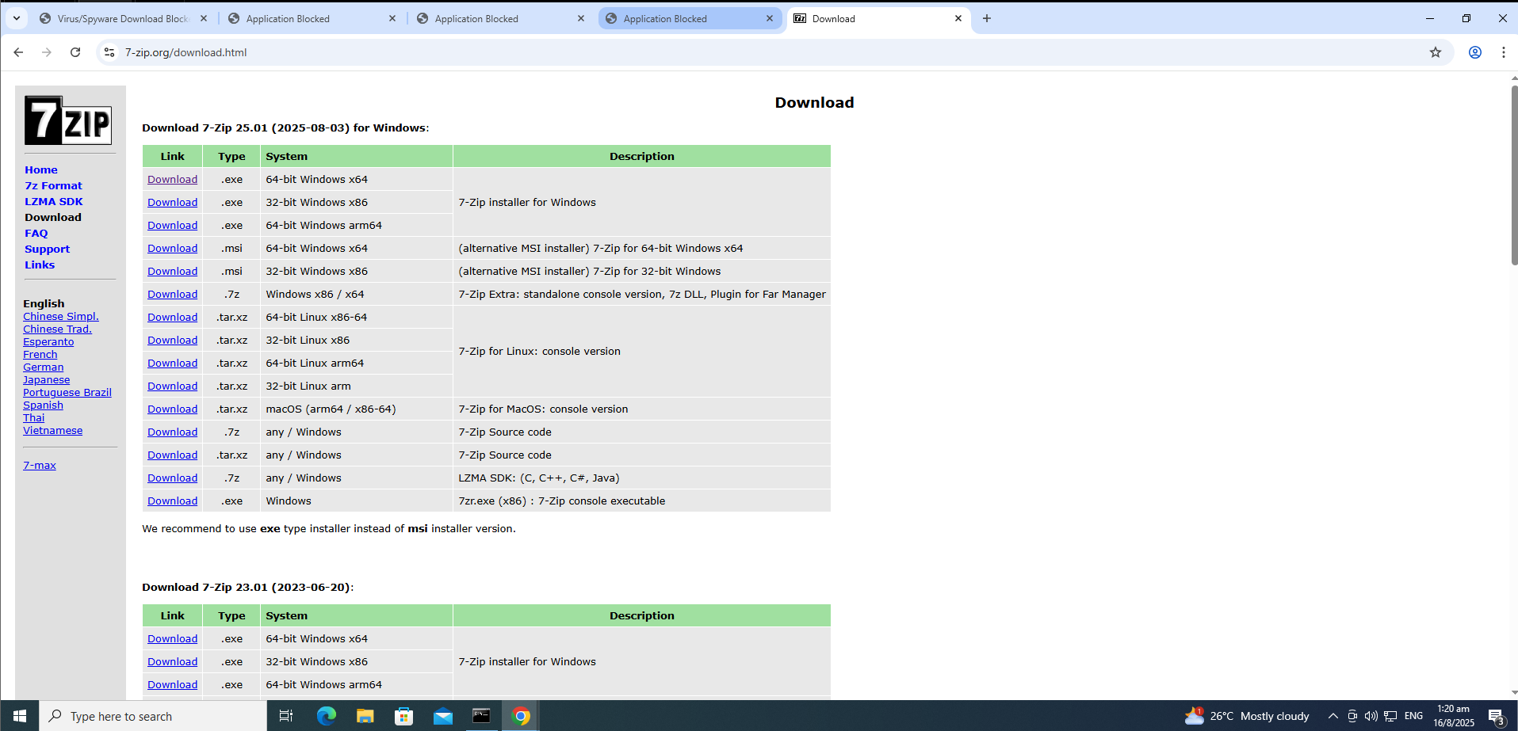

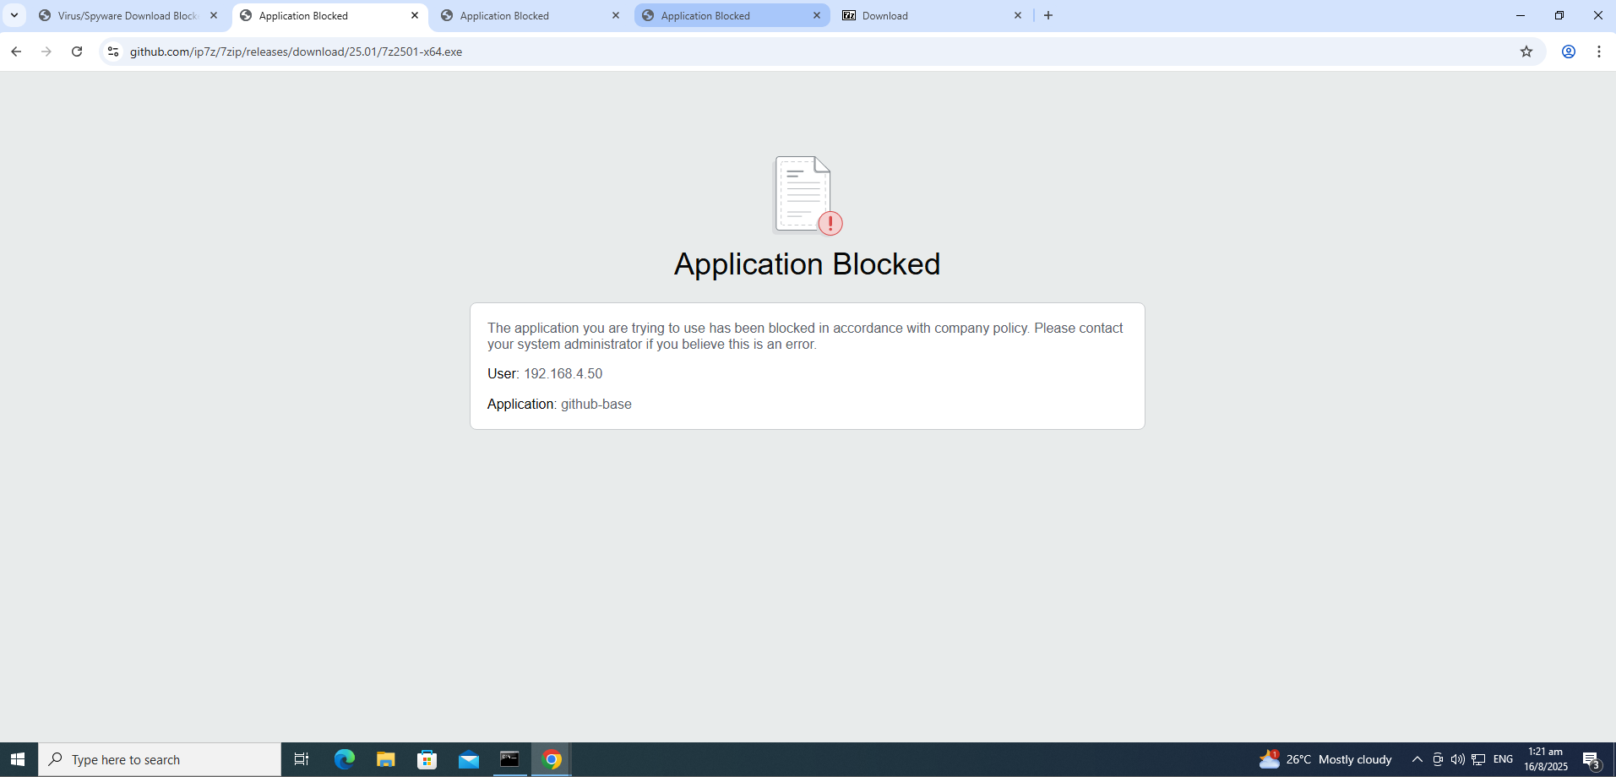

When attempting to download executable files such as the **7-Zip installer (.exe)**, the File Blocking profile successfully prevented the transfer. Instead of allowing the download, the firewall displayed an Application Blocked page, showing the user’s IP and the blocked application. This demonstrates that the File Blocking policy is correctly identifying risky file types and enforcing restrictions, thereby preventing users from downloading potentially harmful executables and reducing the risk of malware infections or unauthorized software installations.

## High Availability

Dashboard of both the Active and the Passive Firewall.

Active Firewall

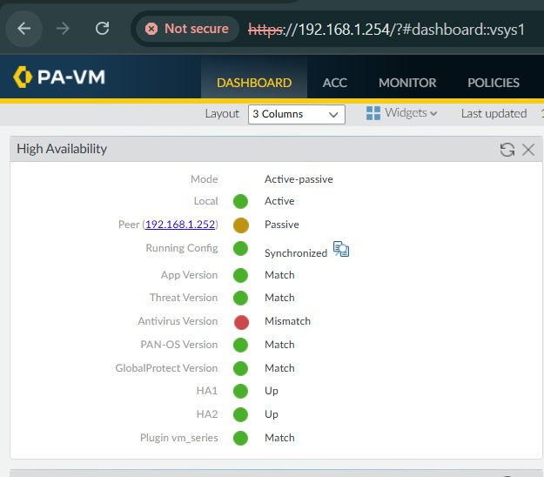

Passive Firewall

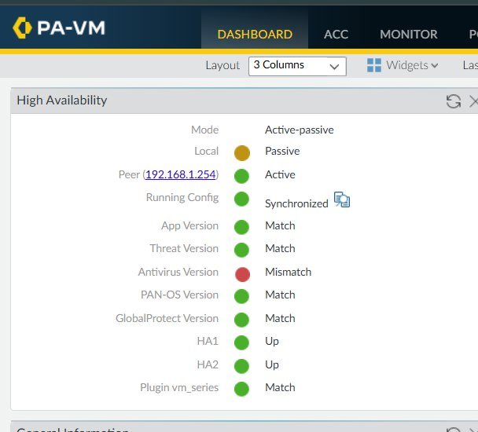

Suspend local device for high availability for the active firewall   
  
Device > High Availability > Operational Commands

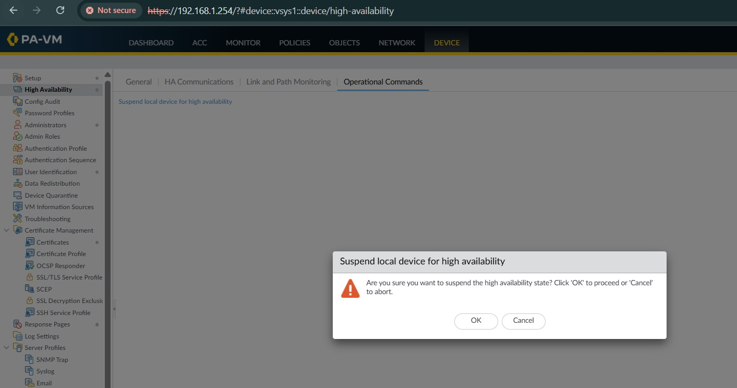

Dashboard of the passive firewall, after reloaded, which became active and shows that the peer firewall has been suspended

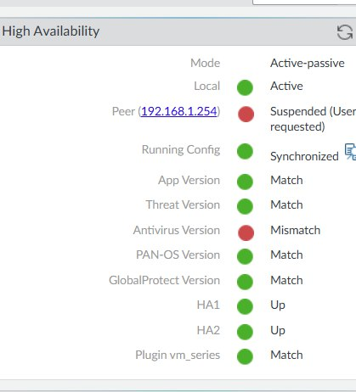

## IDPS (IP Blocking)

Testing communication to the web server in the dmz zone, the logs show that there is a successful connection.

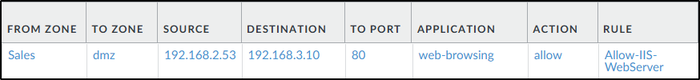

For the purpose of this test case, I will be using Kali Linux (192.168.2.56 as highlighted below) to run an Nmap scan on the web server’s host machine. This would emulate an attacker performing reconnaissance on the target web server.

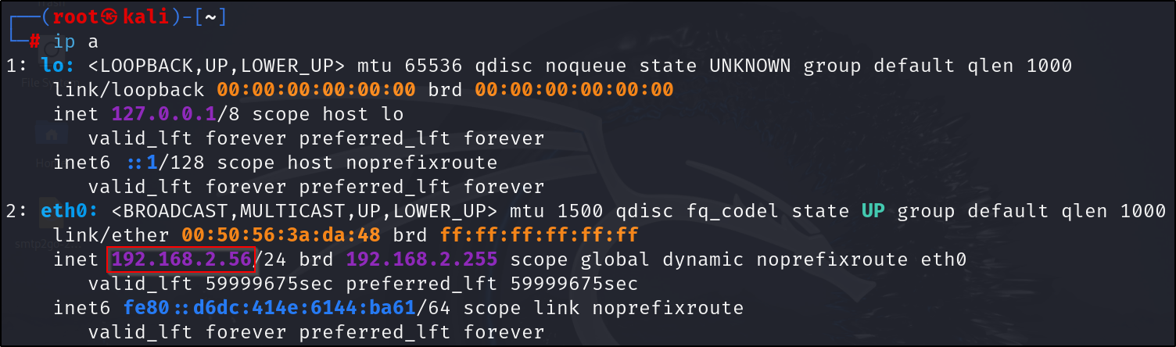

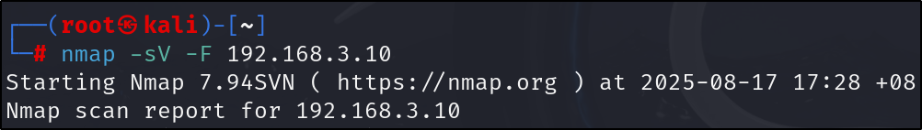

Looking through the logs, we see a threat detected with the threat ID being Nmap Scripting Engine Detection. Since this is a medium severity, the configuration would flag the Kali Linux’s IP address and add it to the source dynamic address group.

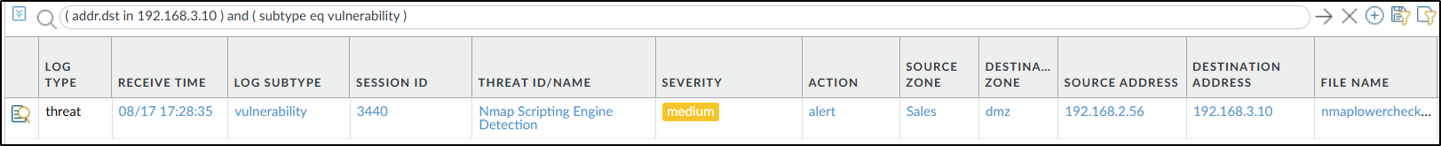

After performing the Nmap scan, it is confirmed that the Kali Linux no longer has access to the web server (192.168.3.10) as all traffic is being dropped by the ‘bad_ips_dynamic’ rule.

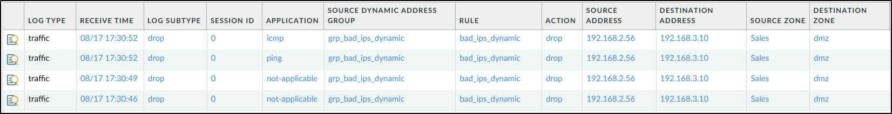

We can also see that the ‘grp_bad_ips_dynamic’ dynamic address group contains a value of the IP address of the Kali Linux. This proves that the IDPS works as the attack has been detected and prevented.

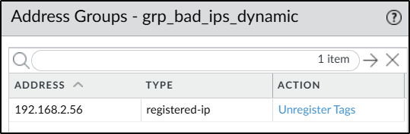

## Client to Site VPN

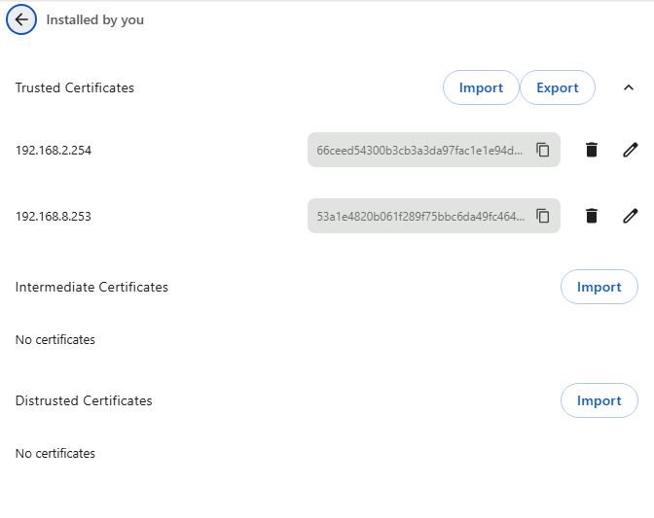

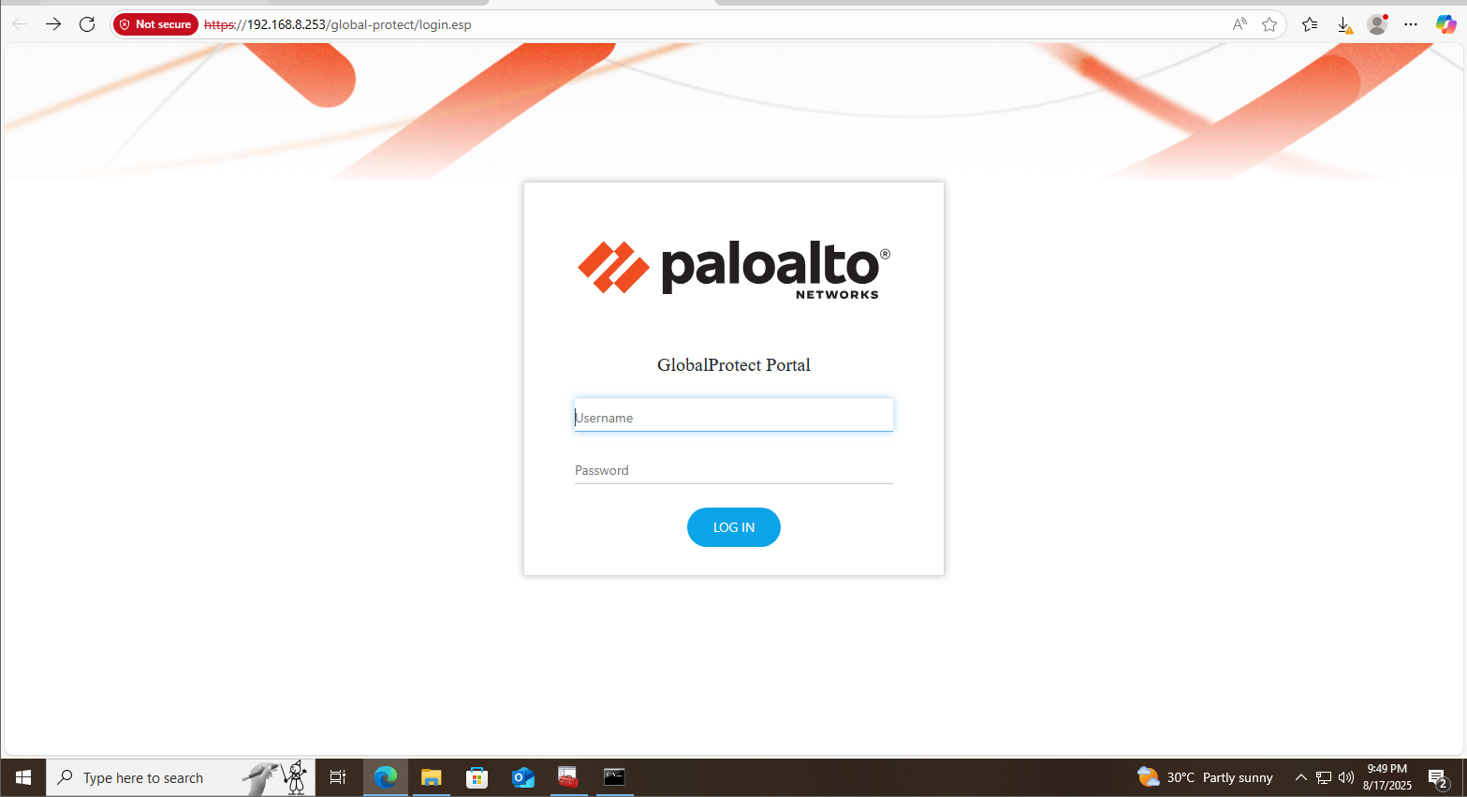

On an external PC, I imported the certificates into the browser and visited <https://192.168.8.253> where the GlobalProtect Portal was configured to be. It shows the Portal, and I logged in with the ‘vpnuser’ credentials that i created in the Local User Database.

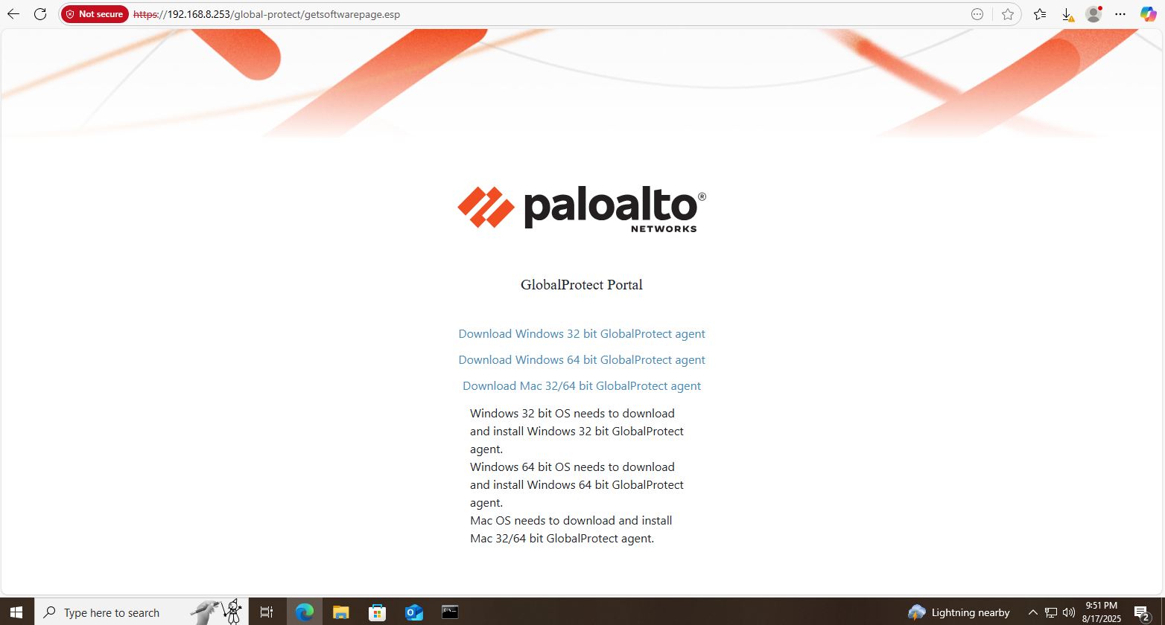

Then it brings me to this page where I have to download the GlobalProtect Application to connect to the VPN.

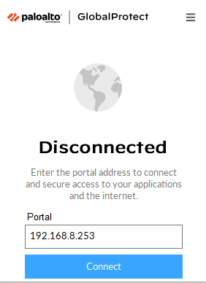

This is the GlobalProtect Application and i set the portal to 192.168.8.253, and logged in with the ‘vpnuser’ credentials.

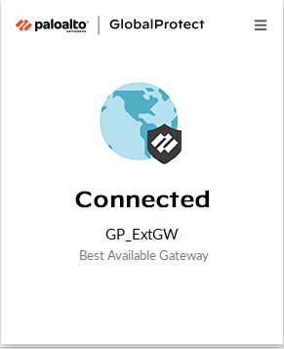

After that it will show that I am connected to the VPN.

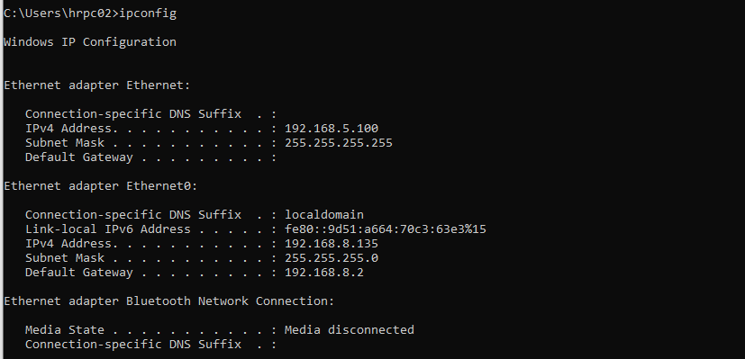

When I do ipconfig, it shows that the IP address is 192.168.5.100 that is in the IP pool range configured in the ‘Client Settings’ for the GlobalProtect Gateway.

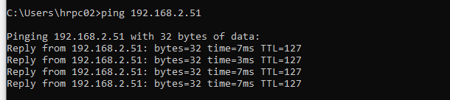

To test the connection, I tried pinging the Sales VM (KL) with IP address 192.168.2.51 and it was successful which proves that the VPN connection was successful

Conclusions and Recommendations

In conclusion, we have successfully implemented a comprehensive network security solution that aligned with the business and technical requirements with the following key approaches:

1. Network segmentation and zoning: In SG Firewall, we created HR, IT, outside and vpn zones and in KL Firewall we created Sales, outside and vpn zones to categorise traffic and apply tailored securities to ensure separation of duties and reduce the risk of lateral movement within the network.
2. Virtual Network Adapters and IP Configuration: SG and KL firewalls were set up with the required virtual network adapters and IP allocations to support departmental segmentation, NAT and VPN connectivity. This includes SG Firewall utilising VMnet1 for the Firewall Interface, VMnet8 for NAT, VMnet3 for IT and VMnet4 for HR, KL utilised VMnet1 for the Firewall Interface, VMnet8 for NAT and VMnet2 for Sales.
3. Application and Traffic Control: App-ID policies were configured to enable essential applications such as Google, Microsoft365 etc while restricting non-essential applications such as LinkedIn messaging, Facebook chat and online storage services.
4. Decryption Policies: We deployed policies to decrypt all traffics except banking and financial websites to ensure compliance with Personal Data Protection Act (PDPA) requirements while maintaining visibility into encrypted traffic.
5. VPN Configuration: We established a site-to-site VPN tunnel between SG and KL to enable encrypted communications and seamless LAN-to-LAN connectivity.
6. Advanced Security Profile: We implemented anti-virus, anti-spyware, URL filtering, and file-blocking profiles and testing confirmed that malicious files, high-risk websites, and unsafe file types were successfully blocked, strengthening the security posture.
7. High Availability: Active-passive HA was configured to ensure firewall redundancy, providing service continuity in any case of device failure.
8. IDPS: A detection system that flags any IP address causing a medium and higher severity level and a prevention system that blocks the IP address for 24 hours.
9. Client to Site VPN: Lets remote users connect to the organization’s internal network from anywhere, so they can do their work anywhere.
10. Test Plan and Results: We conducted testing to validate that all configurations met the business requirements and to ensure that access control restrictions, VPN connectivity, application policies, and decryption rules functioned as intended.

Recommendations for future work:

1. Advanced Threat Detection: We can integrate Endpoint Detection and Response (EDR) for proactive detection of sophisticated threats, complementing the existing firewall defences.
2. Enhanced Monitoring and Logging: We can deploy a centralised Security Information and Event Management (SIEM) solution for real-time monitoring and correlation of logs across both sites, improving incident detection and accelerate response to security events.

# Appendix A: Individual Contribution by Each Team Member

|  |  |  |  |
| --- | --- | --- | --- |
| **No.** | **Member Name** | **Contributions (Role & tasks assigned and accomplishments)** | **Remarks** |
| **1.** | **Wyse** | KL firewall configuration for Sales department and VPN configuration.  Contributed to network diagram.  Troubleshooting KL and SG firewall basic requirements.  Contributed to Technical Implementation requirements. (KL)  Test Plan and Results. (KL)  Test VPN connection.  KL IDPS implementation and testing. |  |
| **2.** | **Ian** | SG firewall configuration for HR, IT departments and VPN configuration  Contributed to Technical Implementation requirements (SG)  Test plan and results (SG)  Test VPN connections  Contributed to network diagram  KL Client to Site VPN implementation and testing  Troubleshooting the KL and SG firewalls (Basic Requirements) |  |
| **3.** | **Si Jia** | SG firewall configuration for HR and IT departments  Contributed to network diagram  Helped with SG Firewall advanced features (Security Profiles)  Contributed to Technical Implementation requirements (SG)  Test plan and results (SG)  Conclusion & Recommendations |  |
| **4.** | **You Tong** | Comprehensive comparison of different firewall options available in the market  Contributed to network diagram   Helped with the VPN configuration for KL   SG firewall advanced feature (High Availability) |  |
| **5.** | **Caeden** | Troubleshooting the KL firewall and Sales department configuration  Contributed to network diagram |  |